
Distribution and Post-Stocking Survival of Bonytail in Lake Havasu

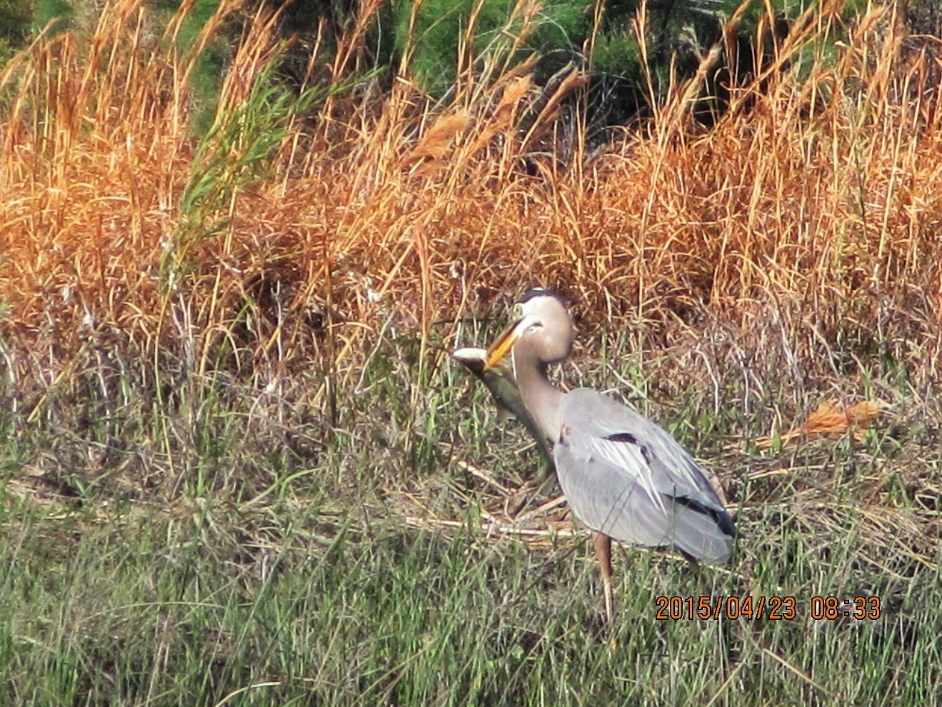
2013 – 2016

Lower Colorado River Multi-Species Conservation Program
Steering Committee Members

Federal Participant Group California Participant Group

Bureau of Reclamation California Department of Fish and Wildlife
U.S. Fish and Wildlife Service City of Needles
National Park Service Coachella Valley Water District
Bureau of Land Management Colorado River Board of California
Bureau of Indian Affairs Bard Water District
Western Area Power Administration Imperial Irrigation District
Los Angeles Department of Water and Power
Palo Verde Irrigation District
Arizona Participant Group San Diego County Water Authority
Southern California Edison Company
Arizona Department of Water Resources Southern California Public Power Authority
Arizona Electric Power Cooperative, Inc. The Metropolitan Water District of Southern
Arizona Game and Fish Department California
Arizona Power Authority
Central Arizona Water Conservation District
Cibola Valley Irrigation and Drainage District Nevada Participant Group
City of Bullhead City
City of Lake Havasu City Colorado River Commission of Nevada
City of Mesa Nevada Department of Wildlife
City of Somerton Southern Nevada Water Authority
City of Yuma Colorado River Commission Power Users
Electrical District No.3, Pinal County, Arizona Basic Water Company
Golden Shores Water Conservation District
Mohave County Water Authority
Mohave Valley Irrigation and Drainage District Native American Participant Group
Mohave Water Conservation District
North Gila Valley Irrigation and Drainage District Hualapai Tribe
Town of Fredonia Colorado River Indian Tribes
Town of Thatcher Chemehuevi Indian Tribe
Town of Wickenburg
Salt River Project Agricultural Improvement and Power District
Unit “B” Irrigation and Drainage District Conservation Participant Group
Wellton-Mohawk Irrigation and Drainage District
Yuma County Water Users’ Association Ducks Unlimited
Yuma Irrigation District Lower Colorado River RC&D Area, Inc.
Yuma Mesa Irrigation and Drainage District The Nature Conservancy

Other Interested Parties Participant Group

QuadState Local Governments Authority
Desert Wildlife Unlimited

Lower Colorado River
Multi-Species Conservation Program
Distribution and Post-Stocking Survival of Bonytail in Lake Havasu

2013 – 2016
Prepared by:
Kristen G. Humphrey, Brian R. Kesner, and Paul C. Marsh
Marsh & Associates, LLC
5016 South Ash Avenue, Suite 108
Tempe, Arizona 85282


Humphrey, K.G., B.R. Kesner, and P.C. Marsh. 2016. Distribution and Post-Stocking Survival of Bonytail in Lake Havasu, 2013 – 2016. Report submitted to the Bureau of Reclamation, Boulder City, Nevada, by Marsh & Associates, LLC, Tempe, Arizona.

Acronyms and Abbreviations

ABS acrylonitrile butadiene styrene
Achii Hanyo Achii Hanyo Native Fish Rearing Facility
Bill Williams River NWR Bill Williams River National Wildlife Refuge
CAP Central Arizona Project
CJS Cormack-Jolly-Seber
cm centimeter(s)
CPUE catch per unit effort
g gram(s)
ID identification
kHz kilohertz
km kilometer(s)
km/day kilometer(s) per day
LCR lower Colorado River
LCR MSCP Lower Colorado River Multi-Species Conservation
Program
m meter(s)
M mass
M&A Marsh & Associates, LLC
mm millimeter(s)
MS-222 tricaine methanesulphonate
N sample size
No. number
NTU nephelometric turbidity unit
PIT passive integrated transponder
PVC polyvinyl chloride
Reclamation Bureau of Reclamation
SE standard error
SNARRC Southwest Native Aquatic Resources & Recovery
Center
SUR submersible ultrasonic receiver
TL total length
UDR ultrasonic diver receiver
USFWS U.S. Fish and Wildlife Service
USGS U.S. Geological Survey

Symbols

°C degrees Celsius
> greater than
≥ greater than or equal to
< less than
% percent

Contents

Page

Executive Summary ES-1

Introduction 1
Primary Objectives 3
Secondary Objectives 4
Methods 4
Study Area 4
Bonytail Surgeries 6
Telemetry 11
Blankenship Bend 12
Bill Williams River 13
Regional Park Moabi 15
Laughlin Lagoon 17
Remote PIT Scanning 17
Blankenship Bend 18
Bill Williams River 19
Regional Park Moabi 20
Laughlin Lagoon 21
Lake Havasu Native Fish Routine Monitoring “Roundup” 22
Results 23
Blankenship Bend Telemetry 23
Autumn 2013 24
Spring 2014 24
Bill Williams River Telemetry 24
Spring 2013 24
Autumn 2014 24
Regional Park Moabi Telemetry 33
Spring 2015 33
Laughlin Lagoon Telemetry 37
Winter 2015 and 2016 37
Remote PIT Scanning 44
Blankenship Bend 44
Bill Williams River 44
Regional Park Moabi 46
Laughlin Lagoon 50
Lake Havasu Native Fish Routine Monitoring “Roundup” 51
Bird Observations 52
Turbidity 55
Discussion 56
Survival 59
Predation: Avian 61
Predation: Fish 64
Page

Predation: Total Length 65
Habitat 66
Movement and Inhabitance 67
Methodologies 69
Study Sites and Seasons 70
Recommendations 72

Literature Cited 75

Acknowledgments 83

Tables

Table Page

1 Data collected from 57 bonytail surgically implanted with
telemetry tags on September 30 and October 21, 2014,
Bill Williams River, Arizona; April 13, 2015, Regional Park
Moabi, California; and December 9, 2015, Laughlin Lagoon,
Nevada 9
2 Dispersal and displacement data collected for acoustic-tagged
bonytail in September – November 2014, Bill Williams River, Arizona 28
3 Summary of habitat data (mean, standard error, and range) during
active acoustic tracking during all six telemetry study iterations, spring 2013 – winter 2016 at the Bill Williams River, Arizona
and California; Blankenship Bend, Arizona and California;
Regional Park Moabi, California; and Laughlin Lagoon,
Nevada 32
4 Dispersal and displacement data collected for acoustic-tagged
bonytail during the April – July 2015 telemetry study, Regional
Park Moabi, California 34
5 Dispersal and displacement data collected for acoustic-tagged
bonytail during the December 2015 – March 2016 telemetry
study, Laughlin Lagoon, Nevada 41
6 Habitat descriptions for PIT scanning antenna deployments where bonytail were contacted less than 1-week post-release (A) and
after 1-week post-release (B) from September – November 2014
and December 2014 – January 2015, Bill Williams River,
Arizona 47

Figures

Figure Page

1 Map of telemetry and passive integrated transponder scanning sites within Lake Havasu on the Colorado River, Arizona, California,
and Nevada. 1
2 Satellite view of the Bill Williams River, Arizona, with place
names mentioned in text. 5
3 Satellite view of Blankenship Bend, Arizona and California,
with place names mentioned in text. 6
4 Satellite view of Regional Park Moabi, California, with place
names mentioned in text. 7
5 Satellite view of Laughlin Lagoon, Nevada, with place names mentioned in text. 8
6 Locations of SURs deployed September 24 to November 19, 2014 (green – stationary), and later through the study (red – additional);
Bill Williams River, Arizona. 14
7 Turbidity sampling sites in the Bill Williams River, Arizona. 15
8 Locations of SURs deployed from April 13 to July 7, 2015 (green – stationary) and deployed for shortened time periods (red –
additional), Regional Park Moabi, California. 16
9 Locations of SURs deployed from December 8, 2015, to
March 1, 2016, Laughlin Lagoon, Nevada. 18
10 Locations of remote PIT scanning antennas deployed from
September – November 2014 (above) and December 2014 –
January 2015 (below), Bill Williams River, Arizona. 19
11 Locations of remote PIT scanning antennas deployed with bait
(yellow) on occasion and without (blue) from April –
July 2015, Regional Park Moabi, California. 21
12 Locations of remote PIT scanning antennas deployed permanently throughout intensive tracking (green) and temporarily to
supplement efforts (red) from December 2015 – January 2016, Laughlin Lagoon, Nevada. 22
13 Summary of study fish fate for all six telemetry study iterations,
spring 2013 – winter 2016 at the Bill Williams River, Arizona
and California; Blankenship Bend, Arizona and California;
Regional Park Moabi, California; and Laughlin Lagoon,
Nevada. 23
14 Active (red) and passive (green) telemetry contacts and bonytail
release site (blue x) during the September – November 2014 telemetry study, Bill Williams River, Arizona and California. 25

Figures (continued)

Figure Page

15 SUR contacts by hour of study fish for all six telemetry study
iterations during spring 2013 – winter 2016 at the Bill Williams
River, Arizona and California; Blankenship Bend, Arizona and California; Regional Park Moabi, California; and Laughlin
Lagoon, Nevada. 26
16 Total number of 19 acoustic-tagged bonytail potentially available
for contact (light gray box) and those actually contacted (dark
gray box) each week during the September – November 2014 telemetry study, Bill Williams River, Arizona. 27
17 Locations of recovered telemetry tags indicating mortalities of
acoustic-tagged bonytail during the September – November 2014 telemetry study, Bill Williams River, Arizona. 29
18 Documented double-crested cormorant roost sites where telemetry
and PIT tags were triangulated or contacted. 30
19 Weekly contacts (X) and non-contacts (gray boxes) for all
19 acoustic-tagged bonytail during the September –
November 2014 telemetry study, Bill Williams River, Arizona. 31
20 Inhabitance represented by percent of days tracked by active and passive data of acoustic-tagged bonytail during the September – November 2014 telemetry study, Bill Williams River, Arizona. 31
21 Active (red) and passive (green) telemetry contacts, the bonytail
release site (blue x), and mortalities (maroon) during the
April – July 2015 telemetry study, Regional Park Moabi,
California. 33
22 Total number of 14 acoustic-tagged bonytail potentially available
for contact (light gray box) and those actually contacted (dark
gray box) each week during the April – July 2015 telemetry
study, Regional Park Moabi, California. 34
23 Weekly contacts (X) and non-contacts (gray boxes) for all
14 acoustic-tagged bonytail during the April – July 2015
telemetry study, Regional Park Moabi, California. 36
24 Inhabitance represented by percent of days tracked by active
and passive data of acoustic-tagged bonytail during the
April – July 2015 telemetry study, Regional Park Moabi,
California. 37
25 Fish visually observed in bulrush (A–D) and the location of fish
visually observed (E) during the December 2015 – March 2016 telemetry study, Laughlin Lagoon, Nevada, and the April –
July 2015 telemetry study, Regional Park Moabi, California (F). 38
26 Active (red) and passive (green) telemetry contacts and bonytail
release site (blue x) during the December 2015 – March 2016 telemetry study, Laughlin Lagoon, Nevada. 39
Figures (continued)

Figure Page

27 Total number of 24 acoustic- and radio-tagged bonytail
potentially available for contact (light gray box) and those
actually contacted (dark gray box) each week during the
December 2015 – March 2016 telemetry study, Laughlin
Lagoon, Nevada. 40
28 Locations of recovered telemetry tags indicating mortalities of
acoustic- and radio-tagged bonytail during the December 2015 – March 2016 telemetry study, Laughlin Lagoon, Nevada. 42
29 Weekly contacts (X) and non-contacts (gray boxes) for all
24 acoustic- and radio-tagged bonytail during the
December 2014 – March 2016 telemetry study, Laughlin
Lagoon, Nevada. 43
30 Contacts of bonytail at remote PIT scanning locations from
September – November 2014 (above) and December 2014 –
January 2015 (below), Bill Williams River, Arizona. 45
31 Contacts of bonytail released September 30, 2014 (blue),
December 10 – 11, 2014 (red), and November 29, 2011,
October 8, 2012, or December 3, 2010 (green) over time by
remote PIT scanning from September 2014 – January 2015,
Bill Williams River, Arizona. 46
32 Contacts of bonytail at remote PIT scanning locations from
April – July 2015, Regional Park Moabi, California. 49
33 Contacts of bonytail released April 13, 2015, at Regional
Park Moabi (blue), and January 14, 2014, at Blankenship Bend
(red), over time by remote PIT scanning from April – July 2015, Regional Park Moabi, California. 50
34 Mean unique bonytail contacts within three defined areas (near
the release site [release], downstream from the release site at
the exit point of a narrow bulrush-lined channel [middle], and
where the Regional Park Moabi backwater enters the main channel [exit]) graphed over days post-release, illustrating potential
egression of bonytail from the release sites to the exit of
Regional Park Moabi during April – July 2015 PIT scanning, Regional Park Moabi, California; see figure 11 for site number locations. 51
35 Contacts of bonytail at remote PIT scanning locations from
December 2015 – January 2016, Laughlin Lagoon, Nevada. 52
36 Contacts of bonytail released December 9, 2015 at Laughlin
Lagoon (blue), and September 15, 2015 at Laughlin Lagoon
(red), over time by remote PIT scanning from December 2015 – January 2016, Laughlin Lagoon, Nevada. 53

Figures (continued)

Figure Page

37 Mean unique bonytail contacts within three defined areas
(near the release site [release], at least ½ km downstream from
the release site [middle], and where Laughlin Lagoon enters the
main channel, including two culverts [exit]) graphed over days
post-release, illustrating potential egression of bonytail from the release sites to the exits of Laughlin Lagoon during December
2015 – January 2016 PIT scanning, Laughlin Lagoon, Nevada;
see figure 12 for site number locations. 54
38 Weekly morning bird counts conducted during the September – November 2014 telemetry study, Bill Williams River, Arizona
(top), April – July 2015 telemetry study, Regional Park Moabi, California (middle), and December 2015 – February 2016
telemetry study, Laughlin Lagoon, Nevada (bottom). 55
39 Deceased bonytail with talon markings discovered during the September – November 2014 bonytail telemetry study,
Bill Williams River, Arizona. 56
40 Great blue heron consuming a bonytail during the April –
July 2015 bonytail telemetry study, Regional Park Moabi,
California. 56
41 Trail camera footage of a double-crested cormorant fishing (A);
birds attracted to the Bill Williams River NWR boat launch after bonytail stocking in the morning of December 11, 2014 (B); a
great blue heron at the cattail islands (C) during the September – November 2014 bonytail telemetry study, Bill Williams River, Arizona; and a great blue heron standing (D) and in flight (E)
near the release site during the April – July 2015 telemetry
study, Regional Park Moabi, California. 57
42 Turbidity (NTU) readings taken October 2 (top), October 23
(middle), and November 19 (bottom), 2014, beginning in the upstream-most watercraft accessible portions of the Bill Williams River (water sample site 1) and ending outside of the refuge boundary for the Bill Williams River NWR, Bill Williams
River, Arizona; see figure 7. 58

Attachments

Attachment

1 Individual Fish Narratives for the September – November 2014 Bonytail Telemetry Study

2 Individual Fish Narratives for the April – May 2015 Bonytail Telemetry Study

3 Individual Fish Narratives for the December 2015 – March 2016 Bonytail Telemetry Study

Executive Summary

The bonytail (Gila elegans), federally listed as endangered, is considered functionally extirpated from its historical range, and its presence in the Colorado River Basin now relies entirely on stocking programs. Lake Havasu, Arizona, California, and Nevada, is one of the few release locations for hatchery fish and sites where stocked individuals are occasionally captured. Information regarding the basic ecology of this species is limited to past field observations and a small number of telemetry projects in the basin. The result is a general lack of knowledge regarding how to better inform managers of the post-stocking fate and habitat use of hatchery-reared bonytail and of practical measures to increase the survival of stocked fish.

A multi-year research project was implemented on Lake Havasu in which the post-stocking distribution, habitat use, and mortality of bonytail were documented. Six iterations of an acoustic telemetry study and five iterations of remote passive integrated transponder (PIT) scanning within Lake Havasu from spring 2013 to winter 2016 were completed. Six to 24 bonytail were surgically implanted with acoustic or radio tags and released during spring and autumn in the Bill Williams River and Blankenship Bend and during spring in Regional Park Moabi and winter in Laughlin Lagoon. Fish were tracked intensively by active and passive efforts for at least 1 month. Additionally, remote PIT scanners were deployed to monitor PIT-tagged bonytail released during a stocking event at each study site. In February 2014 and 2015, Marsh & Associates, LLC, participated in the week-long, multi-agency Native Fish Routine Monitoring “Roundup” at Lake Havasu. During this event, fish sampling was conducted predominantly through trammel netting efforts.

Out of a total of 85 telemetry-tagged bonytail throughout the entirety of the 3-year study, 44 were determined mortalities, and 35 were permanently lost to the study (never contacted again). The majority of these lost fish (83%) were last located within the study area and were not contacted by submersible ultrasonic receivers specifically placed in locations to detect fish leaving the study area. Loss of contact with these tags may have been due to removal from the system (for example, by an avian predator), tag failure, or a result of the inability to detect a signal even though the tag was present and functioning properly.

Most remote PIT scanning contacts (at least 55%) occurred within the first 2 weeks post-stocking. Over the course of all PIT scanning iterations, 27% of bonytail from the corresponding stocking event were contacted during winter 2014 in Blankenship Bend, 5% during both autumn 2014 and winter 2014–15 scanning at the Bill Williams River, 68% in spring 2015 at Regional Park Moabi, and 23% during winter 2015–16 scanning at Laughlin Lagoon. Trammel netting efforts during the multi-agency Native Fish Routine Monitoring “Roundup”

resulted in the capture of eight bonytail in February 2014, one of which was inside the digestive tract of a largemouth bass, and no bonytail in February 2015 or 2016.

Predation was a major threat to bonytail survival at all study areas, and the data suggest that piscivorous birds accounted for a large proportion of mortality in telemetry-tagged fish. Tags recovered on land and under roosting sites and observed capture events provided direct evidence of bird predation. Increased total length of bonytail at release may benefit their survival. Few fish survived long enough after release to determine habitat selectivity, although fish were documented to utilize bulrush (Scirpus sp.). Data do not suggest that fish disperse far from release sites. Off-channel locations with constricted connection to the lower Colorado River where the potential for fish to leave the study area is minimized, such as Regional Park Moabi and Laughlin Lagoon, are ideal sites to track survival through both telemetry and remote PIT scanning efforts. Optimal release locations may also include availability of cover in the form of bulrush, structure (e.g., culverts and riprap), and turbidity (to reduce the impact of piscivorous birds).

Introduction

Lake Havasu, a main stem lower Colorado River (LCR) reservoir, extends for approximately 45 river kilometers (km) from Parker Dam upstream to Lake Havasu City along the Arizona-California border (figure 1). Upstream of the reservoir, the river continues another 87 km through Topock Gorge to Davis Dam. This section of the Colorado River is designated as Reach 3 (hereon referred to as Lake Havasu) of the Lower Colorado River Multi-Species Conservation Program (LCR MSCP) and provides water to the Metropolitan Water District of Southern California and the Central Arizona Project (CAP) through the Colorado River Aqueduct and the CAP Canal, respectively.
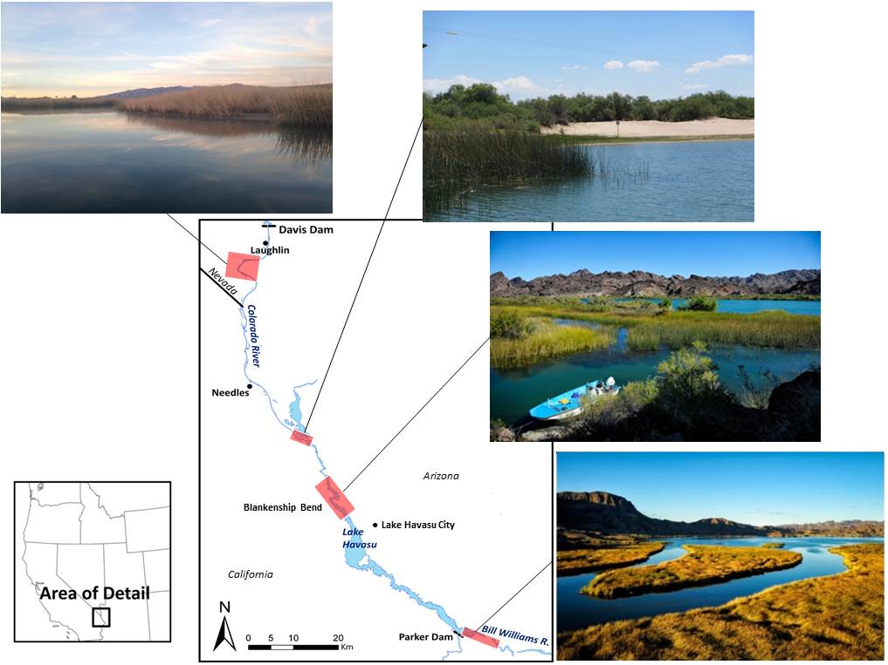
Figure 1.—Map of telemetry and passive integrated transponder scanning sites within Lake Havasu on the Colorado River, Arizona, California, and Nevada.
Photographs include Laughlin Lagoon, Nevada (top left); Regional Park Moabi, California (top right); Topock Gorge near Blankenship Bend, Arizona and California (middle); and the Bill Williams National Wildlife Refuge at the southeast terminus of Lake Havasu, Arizona and California (bottom).

Introductions of non-native fish species to support recreational angling have drastically altered the native fish community within Lake Havasu (Moffett 1942; Dill 1944; Minckley 1979; Minckley and Deacon 1991; Mueller and Marsh 2002). Physical modifications that promote agriculture and urbanization throughout the Southwest have also exacerbated these changes (Reisner 1986; Mueller and Marsh 2002). Bonytail (Gila elegans) and razorback sucker (Xyrauchen texanus) are two fish species endemic to the region and federally listed as endangered (U.S. Fish and Wildlife Service [USFWS] 1980, 1991). The bonytail is among the most endangered North American freshwater fishes (Rinne and Minckley 1991) and considered functionally extirpated from its historical range (Marsh 2004). Persistence of bonytail in the Colorado River Basin now relies entirely on stocking (Bureau of Reclamation [Reclamation] 2004; Minckley and Thorson 2007).

Since 1981 when augmentation began, approximately 218,662 bonytail have been stocked into Lake Havasu, of which 315 have been recaptured during routine monitoring (Pacey 2015). Capture events are an indirect result of the Lake Havasu Fishery Improvement Project, which was initiated in 1993 in part to help re-establish bonytail and razorback sucker populations within the reach (Doelker 1994). The stocking goal of 30,000 bonytail greater than 250 millimeters (mm) total length (TL) established under the project was achieved in 2003 (Minckley and Thorson 2007). Since 2006 and for the next 40 years, the LCR MSCP will stock 4,000 bonytail per year greater than 300 mm TL into Lake Havasu (Reclamation 2004). To date, the program has stocked approximately 45,347 bonytail into the reach, of which approximately 25,000 were passive integrated transponder (PIT) tagged prior to release (unpublished data, Lower Colorado River Native Fish Database).

Bonytail monitoring in Lake Havasu is accomplished through combined efforts of the USFWS, Reclamation, Bureau of Land Management, California Department of Fish and Wildlife, Arizona Game and Fish Department, and public volunteers. Routine monitoring surveys are performed in February and involve trammel netting between the Bill Williams River National Wildlife Refuge (Bill Williams River NWR) and Regional Park Moabi near Needles, California, and extensive boat electroshocking between Needles and Laughlin, Nevada. Out of the 315 bonytail encountered during monitoring, 80 were PIT tagged upon release (unpublished data, Lower Colorado River Native Fish Database), and only 3 of these were recaptured more than a year after stocking. Short times at large and low recapture rates suggest that stocking in the reach has failed to establish a persistent population.

Previous telemetry studies in the Lower Colorado River Basin have involved examining habitat use of bonytail. A telemetry study on Lake Mohave tracked bonytail into deeper portions of the lake during the day and shallower shoreline habitat at night (Marsh and Mueller 1999). A separate study at the Cibola High Levee Pond documented bonytail use of riprap shoreline during daylight and movement into open waters at night (Mueller et al. 2003; Marsh et al. 2013a). In a study completed on Lake Havasu, bonytail were contacted along shorelines or in coves, suggesting near-shore habitat use (Minckley 2006). More recently, Karam et al. (2012) conducted four telemetry studies within the Bill Williams River NWR, concluding that (1) PIT-tagged bonytail could be reliably contacted by remote PIT scanners up to 3 months post-stocking and (2) water clarity, stocking site, and time of year may influence bonytail post-stocking mortality and dispersal. It has been concluded from multiple studies that predation by birds and non-native fishes are likely causes for mortality of native fishes within the LCR (Doelker 1994; Mueller 2003; Schooley et al. 2008; Karam and Marsh 2010; Schooley 2010).

A multi-year research project on Lake Havasu was implemented in which the post-stocking distribution, habitat use, and mortality of bonytail were documented. For all of the investigations, inferences regarding post-stocking habitat use are based on where study fish are contacted over time. No analysis was conducted about the availability of habitat in the release area; therefore, individual or third order habitat selection is not implied or investigated (sensu Martin et al. 2009). The goal of this research is to document post-stocking distribution and survival and guide future stocking endeavors in Lake Havasu. A list of objectives as specified in the Statement of Work for the current study period is provided below.

Primary Objectives

- Continue investigations across multiple release sites and variable habitat conditions within Reach 3.

- Choose up to three release sites: one release site must be near the Bill Williams River NWR, and other proposed sites should be upstream of Lake Havasu. Releases and subsequent monitoring could be accomplished simultaneously or successively.

- Require that each release site be monitored for a minimum of 1 month.

- Identify specific habitat types used or preferred by bonytail within each release site.

- Determine short-term survival estimates (minimum of 1–3 months) for bonytail at each release site.

- Monitor movements and/or movement patterns of individual bonytail within Reach 3.

- Summarize all annual bonytail contact/collection data for Reach 3 that was collected under this project in addition to other Federal and non-Federal entities.

Secondary Objectives

- Participate in at least one annual, week-long, multi-agency, survey event held in February and November each year.

- Compare or assess environmental conditions at survey sites that may influence survival (i.e., turbidity and vegetation).

Methods

Passive and active remote sensing technologies were applied to each of the study sites to meet primary objectives 1 and 2. Passive sampling was achieved using an array of submersible ultrasonic receivers (SURs) and PIT scanning units, while active sampling was conducted by boat using a directional or towable omnidirectional hydrophone. During spring and autumn 2013 and 2014, and spring 2015, acoustic tags were surgically implanted into bonytail. Intensive active sampling began immediately following releases of study fish. Remote PIT scanning systems were deployed in winter 2014, winter 2014–15, and concurrently during telemetry in autumn 2014 and spring 2015. Collaboratively, these data will be used to evaluate bonytail post-stocking movement, habitat preference, and differential survival among stocking locations and seasons (primary objectives 3, 4, 5, and 6).

Study Area

Lake Havasu (see figure 1) is impounded by Parker Dam, which was completed by Reclamation in 1938. The dam creates a 7.98 x 10 cubic meter storage capacity reservoir and generates hydroelectric power for the Metropolitan Water District of Southern California and for utilities in Arizona, California, and Nevada. The Bill Williams River NWR occupies the southeast terminus of Lake Havasu (figure 2). The Lake Havasu Basin extends to the northern reach of Windsor Basin at the Colorado River inflow near Lake Havasu City. Upstream of Windsor Basin, the Colorado River forms a braided channel for approximately 10 km, much of which is within the boundaries of the Lake Havasu National Wildlife Refuge and filled with an extensive network of backwaters that continue through Topock Gorge. Between Topock Gorge and Davis Dam, the Colorado River is sinuous and channelized, flowing through urban areas and farmlands surrounding Laughlin, Nevada, Mohave Valley, and Needles, California (figure 3). North of Topock, Regional Park Moabi is a dredged lagoon, initiated in 1959, connected to the Colorado River approximately 400 meters (m) to the east and extending approximately 2,000 m (figure 4) (Udall 1964). Approximately 13 km downstream from Davis Dam, Laughlin Lagoon, at Reservoir Kilometer 121.8 (Reservoir Mile 75.7), is a dredged lagoon approximately 0.4 km and inundated with shallow areas of bulrush (Scirpus sp.) (figure 5).
Figure 2.—Satellite view of the Bill Williams River, Arizona, with place names mentioned in text.
Image: Google Earth.

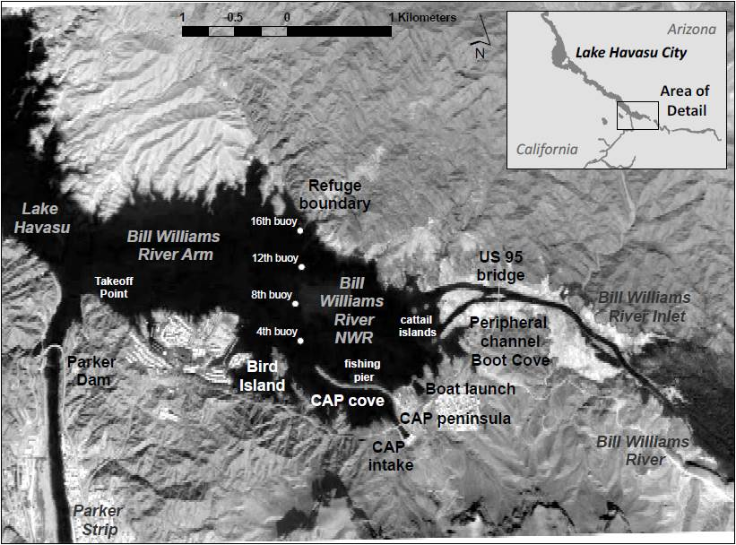
Telemetry studies were conducted within the Bill Williams River (see figure 2), Blankenship Bend (figure 3), Regional Park Moabi (figure 4), and Laughlin Lagoon (figure 5). The termini of the study areas were determined by the most up- and downstream SURs: from the U.S. Geological Survey gaging station to the Castle Rock backwater at Blankenship Bend, from the upper Bill Williams River inlet to Parker Dam at the Bill Williams River, from near Reservoir Kilometer 73.2 (Reservoir Mile 45.5) to Pulpit Rock at Regional Park Moabi, and from Davis Dam to the Boyscout backwater at Laughlin Lagoon. Both the Blankenship Bend and Bill Williams River study areas were sampled during both the spring and autumn seasons in an attempt to compare seasonal variability. These study areas were chosen to represent different habitats within Lake Havasu, focusing respectively on its river and reservoir portions. Further, two separate release sites were chosen within each study area to represent different mesohabitats. Bonytail were released in both a backwater and main channel area at Blankenship Bend and in both the inlet and arm portion of the Bill Williams River. To maximize our ability to assess environmental conditions that influence movement, habitat use, and survival, a third and fourth study area was chosen at Regional Park Moabi and Laughlin Lagoon in spring and winter 2015,

Figure 3.—Satellite view of Blankenship Bend, Arizona and California, with place names mentioned in text.
Image: Google Earth.
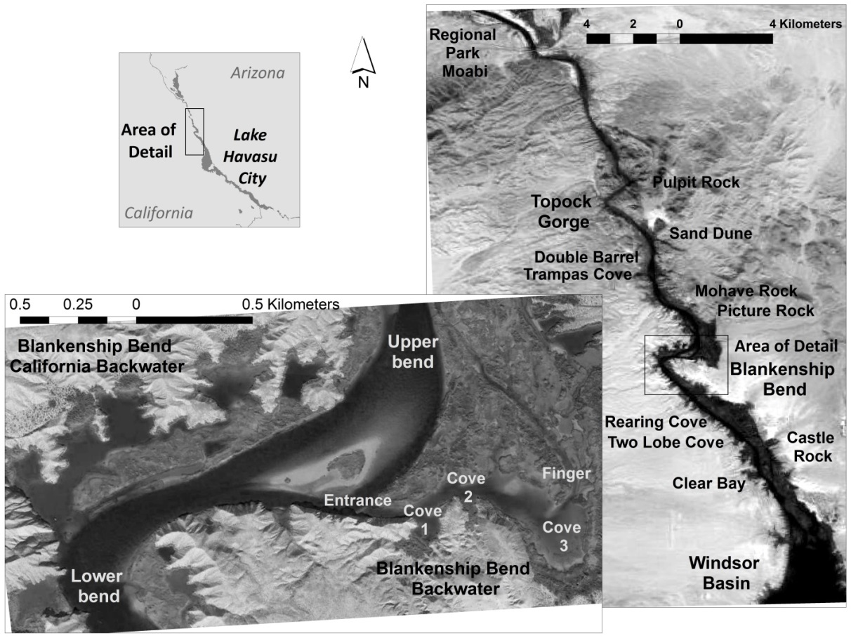

respectively. These sites offered controlled and less complex environments with choke points expected to minimize the loss of fish as a result of tracking limitations and to facilitate monitoring fish egression from the site.

Bonytail Surgeries

Prior to stocking of bonytail within Lake Havasu, study fish were implanted with PT-4 (2.3 grams [g]) or IBT-96-9-I (3.8 g; only Laughlin Lagoon released study fish) acoustic transmitters (Sonotronics, Inc.) with a standard battery life of 3 or 9 months, respectively, or a F-1810 radio tag (6 g; Advanced Telemetry Systems, Inc.; only Laughlin Lagoon released study fish). Acoustic tags were activated with an external magnet and tested for functionality using a directional hydrophone (DH-4; Sonotronics, Inc.) and receiver (USR-08; Sonotronics, Inc.) prior to implantation. Fish were identified by the unique tag number assigned by Sonotronics, Inc., or by radio tag frequency. Surgeries were performed under a constructed shaded area near the release sites, and study fish were immediately

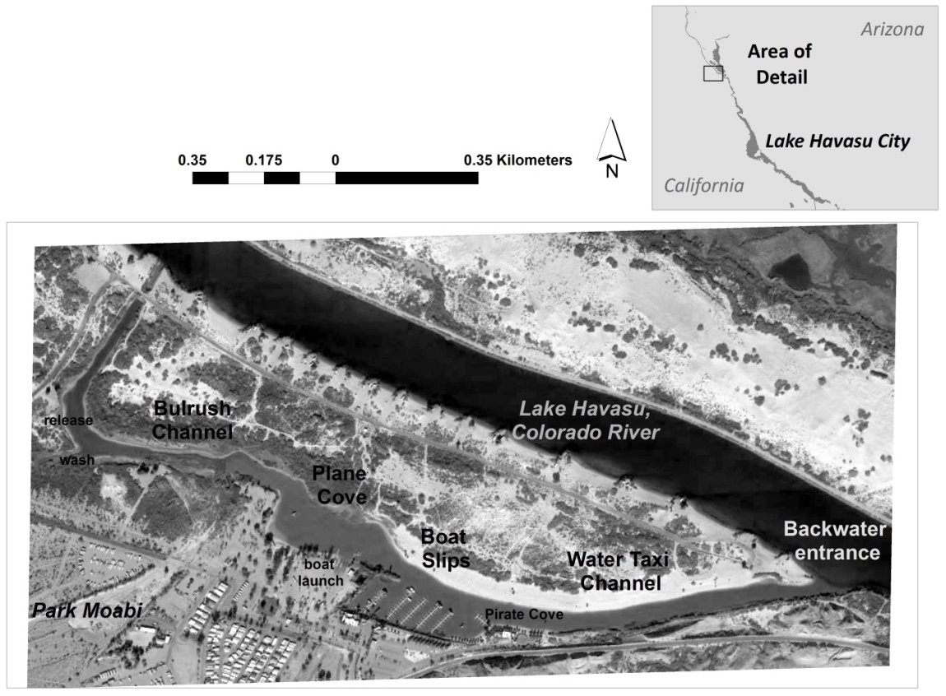
Figure 4.—Satellite view of Regional Park Moabi, California, with place names mentioned in text.
Image: Google Earth.

released post-recovery. As an exception, surgeries during the Laughlin Lagoon telemetry iteration were conducted at the Lake Mead Fish Hatchery, and study fish were held for 1 week prior to release.

Surgeries generally followed the outline described by Marsh (1997) and Karam et al. (2008). Fish were placed into a solution containing tricaine methanesulphonate (MS-222) (125 milligrams per liter) until equilibrium was lost. Anesthesia progress was determined by cessation of all fin and muscular movements and weak operculation. Once the desired depth of anesthesia was reached, the fish was removed from the container, measured (TL; nearest mm), weighed (nearest g), and scanned for a 134-kilohertz (kHz) PIT tag (table 1). The fish then was placed on its dorsum in a cradle specifically made for surgeries with a wet towel wrapped around its body. Once in place, a turkey baster was used to continually pump MS-222 solution (125 milligrams per liter) into its mouth and gills. A short (< 1.5 centimeter [cm]) incision was made slightly anterior and dorsal to the left pelvic fin where a sanitized acoustic tag was then inserted into the abdominal cavity. During radio tag implantations, a puncture was made approximately 2 cm posterior to the incision site using a spinal needle guided by a grooved director. The radio tag’s trailing whip antenna was threaded in through

Figure 5.—Satellite view of Laughlin Lagoon, Nevada, with place names mentioned in text.
Image: Google Earth.

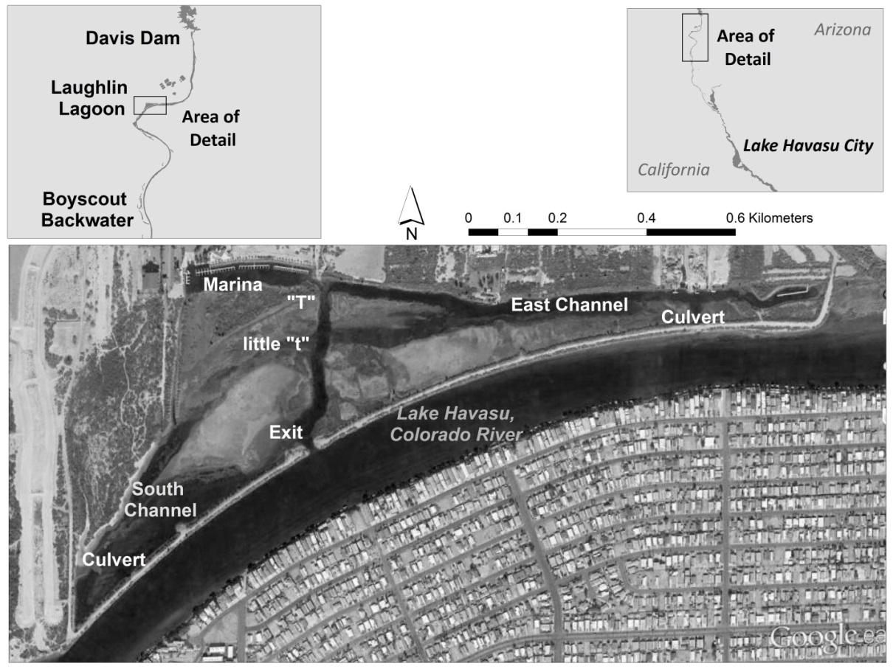
the incision site and out the puncture site by use of the spinal needle so that the radio tag could be inserted into the abdominal cavity and rest posterior to the incision site. The incision was closed with three knots using A CP Medical 4/0 Coated VISORB violet braided suture and a NSH 26-mm ½ taper needle (CP Medical, Portland, Oregon) or PGA Medical 4-0 Coated absorbable braided suture and RB-1 17-mm ½ taper needle (AD Surgical, Sunnyvale, California). Betadine then was swabbed over the incision site, and the antibiotic Baytril was injected using a 10-milligram-per-kilogram dosage into the dorsal-lateral musculature to prevent infection (Martinsen and Horsberg 1995). The fish then was placed into a freshwater recovery tank and closely watched to ensure complete recovery. Two aerated “recovery” tanks were filled with a 50:50 mixture of lake and hatchery water and located near the surgical station. Water temperature (degrees Celsius [°C]) was monitored with a hand-held thermometer or Garmin GPSmap 531s.

Additionally, five dummy tags were surgically implanted into bonytail concurrently under the same conditions and from the same stock during autumn 2014 surgeries. These 5 fish, along with 15 control fish, were transported and held at the Lake Mead Fish Hatchery to monitor post-surgery effects.
Table 1.—Data collected from 57 bonytail surgically implanted with telemetry tags on September 30 and October 21, 2014, Bill Williams River, Arizona; April 13, 2015, Regional Park Moabi, California; and December 9, 2015, Laughlin Lagoon, Nevada
(“Determined dead” is the first date of contact with a sedentary tag.)
Tag ID | TL (mm) | Weight (g) | PIT tag No. | Release date | Release location | Determined dead
2 | 305 | 232 | 003BCB7F27 | 9/30/2014 | Bill Williams River NWR arm boat launch | 10/9/2014
4 | 320 | 290 | 003BCB7DFF | 9/30/2014 | Bill Williams River NWR arm boat launch | 11/11/2014
68 | 340 | 306 | 003BCB7E5F | 9/30/2014 | Bill Williams River NWR arm boat launch | 10/7/2014
70 | 320 | 231 | 003BCB7C5B | 9/30/2014 | Bill Williams River NWR arm boat launch | 10/10/2014
72 | 355 | 338 | 003BCB766C | 9/30/2014 | Bill Williams River NWR arm boat launch | 10/7/2014
141 | 315 | 244 | 003BCB73EB | 9/30/2014 | Bill Williams River NWR arm boat launch | 10/13/2014
32 | 310 | 206 | 003BCB7E69 | 9/30/2014 | Bill Williams River NWR inlet | 10/9/2014
34 | 335 | 277 | 003BCB7757 | 9/30/2014 | Bill Williams River NWR inlet | 11/4/2014
36 | 335 | 250 | 003BCB749C | 9/30/2014 | Bill Williams River NWR inlet | 10/30/2014
38 | 335 | 254 | 003BCB7E34 | 9/30/2014 | Bill Williams River NWR inlet | 10/7/2014
40 | 305 | 262 | 003BCB7BE8 | 9/30/2014 | Bill Williams River NWR inlet | 10/7/2014
177 | 320 | 225 | 003BCB752A | 9/30/2014 | Bill Williams River NWR inlet | 10/30/2014
2-2 | 330 | 310 | 1C2D6BFBED | 10/21/2014 | Bill Williams River NWR inlet | 10/28/2014
32-2 | 325 | 313 | 1C2D6BF7B2 | 10/21/2014 | Bill Williams River NWR inlet | 11/4/2014
40-2 | 315 | 312 | 1C2D6BFFC6 | 10/21/2014 | Bill Williams River NWR inlet
68-2 | 315 | 271 | 1C2D6C3AC7 | 10/21/2014 | Bill Williams River NWR inlet | 11/12/2014
70-2 | 340 | 340 | 1C2D6BF6F4 | 10/21/2014 | Bill Williams River NWR inlet | 11/4/2014
72-2 | 325 | 316 | 1C2D6D08A9 | 10/21/2014 | Bill Williams River NWR inlet | 10/30/2014
141-2 | 320 | 248 | 1C2D6D0E28 | 10/21/2014 | Bill Williams River NWR inlet
152 | 360 | 361 | 003BA15C35 | 4/13/2015 | Regional Park Moabi
153 | 350 | 335 | 003BA15C59 | 4/13/2015 | Regional Park Moabi | 5/27/2015
154 | 361 | 420 | 003BA15C43 | 4/13/2015 | Regional Park Moabi
155 | 336 | 292 | 003BA15C7D | 4/13/2015 | Regional Park Moabi | 5/1/2015
156 | 354 | 320 | 003BA15C4F | 4/13/2015 | Regional Park Moabi
157 | 344 | 297 | 003BA15C32 | 4/13/2015 | Regional Park Moabi
158 | 342 | 284 | 003BA15C65 | 4/13/2015 | Regional Park Moabi
159 | 354 | 361 | 003BA15C61 | 4/13/2015 | Regional Park Moabi
160 | 333 | 286 | 003BA15C2D | 4/13/2015 | Regional Park Moabi
161 | 343 | 297 | 003BA15C4A | 4/13/2015 | Regional Park Moabi
162 | 340 | 299 | 003BA15C5C | 4/13/2015 | Regional Park Moabi
163 | 363 | 280 | 003BA2F49C | 4/13/2015 | Regional Park Moabi | 5/26/2015
164 | 335 | 295 | 003BA15C4E | 4/13/2015 | Regional Park Moabi | 4/28/2015
165 | 367 | 399 | 003BA15C3B | 4/13/2015 | Regional Park Moabi
107 | 393 | 492 | 003BCBF7FF | 12/9/2015 | Laughlin Lagoon | 12/29/2015
108 | 401 | 487 | 003BCBF816 | 12/9/2015 | Laughlin Lagoon
109 | 392 | 503 | 003BCBF7DD | 12/9/2015 | Laughlin Lagoon | 2/19/2016
110 | 387 | 469 | 003BCBF83B | 12/9/2015 | Laughlin Lagoon | 1/25/2016
111 | 391 | 575 | 003BCBF7FB | 12/9/2015 | Laughlin Lagoon | 2/19/2016
112 | 419 | 579 | 003BCBF826 | 12/9/2015 | Laughlin Lagoon
122 | 405 | 617 | 003BCBF7EE | 12/9/2015 | Laughlin Lagoon
123 | 416 | 636 | 003BCBF811 | 12/9/2015 | Laughlin Lagoon
124 | 419 | 701 | 003BCBF825 | 12/9/2015 | Laughlin Lagoon | 2/16/2016
125 | 385 | 494 | 003BCBF7E5 | 12/9/2015 | Laughlin Lagoon | 1/26/2016
126 | 380 | 566 | 003BCBF7EA | 12/9/2015 | Laughlin Lagoon | 1/25/2016
127 | 430 | 634 | 003BCBF821 | 12/9/2015 | Laughlin Lagoon
40.011 | 395 | 521 | 003BCBF7EB | 12/9/2015 | Laughlin Lagoon | 1/27/2016
40.021 | 424 | 608 | 003BCBF7ED | 12/9/2015 | Laughlin Lagoon
40.041 | 383 | 526 | 003BCBF817 | 12/9/2015 | Laughlin Lagoon
40.061 | 382 | 542 | 003BCBF833 | 12/9/2015 | Laughlin Lagoon
40.671 | 405 | 575 | 003BCBF7DE | 12/9/2015 | Laughlin Lagoon
40.681 | 383 | 502 | 003BCBF806 | 12/9/2015 | Laughlin Lagoon
40.691 | 385 | 502 | 003BCBF815 | 12/9/2015 | Laughlin Lagoon | 12/15/2015
40.761 | 440 | 796 | 003BCBF7F2 | 12/9/2015 | Laughlin Lagoon | 12/22/2015
40.771 | 444 | 835 | 003BCBF804 | 12/9/2015 | Laughlin Lagoon | 1/27/2016
40.781 | 405 | 564 | 003BCBF83C | 12/9/2015 | Laughlin Lagoon
40.792 | 409 | 573 | 003BCBF81D | 12/9/2015 | Laughlin Lagoon
40.801 | 391 | 549 | 003BCBF7F5 | 12/9/2015 | Laughlin Lagoon | 2/18/2016

Telemetry

SURs were deployed at different locations throughout the study area prior to the stocking of bonytail. Sites were selected to ensure detection of movement up- or downstream and to determine if fish entered or exited major backwaters. All SURs deployed throughout the study area were attached to a camouflage rope and connected to a 6-m length of galvanized cable that was connected to secure on-shore habitat (e.g., a tree root) or buoy. The cable was used to avoid rope abrasion caused by waves and rocks. Weights were tied near each SUR and to a central location on the rope. The placement of weights ensured that each unit was completely submerged within the water column. Each SUR had a battery life expectancy of 8 months, a nominal detection radius of 200 m, and was programmed to scan continuously. SURs were positioned throughout the study area, targeting passageways of fish movement. Additionally, SURs were placed within backwaters to obtain data on fish entering and exiting these locations. There was no set distance between SUR locations, and deployment relied heavily on the availability of secure on-shore habitat. SUR data were downloaded routinely, and confidence values, defined by the number of detections within a timed window, were calculated using Sonotronics SURsoft Stand Alone Data Processing Center software. Only records from SURs with the highest confidence of 5 were included in the analysis. Data were imported into a Microsoft Access® database used for managing fish contact histories and SUR locations.

Active tracking was conducted with a directional (Model DH-4, Sonotronics, Inc.) or omnidirectional towable (Model TH-2, Sonotronics, Inc.) hydrophone and receiver. The receiver was manually set to specific tag frequencies corresponding to each tagged fish. Active tracking initially began at each release site but later varied depending on recorded fish movement. If all bonytail were not contacted by active tracking, SUR data were downloaded and the data reviewed for the missing fish. Active tracking locations were moved based on the most recent encounter or most recent SUR record for each fish. If fish could not be located, active tracking resumed at the location of the most recent encounter, continuing along a grid system of 1-km spaced waypoints mimicked from previous acoustic telemetry studies (Mueller et al. 2000; Karam et al. 2008). Active tracking efforts were prioritized to a defined study area, such as within Regional Park Moabi or Laughlin Lagoon, although SURs were deployed beyond these areas. When the towable hydrophone was used, boat speed was maintained at about 10 km per hour or less to reduce noise interference from the engine and to allow the device to scan for multiple frequencies. Once a fish was detected using the towable hydrophone, the directional hydrophone was used to triangulate its location. When conditions permitted, an underwater diver receiver (UDR) was used to pinpoint tag locations within a few meters (based on repeated use of the UDR to pinpoint an acoustic tag’s location prior to tag recovery via scuba divers, surface pinpointing is accurate to an approximate 2- to 3-m radius). Habitat variables were recorded at each point of active tracking triangulation. Mesohabitat was described as riverine, lacustrine, cove, backwater, or peripheral channel, while fine-scale habitat variables included surface turbidity (using a calibrated LaMotte 2020we/wi turbidimeter, nephelometric turbidity units [NTUs]), surface water temperature (°C), depth (m), substrate (described as silt, sand, or gravel), distance to shore by visual estimation (m), and major vegetation presence [cattail (Typha sp.) or bulrush]. Mean habitat measurements only included data from dates prior to the date of a determined mortality. The first date of three consecutive active tracking events that a fish was found at the same location was determined as its time of death. A fish was considered a confirmed mortality if the tag was recovered by scuba divers and UDR. The time of the last recorded active or passive (SUR) contact with a fish whose signal was permanently lost during the study period was determined as the time the fish was lost to the study (never contacted again).

The purpose of radio tracking was to identify tags evacuated on land potentially by avian predators, though fine-scale habitat data were collected when possible. The presence of radio-tagged fish was identified within a general area by scanning tag frequencies using a whip antenna and receiver (Advanced Telemetry Systems, Inc.). Further mobile tracking was conducted by identifying peak and null signal bearings with a directional loop antenna to first triangulate a target area and then “home in” (following the signal back to the transmitter) on a study fish. A small, waterproof hand-held directional antenna constructed in house could then be used to determine the precise location of a radio tag and potentially recover tags under water when conditions permitted.

Patterns of dispersal and displacement were assessed for individual fish using Esri® ArcMAP Version 10.1. The farthest maximum dispersal was calculated by measuring the river distance between the release site and the farthest point of contact by active or passive efforts. Results were within 200 m based on the SUR nominal detection radius. Total straight line displacement was assessed in ArcGIS by creating paths between tracking events for each fish. The total distance of these paths was calculated to provide the minimum (straight line) total distance displaced between contacts for each fish and does not account for river sinuosity. The values represent minimal dispersal and displacement if points of contact included SURs deployed at the study area’s termini. Inhabitance in the Bill Williams River NWR arm and inlet are represented by the percentage of days tracked in these areas over the total number of days tracked per fish.

Blankenship Bend

Autumn 2013
In autumn 2013, SURs were deployed from October 22, 2013, to January 19, 2014, and 10 (mean TL = 306 mm, range = 285–325 mm) acoustic-tagged study fish were released into Blankenship Bend. Fish were actively tracked by boat each day for the first 4 weeks and once a month within the following 60 days.

Sampling schedules remained flexible to combat weather unpredictability and to adapt to behavioral observations of tracked fish. The majority of tracking occurred during the daylight hours.

Spring 2014
SURs were deployed from April 8 to May 21, 2014, at Blankenship Bend. Due to an unavailability of hatchery bonytail, 12 (TL = 346 mm, range = 268–486 mm) study fish were captured from the Cibola High Levee Pond (initially developed as a grow-out pond for bonytail and razorback suckers located in the Cibola National Wildlife Refuge near Palo Verde, California) and acoustic tagged. To combat signal detection issues in the complex and highly vegetated backwater systems, acoustic transmitters were programed with increased power, which decreased the nominal battery life to approximately 45 days. Fish were therefore actively tracked by boat each day for 6 weeks during the spring 2014 study, and sampling schedules remained flexible. Most tracking in the spring 2014 study occurred between sunset and sunrise because bonytail are documented to be more active during these hours (Marsh et al. 2013a).

Bill Williams River

Spring 2013
During spring 2013, SURs recorded data from April 11 to May 9, 2013, at the Bill Williams River where six (TL = 325 mm, range = 307–336 mm) acoustic-tagged study fish were intensively tracked for 4 weeks.

Autumn 2014
During autumn 2014, 18 SURs were initially placed throughout the Bill Williams River, and 6 SURs were added a week or more post-stocking (figure 6). SURs were deployed from September 24 to November 19, 2014. Prior to the stocking of bonytail, 19 (mean TL = 324 mm, range = 305–355 mm) study fish were implanted with PT-4 acoustic transmitters. Study fish were propagated and reared at the Southwest Native Aquatic Resources & Recovery Center (SNARRC), Dexter, New Mexico (formerly USFWS Dexter National Fish Hatchery) and released with 2,080 PIT-tagged bonytail into the Bill Williams River NWR on September 30, 2014. Acoustic transmitters used were modified to increase detection, which decreased nominal battery life to approximately 60 days, in an attempt to combat signal detection issues in vegetated systems. Fish were actively tracked by boat for 8 weeks. While sampling schedules remained flexible, the majority of sampling was conducted between sunset and sunrise because bonytail are assumed to be more active during these hours (Marsh et al. 2013a).

Figure 6.—Locations of SURs deployed September 24 to November 19, 2014 (green – stationary), and later through the study (red –additional); Bill Williams River, Arizona.
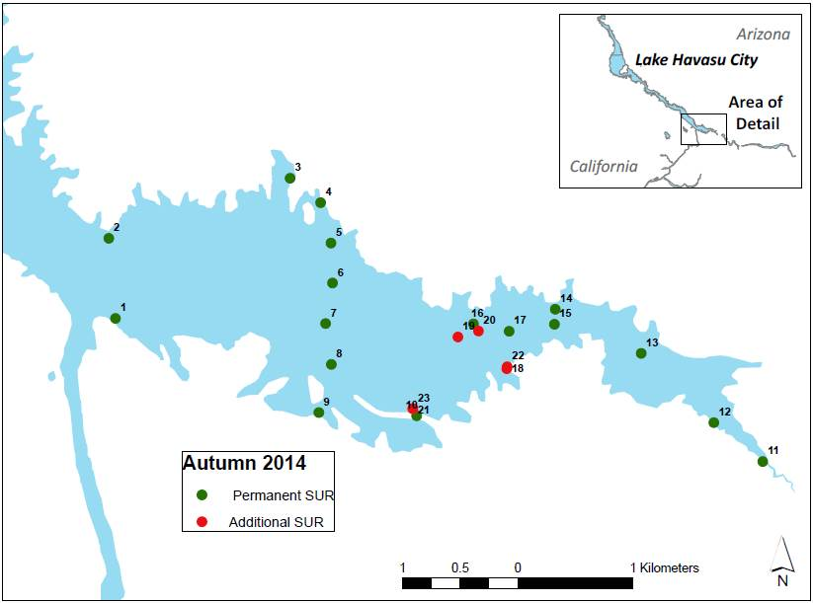

Bird Observations
Bird counts were conducted weekly at cattail islands near the Bill Williams River inlet’s mouth (see figure 2). This area was chosen due to the relative abundance of natural roosting sites. Observation times targeted sunrise and lasted for approximately 15 minutes at a fixed location from the boat. Only potential avian predators (great blue heron [Ardea Herodias], great egret [Ardea alba], double-crested cormorant [Phalacrocorax auritus], gulls [Larus sp.], and osprey [Pandion haliaetus]) of bonytail were recorded. Additionally, stationary camouflaged Moultrie model MCG-12631 and Browning model BTC-6 trail cameras equipped with night vision and motion detection were deployed both at the Bill Williams River NWR boat launch, where bonytail stocking events occurred, and on cattail islands. PIT scanners were deployed under and around known roosting sites at cattail islands in an attempt to contact PIT tags expelled by avian predators post-consumption.

Turbidity
Discharge from the Bill Williams River contributes to comparably high turbidity within the refuge compared to elsewhere in Lake Havasu (Dill 1944; Wiele et al. 2009 and 2011). Accompanying established habitat assessments during active tracking, additional turbidity sampling was included during autumn 2014 following methods of Karam et al. (2013). Turbidity was measured during three events at five sites along a predetermined grid between the eastern‐most watercraft‐accessible portion of the Bill Williams River and just outside the boundary of the Bill Williams River NWR (figure 7). Turbidity was measured in water samples collected at three depths from each site: 0.3 m from the reservoir bottom, mid‐water column (depth/2), and 0.3 m below the surface. Each sample bottle was washed three times before turbidity was measured. Turbidity was measured using a calibrated LaMotte 2020we/wi turbidimeter.
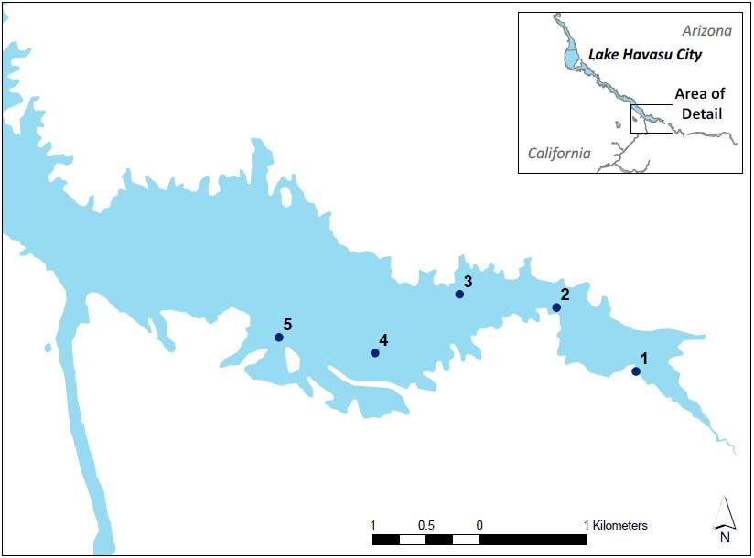
Figure 7.—Turbidity sampling sites in the Bill Williams River, Arizona.
Turbidity samples were taken beginning at the upstream-most watercraft accessible portion of the Bill Williams River inlet (1) and proceeded sequentially toward outside of the boundary of the Bill Williams River NWR, Bill Williams River, Arizona.

Regional Park Moabi

Spring 2015
During spring 2015, 20 SURs were placed throughout Regional Park Moabi, Topock Bay, and in the Colorado River from near Reservoir Kilometer 74 to 60 (Reservoir Mile 46 to 37, Pulpit Rock, figure 8). SURs were deployed from April 7 to July 7, 2015. Prior to the stocking of bonytail, 14 (mean TL = 349 mm, range = 333–367 mm) study fish were implanted with PT-4 acoustic transmitters. Study fish were propagated and reared at the SNARRC and released
with 424 PIT-tagged bonytail into Regional Park Moabi on April 13, 2015. Modifying for vegetated systems, acoustic transmitter battery life was decreased to approximately 60 days to increase detection range. Fish were intensively tracked by boat for 4 weeks and periodically tracked for an additional 60 days. Due to the expectation that bonytail are more active in the evening hours (Marsh et al. 2013a), the majority of sampling was conducted between sunset and sunrise, with some flexibility for weather unpredictability and adapting to behavioral observations of tracked fish.
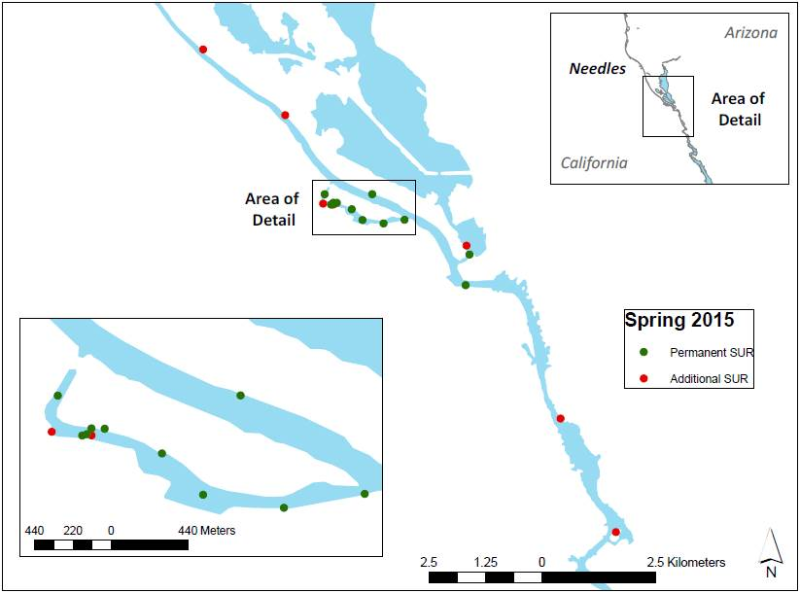
Figure 8.—Locations of SURs deployed from April 13 to July 7, 2015 (green – stationary) and deployed for shortened time periods (red – additional), Regional Park Moabi, California.

Bird Observations
Bird counts were conducted weekly near the release site in upper (north) Regional Park Moabi. Observation times targeted sunrise and lasted for approximately 15 minutes at a fixed location. Only potential avian predators of bonytail were recorded (as listed in the “Autumn 2014” section for the Bill Williams River, above). Additionally, stationary camouflaged Moultrie model MCG-12631 and Browning model BTC-6 trail cameras equipped with night vision and motion detection were deployed near the release site.

Laughlin Lagoon

Winter 2015–16
During winter 2015–16, 17 SURs were deployed within Laughlin Lagoon and the Colorado River from near Davis Dam to the Boyscout backwater near Reservoir Kilometer 116 (Reservoir Mile 72, figure 9, see figure 5 for place names). SURs were deployed from December 8 to at least February 19, 2016. Twelve bonytail (mean TL = 401.5 mm, range = 380–430 mm) were implanted with
IBT-96-I-9 acoustic transmitters, and 12 bonytail (mean TL = 404 mm, range = 382–444 mm) were implanted with F-1810 radio tags. Radio telemetry allowed for detection of tags out of the water, facilitating investigation of avian predation, but signals quickly attenuate in water, and an audible signal can only be received directly above the tag at depths of approximately 3 m. The larger IBT-96-I-9 acoustic tags were utilized due to their higher detection rating and the availability of larger study fish capable of holding a larger tag. These transmitters were modified to increase range to combat signal detection issues caused by dense bulrush vegetation at Laughlin Lagoon. Study fish were sourced from the USFWS Achii Hanyo Native Fish Rearing Facility (Achii Hanyo), Parker, Arizona, and harvested and held post-tagging for 1 week prior to release at the Lake Mead Fish Hatchery. On December 9, 2015, study fish were released into Laughlin Lagoon with 947 PIT-tagged bonytail reared from Achii Hanyo. Fish were intensively tracked by boat for 4 weeks and periodically tracked for an additional 60 days. Sampling was conducted between sunset and sunrise because bonytail are documented to be more active during these hours (Marsh et al. 2013a), with some flexibility for weather unpredictability and adapting to behavioral observations of tracked fish.

Bird Observations
Bird counts were conducted weekly near the release site in Laughlin Lagoon. Observation times targeted sunrise and lasted for approximately 15 minutes. Only potential avian predators of bonytail were recorded (as listed in the “Autumn 2014” section for the Bill Williams River, above). Additionally, stationary camouflaged Moultrie model MCG-12631 and Browning model BTC-6 trail cameras equipped with night vision and motion detection were deployed near the release site.

Remote PIT Scanning

Remote PIT scanning systems, developed in-house at Marsh & Associates, LLC (M&A), were deployed throughout study areas following the release of PIT-tagged bonytail. Submersible PIT scanning units (Kesner et al. 2010) were made of a 0.8 x 0.8 m or 0.7 x 1.3 m polyvinyl chloride (PVC) frame antenna attached to a scanner, logger, and a 10.4 ampere-hour lithium-ion battery pack contained in

Figure 9.—Locations of SURs deployed from December 8, 2015, to March 1, 2016, Laughlin Lagoon, Nevada.
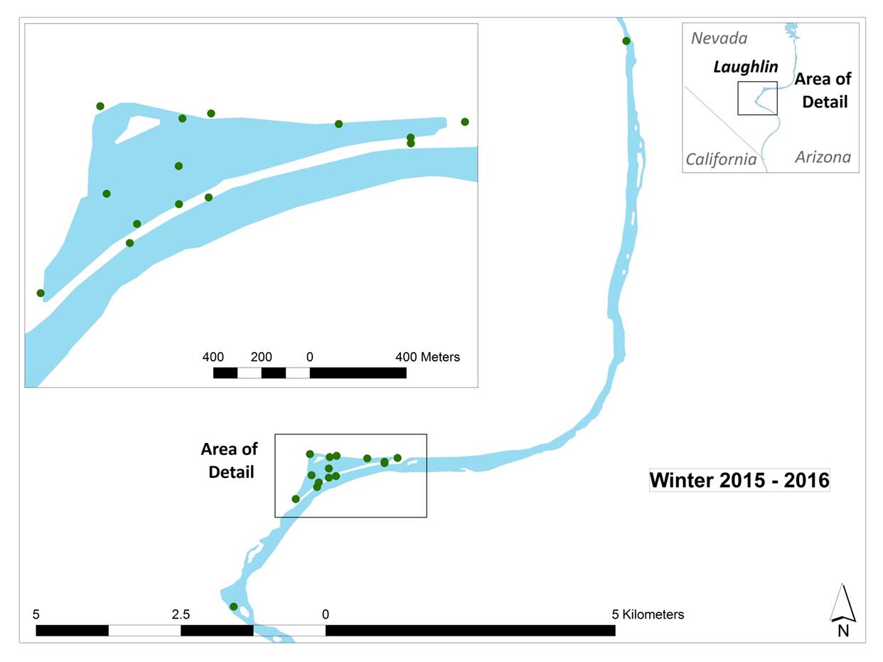

watertight PVC and acrylonitrile butadiene styrene (ABS) piping. Submersible units scanned continuously for up to 120 hours. Each unit was completely submerged and tied to a secure object to prevent movement while in use. Recorded data were downloaded, saved to a text file, and imported into the M&A online remote sensing database (http://www.nativefishlab.net/?page_id=479) at the conclusion of the trip.

Blankenship Bend
Following the release of 509 PIT-tagged bonytail in January 2014, submersible and shore-based PIT scanning units were deployed throughout Blankenship Bend to track post-stocking dispersal and survival. Deployments targeted shallow areas within backwaters, eddies within the main channel, and areas with extensive cover. Scanners were re-deployed at different sites if contacts were not recorded after daily inspection. Additionally, four remote PIT scanners were placed in pairs with different orientations at selected locations on five occasions throughout Blankenship Bend during the autumn 2013 telemetry study to compare effectiveness in contacting PIT-tagged bonytail.

Bill Williams River
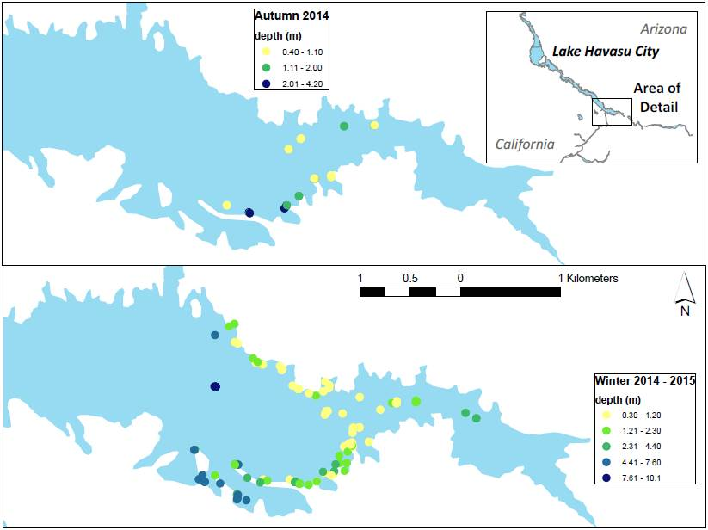
Supplemental PIT scanning occurred simultaneous to the autumn 2014 telemetry study following bonytail stocking. Remote PIT scanners were deployed throughout various habitat types within the Bill Williams River area from September 30 to November 19, 2014 (figure 10). Units were deployed at 10 stationary sites, generally near shore in water less than about 5 m deep.

Figure 10.—Locations of remote PIT scanning antennas deployed from September – November 2014 (above) and December 2014 – January 2015 (below), Bill Williams River, Arizona.
PIT scanners deployed at greater depths are represented by darker colors.

PIT-tagged bonytail (N = 4,019) produced at the SNARRC and reared and harvested at Achii Hanyo were released into the Bill Williams River NWR on December 10 – 11, 2014. From December 9, 2014, to January 15, 2015, submersible PIT scanners were tethered to the shoreline and deployed in the Bill Williams River. Units were deployed at up to 70 different sites (see figure 10). The mean depth among sites was 2.4 m and ranged from 0.3–10.1 m. Adjusting for the expected early decline of bonytail contacts (Humphrey et al. 2014), the initial two scanning events were conducted consecutively beginning the week of stocking, while the final two scanning events occurred biweekly. PIT scanner data were downloaded routinely, and deployment locations were adjusted to

target areas of relatively high contact rates, contributing in part to more location sites compared to September – November scanning. Unique contacts per maximum day of contact were plotted to better represent potential survival over time.

Due to high mortality, acoustic telemetry provided little guidance in PIT scanning deployments during all iterations of scanning at the Bill Williams River, and site selection was therefore informed by prior PIT scanning success of contacts. Because the area is a popular recreation site, deployments were limited to locations where PIT scanners were inconspicuous and water depths were adequate to avoid collisions with boats. Habitat data, including substrate type (categorized as silt or gravel rock), vegetation (presence of cattails or overhanging terrestrial vegetation), and slope (categorized as none, low, medium, or steep), were recorded for each unique deployment location during both iterations of PIT scanning at the Bill Williams River.

Regional Park Moabi
Supplemental PIT scanning was also conducted concurrently to the spring 2015 telemetry study following bonytail stocking. Ten remote PIT scanners were deployed throughout Regional Park Moabi from April 13 to June 11, 2015, generally near shore in water less than about 2 m deep (figure 11). Eight PIT scanners were stationed with the intention of monitoring egress of bonytail out of Regional Park Moabi. Three scanners were deployed within approximately ½ km of the release site (sites 1, 2, and 3 – release), three were downstream from the release site at the exit point of a narrow bulrush-lined channel (sites 6, 7, and 8 – middle), and two were deployed where the Regional Park Moabi backwater enters the main channel (sites 9 and 10 – exit; see figure 11 and figure 4). The mean number of unique bonytail PIT tag contacts within each defined area (release, middle, and exit) was calculated for each day (24-hour period) after release. Daily values were plotted, and least squares tread lines were added to visually assess if egression was evident (i.e., if there was a shift in unique bonytail contacts from release to exit over time). Additionally, two baited PIT scanners were deployed to investigate if baited scanners have an effect on bonytail contacts by attracting fish, as was observed with baited hoop nets and humpback chubs in the Little Colorado River, Arizona (Stone 2005). Bait containers were constructed of either fabric bags or sealed PVC with drilled holes and baited with dog food. Baited scanners were paired with unbaited scanners deployed several meters apart, minimizing the potential for repeated contacts due to proximal scanner deployment. The sum of unique contacts per baited and unbaited deployment were compared for bonytail and razorback suckers. Unique contacts per maximum day of contact were plotted to better represent potential survival over time.

Figure 11.—Locations of remote PIT scanning antennas deployed with bait (yellow) on occasion and without (blue) from April – July 2015, Regional Park Moabi, California.
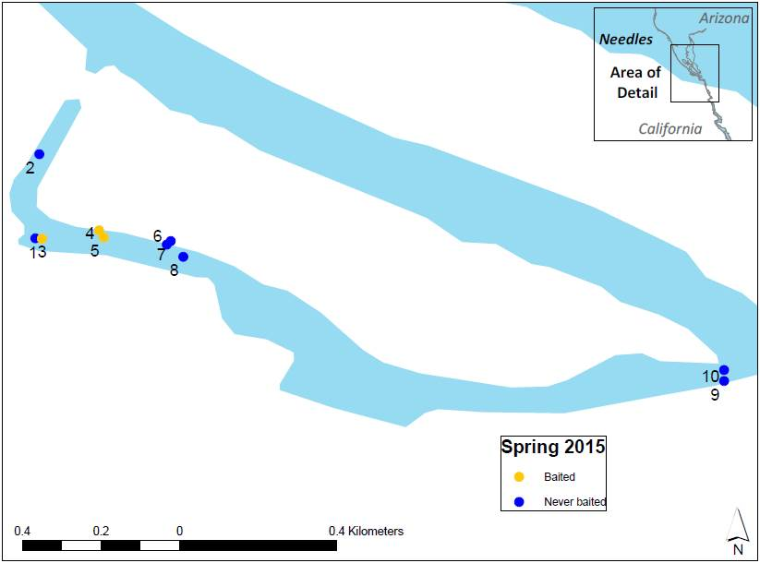

Laughlin Lagoon

During the winter 2015–16 telemetry study, supplemental PIT scanning was concurrently conducted at Laughlin Lagoon. Nine to 12 PIT scanners were deployed throughout Laughlin Lagoon from December 9, 2015 to January 8, 2016, generally near areas of shallow bulrush or gravel areas near shore less than approximately 2 m deep (figure 12). After January 8, 2016, two scanners were deployed, targeting locations of high contact rates. Unique contacts per maximum day of contact were plotted to better represent potential survival over time.

PIT scanners were deployed to monitor bonytail movement indicating egress out of Laughlin Lagoon. Two culverts exist at Laughlin Lagoon and connect to the main stem river, serving as exit points from the lagoon in addition to the main passageway. Two PIT scanners were deployed within approximately ½ km of the release site (sites 1 and 2 – release), four were greater than ½ km downstream from the release (sites 3, 4, 6, and 8 – middle), and three were deployed where Laughlin Lagoon enters the main channel (sites 5, 7, and 9 – exit; see figure 12 and figure 5). The mean number of unique bonytail contacts per scanner within
Figure 12.—Locations of remote PIT scanning antennas deployed permanently throughout intensive tracking (green) and temporarily to supplement efforts (red) from December 2015 – January 2016, Laughlin Lagoon, Nevada.

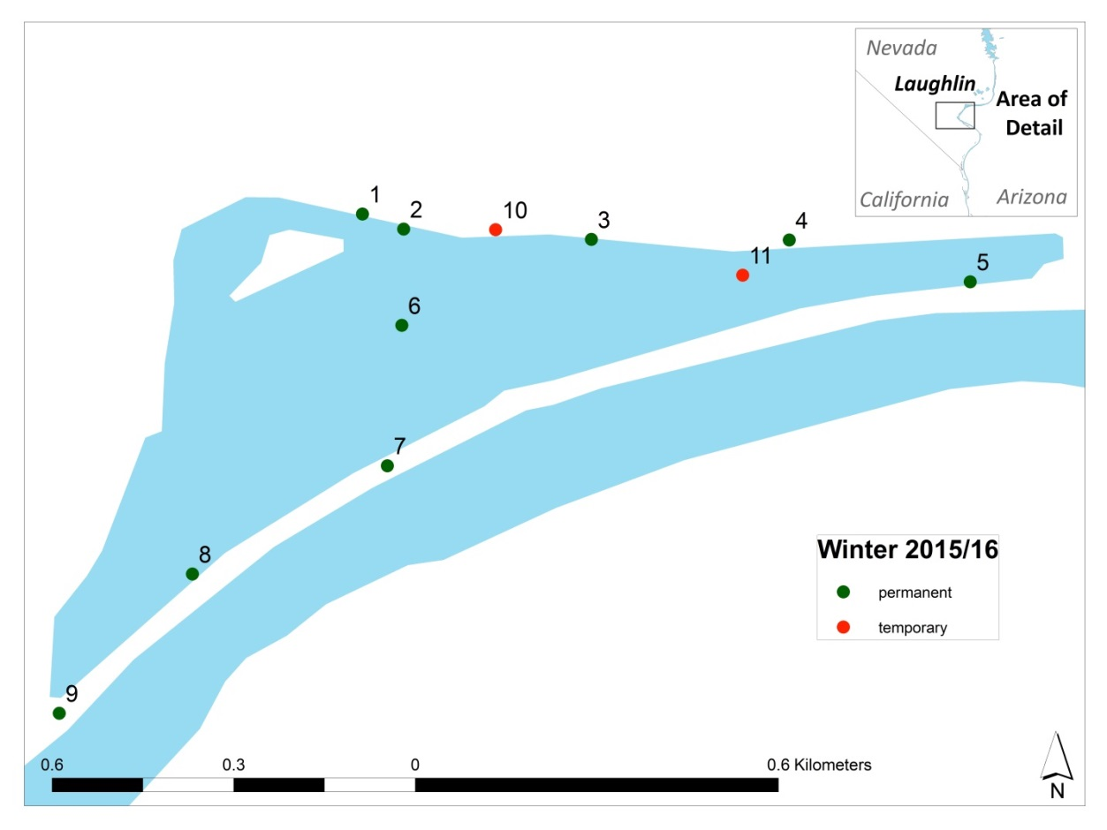
each defined area (release, middle, and exit) was plotted versus the number of days after release. Least squares tread lines were used to visually assess evidence of egression (i.e., a shift in unique bonytail contacts from release to exit).

Lake Havasu Native Fish Routine Monitoring “Roundup”

From February 10–12, 2014, February 9–12, 2015, and February 8–11, 2016, M&A participated in the multi-agency Native Fish Routine Monitoring “Roundup” on Lake Havasu. Trammel nets (45.7 or 91.4 x 1.8 m, 2.5 or 3.8-cm stretch mesh, 30.5-cm bar outer wall) were deployed in overnight sets along the shore of Lake Havasu. Nets were set in the late afternoon, checked and retrieved the following morning, and then re-deployed in a new location later that afternoon for 3 consecutive nights. All fish were removed and processed daily; captured native fishes were enumerated, measured for TL (mm), weighed (g), sexed, scanned for a wire or 134-kHz PIT tag, and tagged if none was present. In 2014, trammel nets were deployed for 48 net-nights at 11 fixed reaches from Regional Park Moabi to Clear Bay. In 2015, nets were deployed for 47 net-nights at 14 fixed reaches, including Blankenship Bend backwaters on the Arizona and California border, Castle Rock, Clear Bay, Double Barrel, Mohave Rock, Regional Park Moabi, Picture Rock, Pulpit Rock, Rearing Cove, Sand Dune, Trampas Cove, and Two Lobe Cove. In 2016, trammel nets were deployed for 31 net-nights at 11 fixed reaches, including Blankenship Bend backwaters on the Arizona and California border, Mohave Rock, Regional Park Moabi, Picture Rock, Pulpit Rock, Sand Dune, Trampas Cove, and Two Lobe Cove (see figure 3).

Results

Blankenship Bend Telemetry
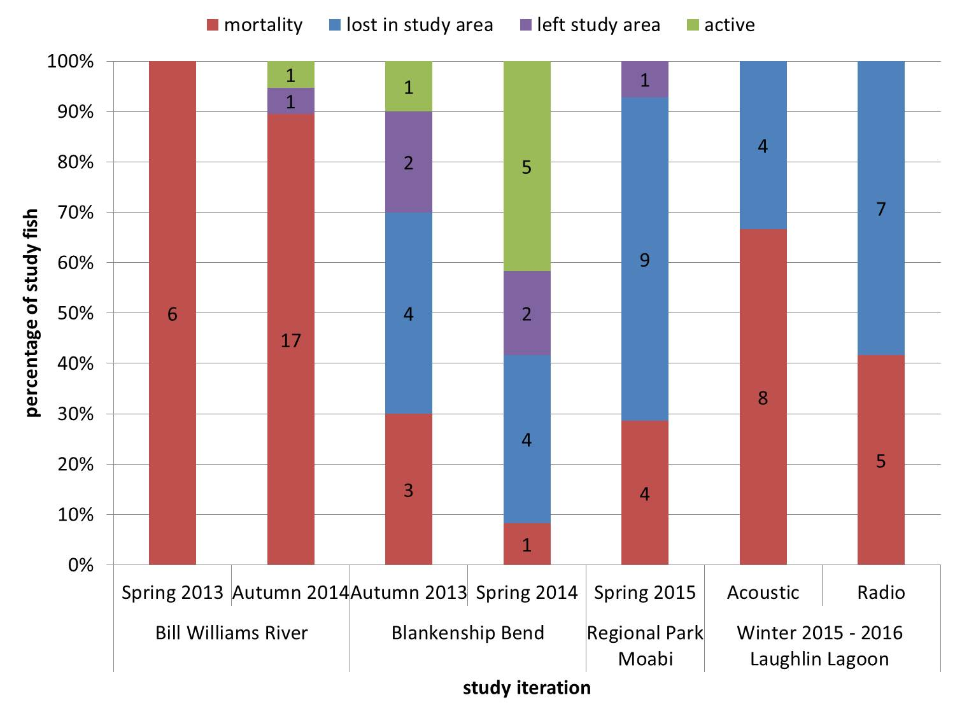
Out of a total of 22 telemetry-tagged bonytail released at Blankenship Bend, 12 were permanently lost to the study (never contacted again) within the first 5 weeks after release (figure 13). The majority of these fish, 67%, were last located within the study area and were not contacted by SURs specifically placed in locations to detect fish leaving the study area. Four of the 22 study fish were last contacted by these SURs at the study area’s termini, documenting emigrating fish (see C-39 2013 Post-Stocking Distribution and Survival of Bonytail in Reach 3, C-39 2014 Post-Stocking Distribution and Survival of Bonytail in Reach 3 ).
Figure 13.—Summary of study fish fate for all six telemetry study iterations, spring 2013 – winter 2016 at the Bill Williams River, Arizona and California; Blankenship Bend, Arizona and California; Regional Park Moabi, California; and Laughlin Lagoon, Nevada.

Autumn 2013
During the autumn telemetry study, three bonytail were determined dead within 13 weeks post-release, contact was lost with six study fish, and one tag was still active by the end of the study (N = 10). Study fish released into the main channel in autumn 2013 were the only fish to disperse out of Blankenship Bend, as fish released into the backwater remained in the vicinity of Blankenship Bend throughout the study. Autumn 2013 main channel released fish were contacted farther up- and downstream (difference in mean up- and downstream dispersal of 4.6 km from the release site) than backwater-released fish. Autumn 2013 passive contacts between sunset and sunrise comprised 57% of the total passive contacts.

Spring 2014
During the spring telemetry study, only one fish was determined dead, contact was lost with six study fish, and five fish were still active 6 weeks post-stocking (N = 12). Backwater-released fish from spring 2014 spent 64% of days tracked in Blankenship Bend compared to main channel released fish spending only 40% of days tracked in Blankenship Bend. The total number of days tracked was adjusted for the time of determined mortality. Spring 2014 main channel released fish were also contacted farther upstream (difference in mean upstream dispersal of 5.7 km from the release site) but less downstream (difference in mean downstream dispersal of 3.0 km) than backwater-released fish. During spring 2014 telemetry tracking, passive contacts between sunset and sunrise comprised 84% of the total passive contacts.

Bill Williams River Telemetry

Spring 2013
All six study fish released in April 2013 were confirmed mortalities recovered within 3,000 m of the release site less than 2 weeks after release (see figure 13). One tag was recovered at a known roosting site of double-crested cormorants where 11 PIT tags were also contacted (none from acoustic-tagged fish) after the area was scanned via snorkeling (C-39 2013 Post-Stocking Distribution and Survival of Bonytail in Reach 3).

Autumn 2014
Nineteen fish were released within Bill Williams NWR in autumn 2014, and over the course of the study, 79,867 contacts were recorded by active and passive tracking. Of those contacts, 175 (0.2%) were recorded by active tracking, and 79,692 (99.8%) were recorded by passive tracking (figure 14). Passive contacts between sunset and sunrise comprised 61% of the total passive contacts (figure 15).

Figure 14.—Active (red) and passive (green) telemetry contacts and bonytail release site (blue x) during the September – November 2014 telemetry study, Bill Williams River, Arizona and California.
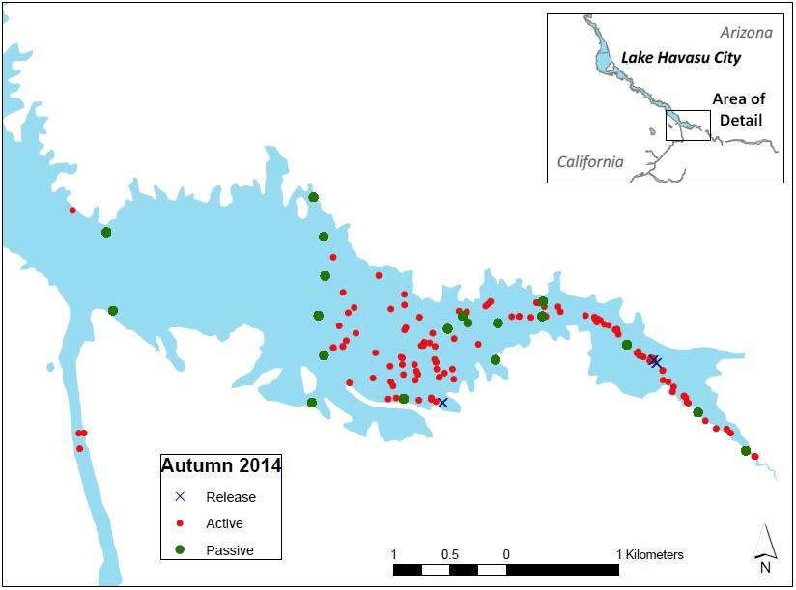

Contacts per week declined following the first week (figure 16). Study fish were tracked for a mean of 16.4 days (range = 7–42 days; table 2). The mean number of contacts per tag was 8.6 (range = 2–19; median = 7) active contacts and 4,546 (range = 13–21,590; median = 4,003) passive contacts.

Post-Stocking Mortality and Transmitter Recovery
Seventeen of 19 (89%) study fish were determined mortalities within the study period (figure 17). Eight of 17 (47%) mortalities occurred within the first 2 weeks post-release, and 13 (76%) mortalities occurred within the first month post-release. Twelve tags were successfully recovered by scuba divers. Based on the location of determined mortalities, at least four study fish were likely prey of avian predators. Three of these mortalities were discovered downstream from Parker Dam, two of which were triangulated directly under power lines known to act as double-crested cormorant roosting sites (figure 18), and an additional tag was recovered by scuba divers directly under power lines that may act as double-crested cormorant roosting sites upstream of Parker Dam. The mean number of days post-release that active fish were last contacted was 16 days, but the mean days post-release fish were alive may be less if active fish contacts were recorded

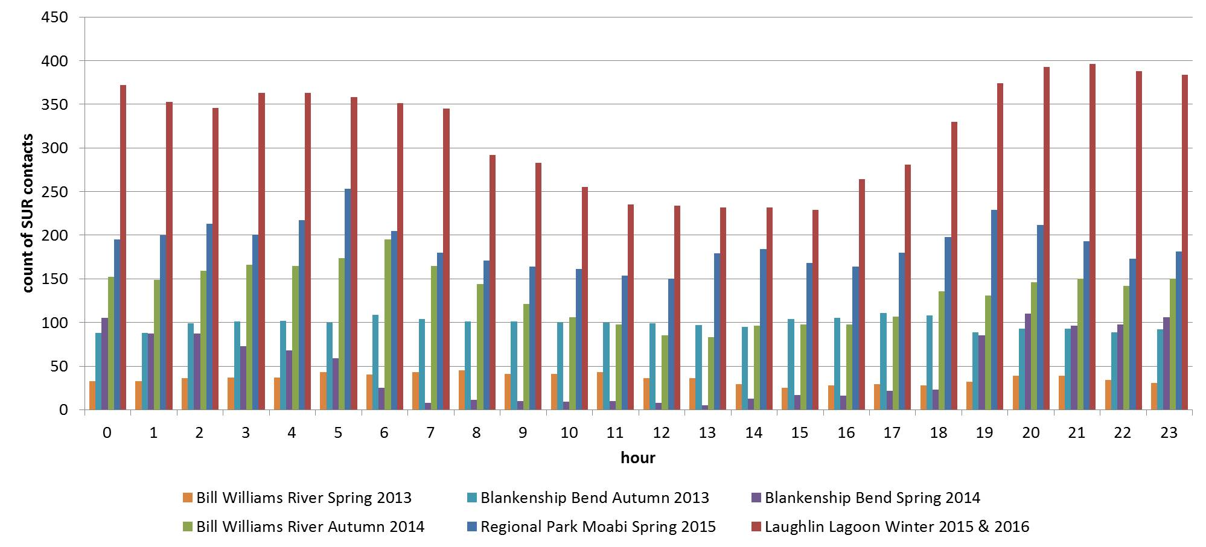
Figure 15.—SUR contacts by hour of study fish for all six telemetry study iterations during spring 2013 – winter 2016 at the Bill Williams River, Arizona and California; Blankenship Bend, Arizona and California; Regional Park Moabi, California; and Laughlin Lagoon, Nevada.

Figure 16.—Total number of 19 acoustic-tagged bonytail potentially available for contact (light gray box) and those actually contacted (dark gray box) each week during the September – November 2014 telemetry study, Bill Williams River, Arizona.
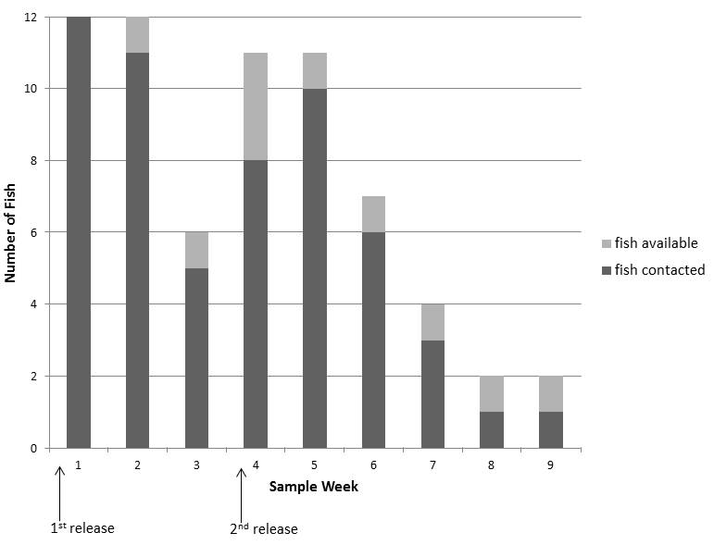

after the fish was consumed. Six tags of the 17 determined mortalities were recovered under cover consisting of cattails, overhanging canopies, or woody debris, all within the Bill Williams River inlet. Only one fish (fish 141-2) released into the Bill Williams River inlet was lost to the study (never contacted again). This fish was last contacted at the SUR deployed across from Takeoff Point, at the study area’s terminus, indicating that the fish may have traveled out of the study detection reach. The majority of actively tracked bonytail within the study area were contacted on a weekly basis (figure 19). Two fish (fish 34-1 and fish 177-1) had a 1-week gap between contacts, and only one fish (fish 4-1) had more than a 1-week gap between contacts.

Movement Patterns and Inhabitance
Five of 6 (83%) study fish released into the Bill Williams River arm remained in the arm, while 1 (17%) moved from the arm to the Bill Williams River inlet. Five of 13 (38%) study fish released into the Bill Williams River inlet remained in the inlet, while 8 (62%) moved out of the inlet into the Bill Williams River arm. The

Table 2.—Dispersal and displacement data collected for acoustic-tagged bonytail in September – November 2014, Bill Williams River, Arizona
(Values of dispersal and displacement for fish that were contacted at a SUR deployed at the study area’s termini or by active efforts outside of the study area’s termini are notated by ≥.)
Tag | Release site | Sinuous dispersal (km) | Straight line displacement (km) | Days at large | Displacement per day (kilometers per day)
2-1 | Bill Williams River NWR arm boat launch | 2.15 | 237.00 | 9.00 | 26.33
2-2 | Bill Williams River NWR inlet | ≥ 1.12 | ≥ 4.00 | 7.00 | ≥0.57
4-1 | Bill Williams River NWR arm boat launch | ≥ 3.07 | ≥ 492.00 | 42.00 | ≥11.71
32-1 | Bill Williams River NWR inlet | ≥ 1.15 | ≥ 4.00 | 9.00 | ≥0.44
32-2 | Bill Williams River NWR inlet | ≥ 1.12 | ≥ 17.00 | 14.00 | ≥1.21
34-1 | Bill Williams River NWR inlet | 3.38 | 19.00 | 35.00 | 0.54
36-1 | Bill Williams River NWR inlet | 3.66 | 40.00 | 30.00 | 1.33
38-1 | Bill Williams River NWR inlet | 1.83 | 17.00 | 7.00 | 2.43
40-1 | Bill Williams River NWR inlet | 0.27 | 3.00 | 7.00 | 0.43
40-2 | Bill Williams River NWR inlet | ≥ 5.16 | ≥ 957.00 | 31.00 | ≥30.87
68-1 | Bill Williams River NWR arm boat launch | 2.15 | 304.00 | 7.00 | 43.43
68-2 | Bill Williams River NWR inlet | ≥ 5.54 | ≥ 684.00 | 22.00 | ≥31.09
70-1 | Bill Williams River NWR arm boat launch | 1.34 | 4.00 | 10.00 | 0.40
70-2 | Bill Williams River NWR inlet | 3.38 | 245.00 | 14.00 | 17.50
72-1 | Bill Williams River NWR arm boat launch | 2.25 | 16.00 | 7.00 | 2.29
72-2 | Bill Williams River NWR inlet | 2.29 | 6.00 | 9.00 | 0.67
141-1 | Bill Williams River NWR arm boat launch | 2.15 | 243.00 | 13.00 | 18.69
141-2 | Bill Williams River NWR inlet | ≥ 5.16 | ≥ 112.00 | 8.00 | ≥14.00
177-1 | Bill Williams River NWR inlet | 3.38 | 16.00 | 30.00 | 0.53
Mean and standard deviation all fish |  | 2.66 ± 1.49 | 180 ± 268.07 | 16.37 ± 11.44 | 10.76 ± 13.55
Mean and standard deviation by release site
Bill Williams River NWR inlet |  | 2.88 ± 1.54 | 163.38 ± 312.52 | 17.15 ± 12.78 | 7.82 ± 14.97
Bill Williams River NWR arm boat launch |  | 2.19 ± 1.49 | 216 ± 115.93 | 14.67 ± 2.14 | 17.14 ± 11.04

mean percentage of days tagged fish were tracked in only the Bill Williams River arm was 25.9%. Broken down by release mesohabitat the percentages were 14.4% (range = 0–62.5%) and 50.7% (range = 23.8–100%) for inlet- and arm-released fish, respectively (figure 20). The mean percentage of days tagged fish were tracked in only the Bill Williams River inlet was 33.9%. Broken down by release mesohabitat the percentages were 44.8% (range = 2.86– 100%) and 10.3% (range = 0–57.4%) for inlet- and arm-released fish, respectively. While eight study fish were contacted by SUR at one of the study area’s termini, only one tag

Figure 17.—Locations of recovered telemetry tags indicating mortalities of acoustic-tagged bonytail during the September – November 2014 telemetry study, Bill Williams River, Arizona.
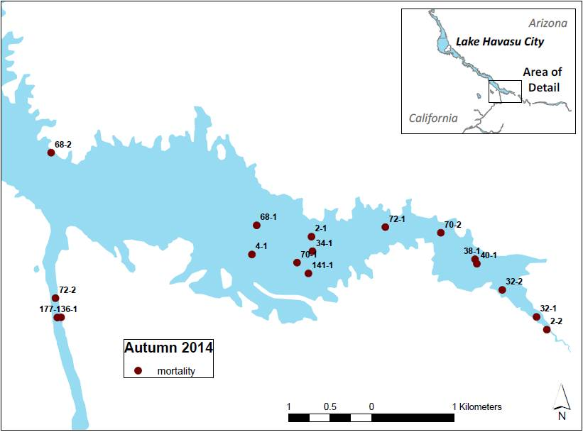

was actively tracked and recovered outside of the study area. One fish was lost after passive contact at the downstream terminus.

The mean dispersal from release sites along the channel thalweg (i.e., accounting for river sinuosity), was 2.7 km (range = 0.3–5.5 km; 2.9 and 2.2 km for inlet- and arm-released fish, respectively; see table 2). Three inlet released fish dispersed farther upstream in the Bill Williams River inlet, while all other fish dispersed farther downstream or across the Bill Williams River arm. The mean total minimum (straight line) displacement was 180 km (range = 3–957 km; 163 and 216 km for inlet- and arm-released fish, respectively), with a mean displacement of 10.8 km/day (range = 0.4–43 km/day); 7.8 and 17.1 km/day for inlet- and
arm-released fish, respectively).

Habitat Assessment
The mean surface water temperature was 20.89 °C (range = 12.70–28.00 °C), the depth was 3.62 m (range = 1.20–23.00 m), the turbidity was 2.08 NTU (range =
-0.00–5.28 NTU), and the distance to shore was 102.23 m (range = 0.00–430.00 m)
Figure 18.—Documented double-crested cormorant roost sites where telemetry and PIT tags were triangulated or contacted.
Two tags were located under power lines directly downstream from Davis Dam during the December 2015 – March 2016 telemetry study, Laughlin Lagoon, Nevada (left); two tags were located under power lines directly downstream from Parker Dam during September – November 2014 telemetry study, Bill Williams River, Arizona (middle); and 1telemetry tag and 14 PIT tags were located under woody debris during the April – May 2013 telemetry study, Bill Williams River, Arizona (right).
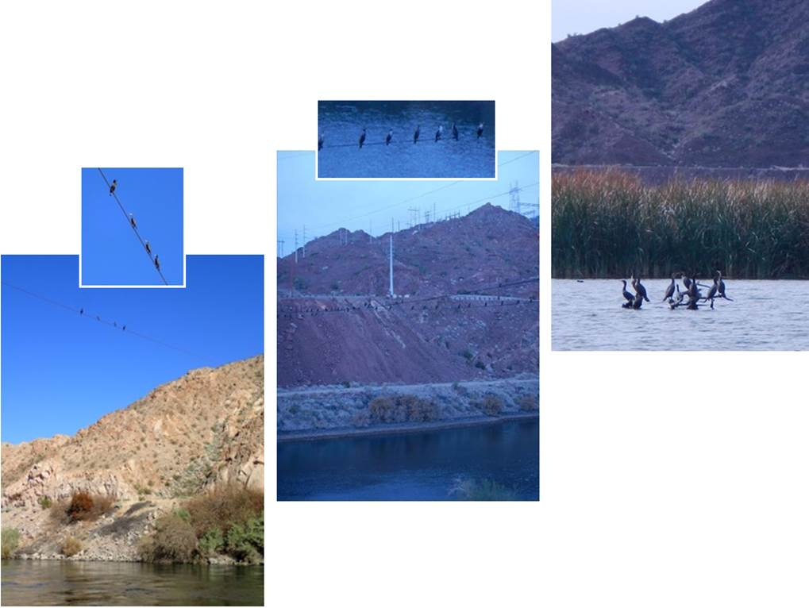

across all points of active triangulation (table 3). The mean distance to shore was 9.00 m among active contact sites solely in riverine mesohabitats and 225 m among lacustrine sites. The active tracking contacts occurring in riverine mesohabitats accounted for 48.5%, contacts in lacustrine mesohabitats accounted for 45.6%, contacts located in the peripheral channels accounted for 4.9%, and contacts in a cove accounted for 1% of active contacts.

Dummy Tags
One control fish was determined a mortality shortly after arrival at the Lake Mead Fish hatchery. All five dummy-tagged and 14 out of 15 control fish perished with other hatchery fish likely due to cleaning and power outages at the hatchery; therefore, it is not possible to attribute mortality of the dummy-tagged fish to surgical procedure. The incision sites of dummy-tagged fish healed normally and

Fish ID | 2-1 | X | X*
Fish ID | 2-2 |  |  |  | X | X*
Fish ID | 4-1 | X |  | X |  |  | X | X*
Fish ID | 32-1 | X | X*
Fish ID | 32-2 |  |  |  | X | X | X*
Fish ID | 34-1 | X | X | X | X |  | X*
Fish ID | 36-1 | X | X | X | X | X*
Fish ID | 38-1 | X | X*
Fish ID | 40-1 | X | X*
Fish ID | 40-2 |  |  |  | X | X | X | X | X | X
Fish ID | 68-1 | X | X*
Fish ID | 68-2 |  |  |  | X | X | X | X*
Fish ID | 70-1 | X | X | X*
Fish ID | 70-2 |  |  |  | X | X | X*
Fish ID | 72-1 | X | X*
Fish ID | 72-2 |  |  |  | X | X*
Fish ID | 141-1 | X | X | X*
Fish ID | 141-2 |  |  |  | X | X
Fish ID | 177-1 | X | X | X |  | X*
1 release |  | 1 | 2 | 3 | 4 | 5 | 6 | 7 | 8 | 9
2 release |  |  |  |  | 1 | 2 | 3 | 4 | 5 | 6
 |  | sample week
Figure 19.—Weekly contacts (X) and non-contacts (gray boxes) for all 19 acoustic-tagged bonytail during the September – November 2014 telemetry study, Bill Williams River, Arizona.
(Note: * denotes a mortality, and black boxes denote the time period prior to second release.)
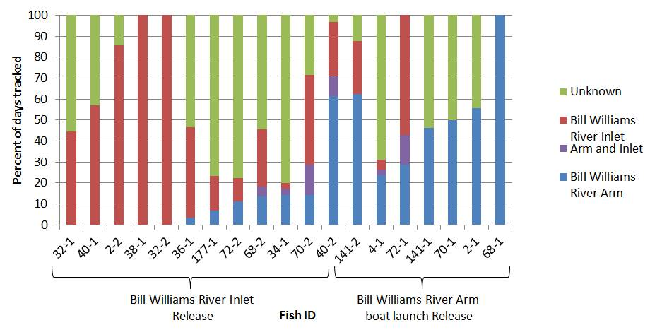
Figure 20.—Inhabitance represented by percent of days tracked by active and passive data of acoustic-tagged bonytail during the September – November 2014 telemetry study, Bill Williams River, Arizona.
Table 3.—Summary of habitat data (mean, standard error, and range) during active acoustic tracking during all six telemetry study iterations, spring 2013 – winter 2016 at the Bill Williams River, Arizona and California; Blankenship Bend, Arizona and California; Regional Park Moabi, California; and Laughlin Lagoon, Nevada
Study site | Study iteration | N = | Mean surface water temperature  (°C) | Mean depth  (m) | Mean turbidity  (NTU) | Mean distance  to shore  (m)
Bill Williams River | Spring 2013 | 6 | 17.30 ± 0.17 (14.50–20.00) | 19.00 ± 2.09 (1.00–62.80) | N/A | N/A
Blankenship Bend | Autumn 2013 | 10 | 16.07 ± 0.21 (9.00–19.00) | 7.60 ± 0.51 (1.00–17.60) | N/A | N/A
Blankenship Bend | Spring 2014 | 12 | 17.30 ± 0.29 (12.00–22.80) | 10.40 ± 0.79 (1.70–34.80) | 1.59 ± 0.07 (0.53–3.67) | N/A
Bill Williams River | Autumn 2014 | 19 | 20.89 ± 0.42 (12.70–28.00) | 3.62 ± 0.33 (1.20–23.00) | 2.08 ± 0.13 (0.00–5.28) | 102.23 ± 15.90 (0.00–430.00)
Regional Park Moabi | Spring 2015 | 14 | 19.90 ± 0.19 (15.30–23.80) | 2.63 ± 0.08 (0.80–4.20) | 2.78 ± 0.10 (0.16–5.81) | 16.18 ± 1.51 (1.00–60.00)
Laughlin Lagoon | Winter 2015 | 24 | 12.60 ± 0.52 (5.00–29.00) | 1.57 ± 0.07 (0.07–3.00) | 1.84 ± 0.12 (0.00–4.64) | 9.88 ± 0.91 (0.00–20.00)
Habitat parameters reported do not include data from dates after which a study fish was determined a mortality. This may not coincide with results from previous reports (C-39 2013 Post-Stocking Distribution and Survival of Bonytail in Reach 3, C-39 2014 Post-Stocking Distribution and Survival of Bonytail in Reach 3).

displayed no indication of infection. Dummy-tagged fish survived longer (November 13, 2014) than the last determined mortality among the study fish (November 12, 2014).

Regional Park Moabi Telemetry

Spring 2015
Fourteen fish were released into Regional Park Moabi in spring 2015, and over the course of the study, 81,377 contacts were recorded by active and passive tracking. Of those contacts, 200 (.003%) were recorded by active tracking, and 81,177 (99.7%) were recorded by passive tracking (figure 21). Passive contacts between sunset and sunrise comprised 49% of the total passive contacts (see figure 15). Contacts per week declined following the first week (figure 22). Study fish were tracked for a mean of 19 days (range = 3–45 days; table 4). The mean number of contacts per tag was 14 (range = 2–39; median = 12) active contacts and 5,798 (range = 879–18,136; median = 4,574) passive contacts.

Figure 21.—Active (red) and passive (green) telemetry contacts, the bonytail release site (blue x), and mortalities (maroon) during the April – July 2015 telemetry study, Regional Park Moabi, California.
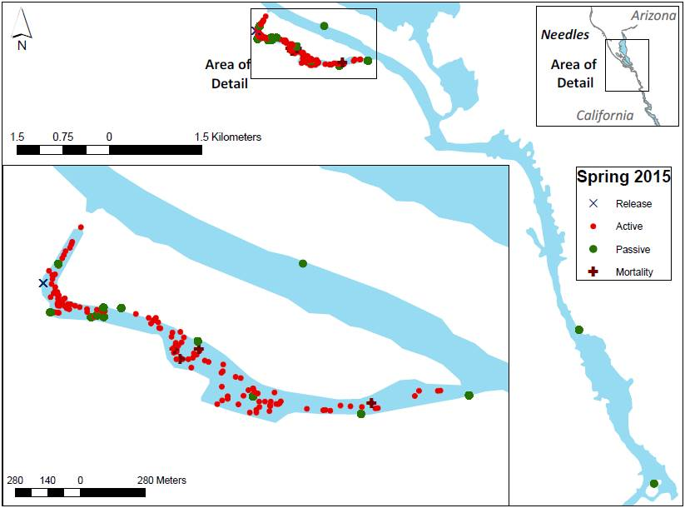

Figure 22.—Total number of 14 acoustic-tagged bonytail potentially available for contact (light gray box) and those actually contacted (dark gray box) each week during the April – July 2015 telemetry study, Regional Park Moabi, California.

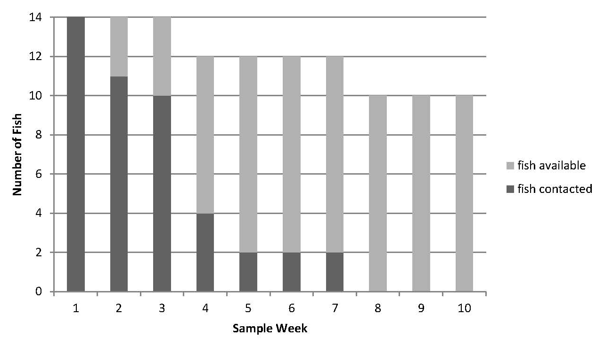
Table 4.—Dispersal and displacement data collected for acoustic-tagged bonytail during the April – July 2015 telemetry study, Regional Park Moabi, California
(Values of dispersal and displacement for fish that were contacted at a SUR deployed at the study area’s termini are notated by ≥.)
Tag | Release site | Sinuous dispersal (km) | Straight line displacement (km) | Days at large | Displacement per day (km/day)
152 | Regional Park Moabi | 0.37 | 31.00 | 3 | 10.33
153 | Regional Park Moabi | ≥ 11.20 | ≥ 85.00 | 45 | ≥ 1.89
154 | Regional Park Moabi | 1.98 | 225.00 | 17 | 13.24
155 | Regional Park Moabi | 1.53 | 59.00 | 19 | 3.11
156 | Regional Park Moabi | 1.98 | 52.00 | 3 | 17.33
157 | Regional Park Moabi | 1.53 | 342.00 | 24 | 14.25
158 | Regional Park Moabi | 1.53 | 97.00 | 14 | 6.93
159 | Regional Park Moabi | 1.98 | 645.00 | 23 | 28.04
160 | Regional Park Moabi | ≥ 11.20 | ≥ 33.00 | 10 | ≥ 3.30
161 | Regional Park Moabi | 1.53 | 82.00 | 15 | 5.47
162 | Regional Park Moabi | 1.98 | 80.00 | 16 | 5.00
163 | Regional Park Moabi | 1.98 | 170.00 | 44 | 3.86
164 | Regional Park Moabi | 1.98 | 115.00 | 16 | 7.19
165 | Regional Park Moabi | 0.94 | 261.00 | 16 | 16.31
Mean and standard deviation all fish |  | 2.98 ± 3.51 | 162.64 ± 166.76 | 18.93 ± 12.42 | 9.73 ± 7.37

Post-Stocking Mortality and Transmitter Recovery
Four of 14 (29%) study fish were determined mortalities within the study period (see figure 13). Two of four mortalities occurred within the first 3 weeks post-release, and the other two mortalities occurred prior to the study’s end. All four tags were successfully recovered by scuba divers within Regional Park Moabi, and no tag was recovered under heavy cover. Ten of 14 (71%) bonytail were lost to the study (never contacted again). One lost study fish (fish 160) was last contacted in the second week of the study at Pulpit Rock, the study area’s terminus, indicating that the fish may have traveled out of the study detection reach. Two bonytail (fish 156 and fish 159) were last contacted at the entrance to Regional Park Moabi by SUR in the first and fourth week of the study. All other fish were last contacted within Regional Park Moabi: three (fish 157 and fish 165) in the bulrush channel (one [fish 162] of which was in the bulrush), two (fish 158 and fish 161) in Plane Cove, one (fish 152) in the upper inlet, and one (fish 154) in the water taxi channel. The majority of actively tracked bonytail within the study area were contacted on a weekly basis before contact was lost (figure 23). Only one fish (fish 154) had a 1-week gap between contacts, and no fish had more than a 1-week gap between contacts.

Movement Patterns and Inhabitance
The mean dispersal from release sites along the channel thalweg (i.e., accounting for river sinuosity), was 3.0 km (range = 0.4–11 km; see table 4). Only one fish moved a short distance upstream of Regional Park Moabi, and only two fish were contacted downstream from Regional Park Moabi, both of the latter at Pulpit Rock. The mean total minimum (straight line) displacement was 163 km (range = 31–645 km), with a mean displacement of 9.7 km/day (range = 1.9–28 km/day).

Nine of 14 (64%) study fish released into Regional Park Moabi remained within or near Regional Park Moabi. One study fish left the backwater but remained relatively close within the main channel, and an additional two study fish likely remained within or near Regional Park Moabi (last contacted at the entrance to the backwater and not detected by any SUR in the main channel). The final 2 of 14 (14%) study fish moved out of Regional Park Moabi (downstream to Pulpit Rock), after which one fish returned to Regional Park Moabi while contact was lost with the other. The mean percentage of days tagged fish were tracked in only Regional Park Moabi was 79% (range = 20–100%; figure 24). The mean percentage of days tagged fish were tracked in only the main channel was 1.8% (range = 0–16%). Study fish were at an unknown location for a mean of 18% (range = 0–60%) of the total tracked days.

Fish ID | 152 | X
Fish ID | 153 | X | X | X | X | X | X | X*
Fish ID | 154 | X |  | X
Fish ID | 155 | X | X | X*
Fish ID | 156 | X
Fish ID | 157 | X | X | X | X
Fish ID | 158 | X | X
Fish ID | 159 | X | X | X | X
Fish ID | 160 | X | X
Fish ID | 161 | X | X | X
Fish ID | 162 | X | X | X
Fish ID | 163 | X | X | X | X | X | X | X*
Fish ID | 164 | X | X | X*
Fish ID | 165 | X | X | X
 |  | 1 | 2 | 3 | 4 | 5 | 6 | 7 | 8 | 9 | 10 | 11 | 12 | 13
 |  | Sample week
Figure 23.—Weekly contacts (X) and non-contacts (gray boxes) for all 14 acoustic-tagged bonytail during the April – July 2015 telemetry study, Regional Park Moabi, California.
(Note: * denotes a mortality.)

Figure 24.—Inhabitance represented by percent of days tracked by active and passive data of acoustic-tagged bonytail during the April – July 2015 telemetry study, Regional Park Moabi, California.

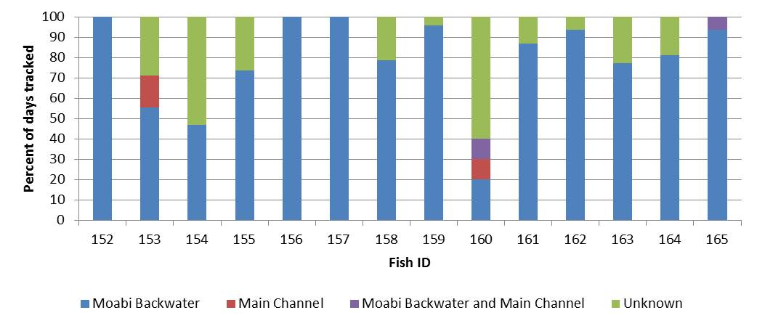

Habitat Assessment

The mean surface water temperature was 19.90 °C (range = 15.30–23.80 °C), the depth was 2.63 m (range = 0.80–4.20 m), the turbidity was 2.78 NTU (range = 0.16–5.81 NTU), and the distance to shore was 16.18 m (range = 1.00–60.00 m) across all points of active triangulation (see table 3). Active tracking contacts recorded in lower Regional Park Moabi, the upper inlet, and the bulrush channel accounted for 50, 40.6, and 9.4% of the total active contacts, respectively. Active contacts recorded in or near bulrush mesohabitats across all sites, including the upper and lower inlet, accounted for 22% of the total active contacts. Fish 163 was visually observed stationary in bulrush (figure 25).

A recovered acoustic tag, assumed to be representative of all tags of increased detection power surgically implanted during this study, was used to measure detection radii of telemetry equipment through bulrush. SUR and hydrophone signal detection was completely attenuated within 2 m of thick bulrush.

Laughlin Lagoon Telemetry

Winter 2015 and 2016
Twenty-four fish were released into Laughlin Lagoon winter 2015–16, and over the course of the study, 306,989 contacts were recorded by active and passive tracking. Of those contacts, 432 (.001%) were recorded by active tracking, and 306,557 (99.9%) were recorded by passive tracking (figure 26). Passive contacts between sunset and sunrise comprised 66% of the total passive contacts (see figure 15). Contacts per week declined following the first week (figure 27). Study fish were tracked for a mean of 58 days (range = 20–82 days; table 5). The mean number of active contacts per tag was 16 (range = 8–28; median = 17.5)
Figure 25.—Fish visually observed in bulrush (A–D) and the location of fish visually observed (E) during the December 2015 – March 2016 telemetry study, Laughlin Lagoon, Nevada, and the April – July 2015 telemetry study, Regional Park Moabi, California (F).

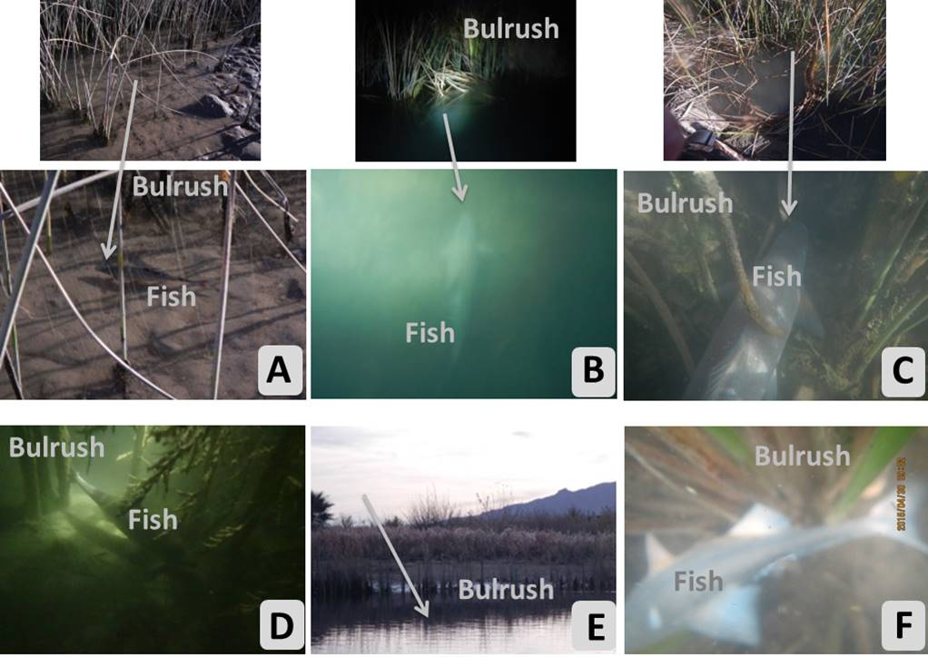
and 19.33 (range = 5–29; median = 21.5) for acoustic and radio tags, respectively. The mean number of passive contacts was 25,546 (range = 8,890–98,403;
median = 18,340) for acoustic tags.

Post-Stocking Mortality and Transmitter Recovery
Thirteen of 24 (54%) study fish were determined mortalities within the study period (see figure 13, figure 28). One mortality (radio fish 691) occurred within the first week post-release and was recovered along the shoreline of the little “t” (see figure 5). Two additional radio tags (radio fish 077 and radio fish 011) were recovered on land, representing mortalities occurring in the seventh week post-release. An additional two radio tags (radio fish 761 and radio fish 801) determined to be mortalities in the second and eleventh week post-stocking were located in the water, both investigated by scuba divers and one successfully recovered. Five acoustic tagged fish were determined mortalities and the tags were recovered by scuba divers within Laughlin Lagoon – one in the east channel (acoustic fish 107, week 3), one in bulrush above the substrate (acoustic fish 125; week 7), one over the mudflat (acoustic fish 126; week 7), one in the marina (acoustic fish 110; week 7), and one at the exit after an increase in behavior and movement outside of the lagoon and in the south channel (acoustic fish 124; week 10). An additional
Figure 26.—Active (red) and passive (green) telemetry contacts and bonytail release site (blue x) during the December 2015 – March 2016 telemetry study, Laughlin Lagoon, Nevada.
Points displayed in white space are due to discrepancy in the Laughlin Lagoon shapefile. Contacts occurred in water.

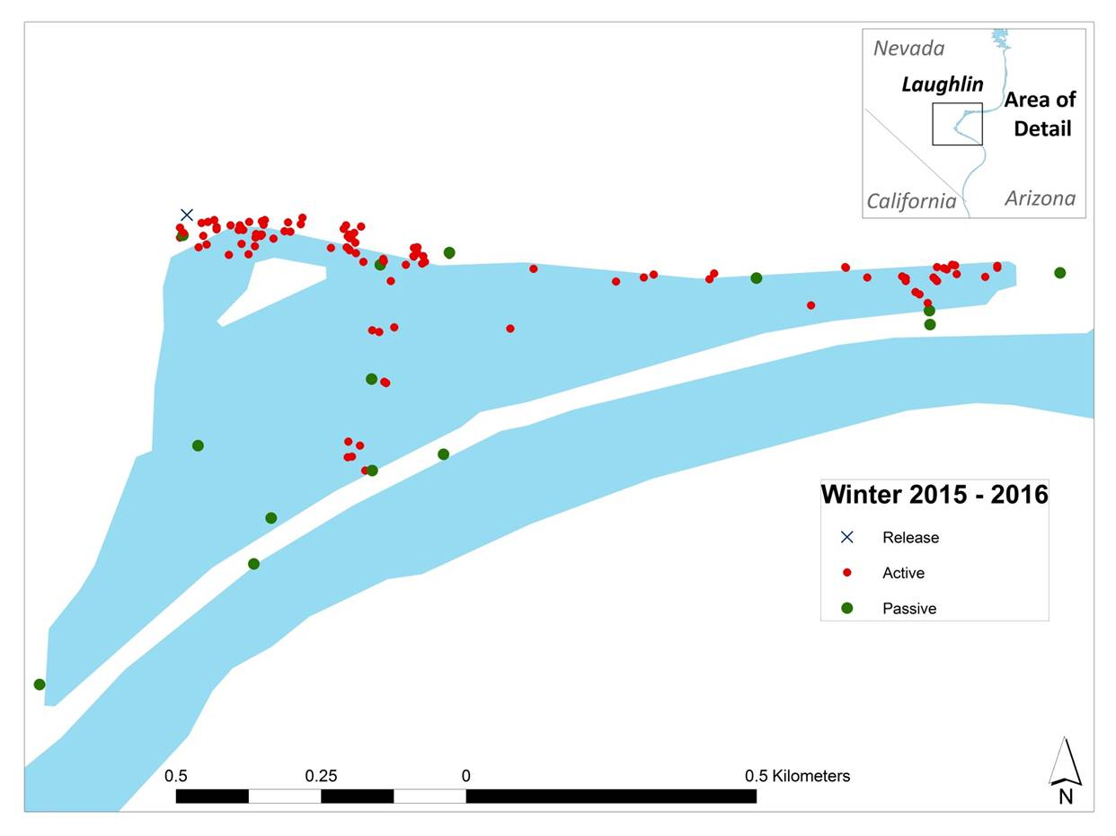
acoustic tag was recovered a meter from shore (acoustic fish 122; week 13). Two additional tags (acoustic fish 109 and acoustic fish 111; week 5) were triangulated under power lines documented to be double-crested cormorant roosting sites just downstream from Davis Dam. The remaining 46% of study fish were lost to the study (never contacted again). All study fish were last contacted within Laughlin Lagoon. The majority of actively tracked bonytail within the study area were contacted on a weekly basis before contact was lost (figure 29). Only two study fish (acoustic fish 124 and acoustic fish 108) had a 2-week gap between contacts, and one study fish (acoustic fish 123) had a 3-week gap.

Movement Patterns and Inhabitance
Due to lack of triangulation data for radio-tagged study fish, movement reporting was restricted to acoustic-tagged study fish only. The mean dispersal from release sites along the channel thalweg (i.e., accounting for river sinuosity) was 1.14 km (range = 0.30–1.50 km; table 5). The mean total minimum (straight line) displacement was 26.5 km (range = 2.00–71.4 km), with a mean displacement of 0.60 km/day (range = 0.00–3.10 km/day).
Figure 27.—Total number of 24 acoustic- and radio-tagged bonytail potentially available for contact (light gray box) and those actually contacted (dark gray box) each week during the December 2015 – March 2016 telemetry study, Laughlin Lagoon, Nevada.

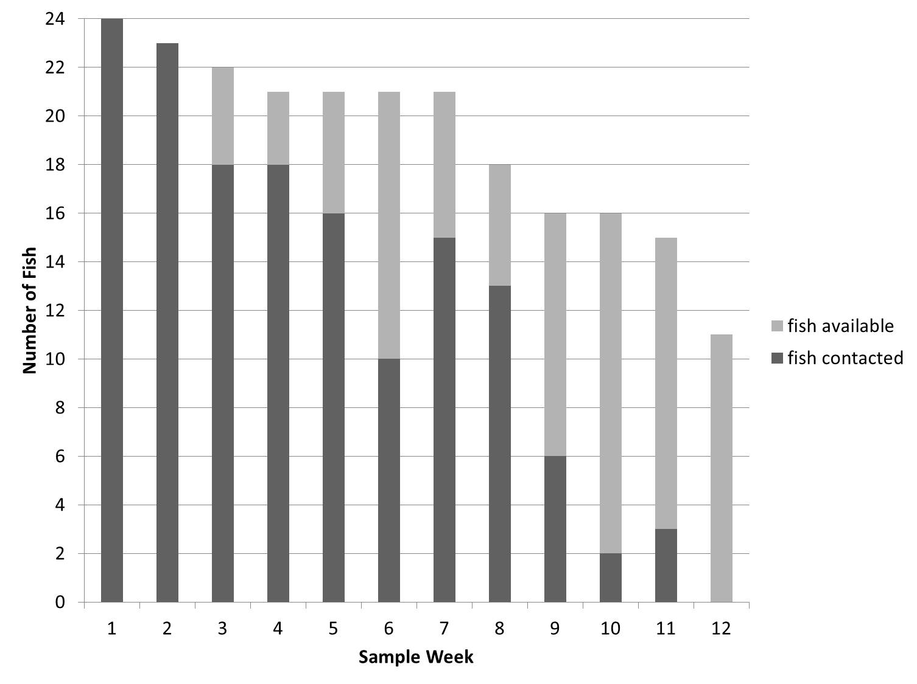
While five tags were contacted outside of Laughlin Lagoon at the culvert, only three tags were contacted in the main stem not associated with the culvert. Of these three tags, two were contacted for short time periods (less than 1 day) near the entrance to the lagoon. The third tag was suspected to be the result of a consumed bonytail based on changed behavior of the fish and subsequent tag recovery. Study fish were at an unknown location for a mean of 43% (range = 19–61%) of the total tracked days.

Habitat Assessment
The mean surface water temperature was 12.60 °C (range = 5.00–29.00 °C), the depth was 1.57 m (range = 0.07–3.00 m), the turbidity was 1.84 NTU (range = 0.00–4.64 NTU), and the distance to shore was 9.88 m (range = 0.00–20.00 m) across all points of active triangulation for acoustic telemetry fish only (see table 3). Active tracking contacts of acoustic telemetry fish occurring in the marina accounted for 67% of total active contacts, while contacts triangulated in the east channel accounted for 30% of all active contacts. Active contacts for both radio- and acoustic-tagged study fish triangulated in or near bulrush mesohabitats across all sites accounted for 15% of total active contacts.
Table 5.—Dispersal and displacement data collected for acoustic-tagged bonytail during the December 2015 – March 2016 telemetry study, Laughlin Lagoon, Nevada
Tag | Release site | Sinuous dispersal  (km) | Straight line displacement (km) | Days at large | Displacement per day (km/day)
107 | Laughlin Lagoon | 1.52 | 61.85 | 20 | 3.09
108 | Laughlin Lagoon | 0.34 | 1.96 | 71 | 0.03
109 | Laughlin Lagoon | 1.52 | 68.30 | 72 | 0.95
110 | Laughlin Lagoon | 0.34 | 2.93 | 47 | 0.06
111 | Laughlin Lagoon | 1.29 | 10.56 | 72 | 0.15
112 | Laughlin Lagoon | 0.99 | 13.57 | 37 | 0.37
122 | Laughlin Lagoon | 1.52 | 20.87 | 82 | 0.25
123 | Laughlin Lagoon | 0.99 | 10.30 | 71 | 0.15
124 | Laughlin Lagoon | 1.29 | 39.34 | 69 | 0.57
125 | Laughlin Lagoon | 1.32 | 9.97 | 48 | 0.21
126 | Laughlin Lagoon | 0.99 | 6.62 | 47 | 0.14
127 | Laughlin Lagoon | 1.52 | 71.41 | 62 | 1.15
Mean and standard deviation all fish |  | 1.14 ± 3.51 | 26.47 ± 166.76 | 58.17 ± 12.42 | 0.59 ± 7.37

Eight radio-tagged fish were triangulated in a patch of bulrush at least once. With the implementation of stronger acoustic tags, detection through bulrush of acoustic-tagged study fish appeared higher than during previous studies. One study fish (acoustic fish 110) was triangulated approximately 10 meters into bulrush after being detected with the omnidirectional towable hydrophone. One study fish (fish 111) was triangulated inside of a culvert at the marina, and three study fish (fish 109, fish 122, and fish 127) were actively tracked within 200 m of the culvert in the east channel for a minimum of 3 days (attachment 3). Habitat measurements collected during active tracking near the culvert in the east channel were 14.8 °C (range = 10.0–22.0 °C) mean surface water temperature, 1.30 m (range = 0.39–1.86 m) mean depth, 1.30 NTU (range = 0.50–2.20 NTU) mean turbidity, and 2.70 m (range = 0.00–8.00 m) mean distance to shore. In addition to cover provided by the culvert, these sites were also characterized by relatively higher flows corresponding with velocities of the main stem river.

In addition to active triangulation, seven bonytail were visually observed in or near bulrush (see figure 25). Two acoustic-tagged fish were stationary in or at the edge of bulrush between sunrise and sunset and were not disturbed upon approach. The third acoustic fish was more active, initially consuming drift material and disturbing the sediment before swimming into the mid-channel and later returning to the bulrush. Three non-telemetry-tagged fish were observed
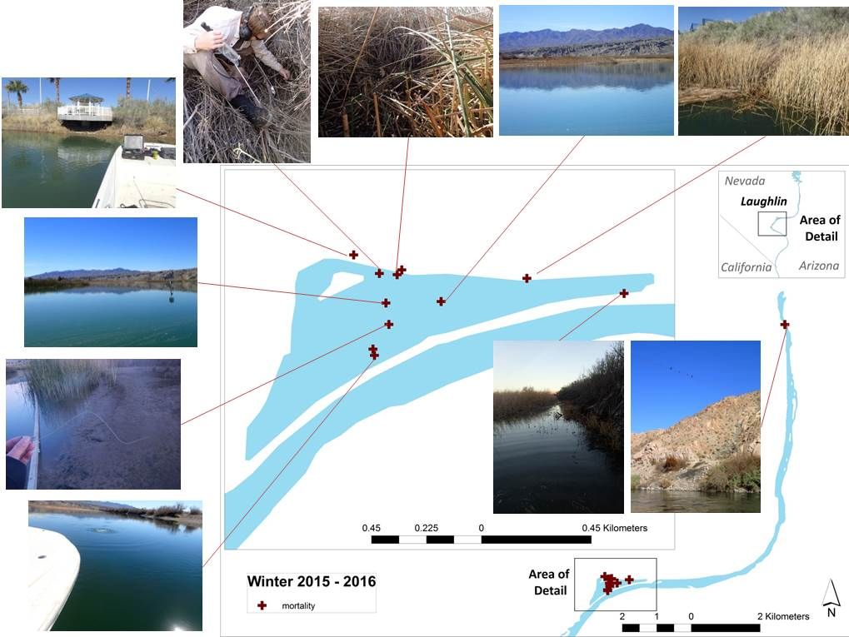
Figure 28.—Locations of recovered telemetry tags indicating mortalities of acoustic- and radio-tagged bonytail during the December 2015 – March 2016 telemetry study, Laughlin Lagoon, Nevada.
Fish ID | Acoustic | 107 | X | X | X*
Fish ID | Acoustic | 108 | X | X | X | X |  |  | X | X | X
Fish ID | Acoustic | 109 | X | X | X | X | X | X |  | X |  |  | X*
Fish ID | Acoustic | 110 | X | X | X | X | X | X | X*
Fish ID | Acoustic | 111 | X | X | X | X | X | X | X | X | X |  | X*
Fish ID | Acoustic | 112 | X | X | X | X | X | X
Fish ID | Acoustic | 122 | X | X | X | X | X | X | X | X | X | X |  | X*
Fish ID | Acoustic | 123 | X | X |  |  |  | X | X | X | X |  | X
Fish ID | Acoustic | 124 | X | X |  |  | X | X | X | X | X | X*
Fish ID | Acoustic | 125 | X | X | X | X | X | X | X*
Fish ID | Acoustic | 126 | X | X | X | X | X | X | X*
Fish ID | Acoustic | 127 | X | X | X | X | X | X | X | X | X
Fish ID | Radio | 011 | X | X | X | X | X | (no radio effort) | X | X* | (no radio effort) | (no radio effort)
Fish ID | Radio | 021 | X | X | X | X | X | (no radio effort) | X | X | (no radio effort) | (no radio effort)
Fish ID | Radio | 041 | X | X | X | X | X | (no radio effort) | X | X | (no radio effort) | (no radio effort)
Fish ID | Radio | 061 | X | X | X | X | X | (no radio effort) |  |  | (no radio effort) | (no radio effort)
Fish ID | Radio | 671 | X | X |  |  |  | (no radio effort) |  |  | (no radio effort) | (no radio effort)
Fish ID | Radio | 681 | X | X | X | X | X | (no radio effort) | X | X | (no radio effort) | (no radio effort)
Fish ID | Radio | 691 | X* |  |  |  |  | (no radio effort) |  |  | (no radio effort) | (no radio effort)
Fish ID | Radio | 761 | X | X* |  |  |  | (no radio effort) |  |  | (no radio effort) | (no radio effort)
Fish ID | Radio | 771 | X | X | X | X | X | (no radio effort) | X | X* | (no radio effort) | (no radio effort)
Fish ID | Radio | 781 | X | X |  | X |  | (no radio effort) |  |  | (no radio effort) | (no radio effort)
Fish ID | Radio | 792 | X | X | X | X | X | (no radio effort) | X | X | (no radio effort) | (no radio effort)
Fish ID | Radio | 801 | X | X | X | X |  | (no radio effort) |  | X | (no radio effort) | (no radio effort) | X*
 |  |  | 1 | 2 | 3 | 4 | 5 | 6 | 7 | 8 | 9 | 10 | 11 | 12
 |  |  | Sample week

Figure 29.—Weekly contacts (X) and non-contacts (gray boxes) for all 24 acoustic- and radio-tagged bonytail during the December 2014 – March 2016 telemetry study, Laughlin Lagoon, Nevada.
(Note: * denotes a mortality; no radio tracking occurred during weeks 6, 9, or 10.)

swimming together in water less than half a meter 12 days post-stocking, while an additional non-telemetry-tagged fish was observed stationary in water less than half a meter 6 days post-stocking, all near bulrush.

Remote PIT Scanning

Blankenship Bend
Over the course of PIT scanning at Blankenship Bend, including other LCR MSCP Reach 3 study efforts, antennas scanned collectively for a total of 9,045 hours, and 150 unique bonytail were contacted, 13 of which were released in October 2013. The remainder of contacts represents 27% of bonytail released from the corresponding stocking event in January 2014. Most contacts (96%, only including fish stocked in January 2014) occurred during the week of release, after which contacts steeply declined. Besides release location, seven PIT-tagged bonytail were contacted in Trampas Cove, and one was contacted in Clear Bay.

The low number of bonytail contacts prevented analysis of different scanner orientation effectiveness. During the October 2013 study, remote PIT scanners that were deployed horizontally with all sides contacting the substrate resulted in four unique bonytail contacts, more than those oriented vertically with the bottom edge contacting the substrate (two contacts).

Bill Williams River
During the autumn 2014 telemetry study, remote PIT scanning antennas deployed in the Bill Williams River collectively scanned for a total of 5,534.5 hours and recorded 103 unique contacts, of which 100 were bonytail and 3 were unknown (no record of release or capture; figure 30). Of the unique bonytail, one fish was released in November 2011 (mean TL = 376), one fish in October 2012 (mean TL = 320), and the remaining 98 fish (5% of bonytail from the corresponding stocking event) were released as part of the September 2014 stocking, all within the Bill Williams River NWR. Most contacts (70%, only including fish stocked in September 2014) occurred within a week (September 30 – October 7, 2014) post-stocking (figure 31).

From December 2014 – January 2015, remote PIT scanning antennas deployed in the Bill Williams River collectively scanned for a total of 7,257.8 hours, contacting 184 unique fish, of which 183 were bonytail and 1 a razorback sucker (see figure 30). Of the unique bonytail contacted over the course of the study, one fish had been released in December 2010 (TL = 372), and the remaining 182 bonytail (5% of bonytail from the corresponding stocking event) all were released as part of the stocking in December 2014, all within the Bill Williams River NWR. The one razorback sucker was released in November 2007

Figure 30.—Contacts of bonytail at remote PIT scanning locations from September – November 2014 (above) and December 2014 – January 2015 (below), Bill Williams River, Arizona.
Locations with greater bonytail contacts are represented by darker colors.
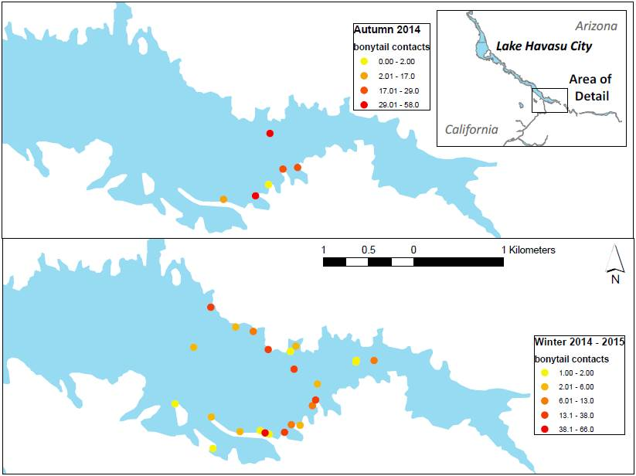

at the Bill Williams River NWR. No fish were contacted from the September 2014 stocking during winter 2014–15 PIT scanning efforts. Most contacts (72%, only including fish stocked in December 2014) occurred solely within a week (December 10–17, 2014) post-stocking (figure 31). No additional bonytail were contacted during the study period through other LCR MSCP Reach 3 scanning efforts.

During autumn PIT scanning, the greatest number of unique bonytail contacts occurred at the release site. Boot Cove and the fishing pier were also successful locations of bonytail contacts. The greatest number of unique bonytail contacts during winter PIT scanning occurred at the release site and upstream of the fishing pier. Several locations along the north shore of the Bill Williams River arm and the entrance of Boot Cove were also successful deployment locations for bonytail contacts. Habitat descriptions of deployment sites combining all iterations of PIT scanning at the Bill Williams River are presented in table 6. The results are not representative of all available habitat.

Figure 31.—Contacts of bonytail released September 30, 2014 (blue), December 10 – 11, 2014 (red), and November 29, 2011, October 8, 2012, or December 3, 2010 (green) over time by remote PIT scanning from September 2014 – January 2015, Bill Williams River, Arizona.

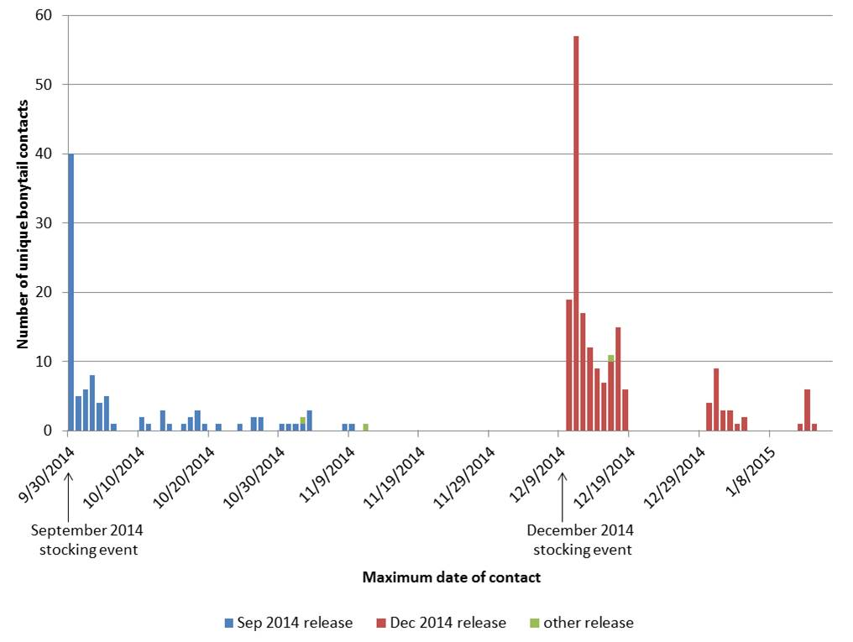

Regional Park Moabi
Remote PIT scanning antennas deployed in Regional Park Moabi collectively scanned for a total of 6,779 hours and contacted 1,003 unique fish, of which 274 were bonytail, 720 were razorback suckers (2 of which lacked release information), and 9 were unknown (no record of release or capture; figure 32). Of the unique bonytail contacted, one fish was released in January 2014 at Blankenship Bend (TL = 300 mm), while all others were released in April 2015 at Regional Park Moabi. Bonytail contacts from the April 2015 release group represented 68% of the total 424 bonytail released. Most contacts (73%, only including fish stocked in April 2014) occurred the first two weeks (April 13–26, 2015) of sampling (figure 33). An additional 14 bonytail from the same release group were contacted during the study period through other LCR MSCP Reach 3 study efforts in Regional Park Moabi.

PIT scanning data did not provide evidence of egression out of Regional Park Moabi (figure 34). No pulse in contact rates was recorded on PIT scanners from the release site to the backwater exit (i.e., locations of high relative contact rates did not shift from release site to backwater exit through time). Contact rates at the
Table 6.—Habitat descriptions for PIT scanning antenna deployments where bonytail were contacted less than 1-week post-release (A) and after 1-week post-release (B) from September – November 2014 and December 2014 – January 2015, Bill Williams River, Arizona
(Catch per unit effort [CPUE] is represented by total bonytail contacts per scanning day. “N/A” designates data were not collected for this field.)
< 1 week post-release
Distance from release site (m) | (CPUE) |  | Number of deployments |  | Mean distance to shore (m) | Mean depth (m) | Vegetation | Substrate | Slope
A.
< 500 m | 12.0 |  | 3 |  | 5.00 | 1.20 | None | Rock | Low
< 500 m | 6.96 |  | 2 |  | 0.00 | 3.60 | Overhanging | Silt | Low
< 500 m | 4.04 |  | 12 |  | 4.17 | 2.45 | Overhanging | Rock | Medium
< 500 m | 1.85 |  | 13 |  | 3.85 | 1.65 | Overhanging | Rock | Low
< 500 m | 0.36 |  | 3 |  | 5.00 | 5.90 | None | Rock | N/A
< 500 m | 0.26 |  | 5 |  | 5.00 | 3.16 | None | Rock | Medium
< 500 m | 0.08 |  | 10 |  | 4.00 | 5.11 | Overhanging | Rock | Steep
< 500 m | 0.00 |  | 1 |  | 0.00 | 1.60 | N/A | N/A | N/A
< 500 m | 0.00 |  | 2 |  | 1.00 | 0.60 | Cattails | Silt | None
< 500 m | 0.00 |  | 3 |  | 5.00 | 4.43 | None | Rock | Steep
< 500 m | 0.00 |  | 1 |  | 5.00 | 1.20 | Overhanging, cattails | Silt | Low
> 500 m | 2.06 |  | 6 |  | 5.00 | 0.78 | Overhanging, cattails | Rock | Low
> 500 m | 1.44 |  | 3 |  | 5.00 | 0.70 | Cattails | Rock | Low
> 500 m | 0.41 |  | 6 |  | 88.3 | 9.10 | None | Silt | None
> 500 m | 0.30 |  | 34 |  | 1.76 | 1.19 | Cattails | Silt | None
> 500 m | 0.20 |  | 3 |  | 5.00 | 1.17 | Cattails | Rock, silt | Low
> 500 m | 0.20 |  | 9 |  | 4.56 | 1.10 | Overhanging | Rock | Low
> 500 m | 0.00 |  | 1 |  | 5.00 | 0.50 | N/A | Na | Low
> 500 m | 0.00 |  | 2 |  | 1.00 | 1.00 | Cattails | Silt | Low
> 500 m | 0.00 |  | 1 |  | 5.00 | 1.60 | None | Rock | Low
B.
< 500 m |  | 0.64 |  | 6 | 0.00 | 0.90 | Overhanging | N/A | Low
 |  | 0.41 |  | 14 | 2.50 | 1.34 | Overhanging | Rock | Low
 |  | 0.22 |  | 4 | 5.00 | 1.60 | N/A | N/A | N/A
 |  | 0.04 |  | 20 | 3.25 | 2.03 | Overhanging | Rock | Medium
 |  | 0.00 |  | 1 | 5.00 | 2.20 | N/A | Rock | Low
 |  | 0.00 |  | 3 | 2.33 | 0.90 | Cattails | Silt | None
 |  | 0.00 |  | 1 | 5.00 | 7.30 | None | Rock | N/A
 |  | 0.00 |  | 4 | 5.00 | 3.33 | None | Rock | Medium
 |  | 0.00 |  | 1 | 5.00 | 5.00 | None | Rock | Steep
 |  | 0.00 |  | 3 | 5.00 | 6.10 | Overhanging | Rock | Steep
 |  | 0.00 |  | 3 | 0.00 | 2.67 | Overhanging | Silt | Low
> 500 m |  | 1.44 |  | 3 | 10.00 | 0.97 | N/A | Rock | N/A
 |  | 0.80 |  | 3 | 5.00 | 0.83 | Cattails | Rock | Low
 |  | 0.24 |  | 4 | 100.0 | 9.98 | None | Silt | None
 |  | 0.15 |  | 1 | 5.00 | 1.00 | Overhanging | Rock | Low
 |  | 0.07 |  | 27 | 3.04 | 1.20 | Cattails | Silt | None
 |  | 0.00 |  | 1 | 5.00 | 0.90 | N/A | N/A | N/A
 |  | 0.00 |  | 1 | 5.00 | 0.60 | N/A | N/A | Low
 |  | 0.00 |  | 3 | 5.00 | 1.00 | N/A | Rock | Low
 |  | 0.00 |  | 1 | 5.00 | 1.00 | Algae | Rock | Medium
 |  | 0.00 |  | 1 | 5.00 | 0.80 | Cattails | Rock | Steep
 |  | 0.00 |  | 1 | 5.00 | 1.70 | Cattails | Rock, silt | Low
 |  | 0.00 |  | 4 | 5.00 | 0.95 | Overhanging, cattails | Rock | Low

Figure 32.—Contacts of bonytail at remote PIT scanning locations from April – July 2015, Regional Park Moabi, California.
Locations with greater bonytail contacts are represented by darker colors.
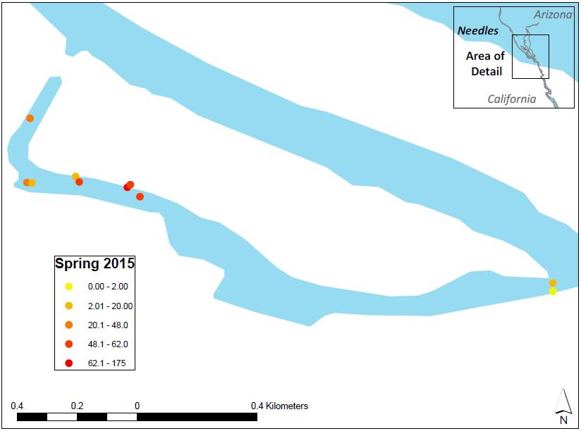

release and exit were variable (R = 0.13, 0.14, respectively). A stronger trend in the contact rate was observed at the middle sites between the release and exit
(R = 0.55). A total of 12 bonytail were contacted at PIT scanners stationed at the backwater exit. Of these 12 fish, 7 bonytail were later contacted by PIT scanners upstream of the exit within the Regional Park Moabi backwater, and one fish was contacted at the exit 3 weeks later.

The number of PIT tag contacts were lower for baited compared to unbaited scanners for bonytail (sum = 11 and 126; mean = 2.75 and 7.00 for baited and unbaited scanners, respectively) and razorback suckers (sum = 262 and 1,070; mean = 29.1 and 38.2 for baited and unbaited scanners, respectively). Of the two pairs of scanner deployments in which baiting occurred, the mean sum of unique contacts per baited and unbaited deployment was 2.8 and 7, respectively, for bonytail and 29 and 38, respectively, for razorback suckers. Baiting efforts were modest and encountered obstacles such as the loss of or damage to bait bags, likely by larger fish, once deployed. The use of PVC-constructed bait containers was most effective in retaining bait. In several instances, though not statistically significant, the non-baited PIT scanners contacted more fish than baited PIT scanners.

Figure 33.—Contacts of bonytail released April 13, 2015, at Regional Park Moabi (blue), and January 14, 2014, at Blankenship Bend (red), over time by remote PIT scanning from April – July 2015, Regional Park Moabi, California.
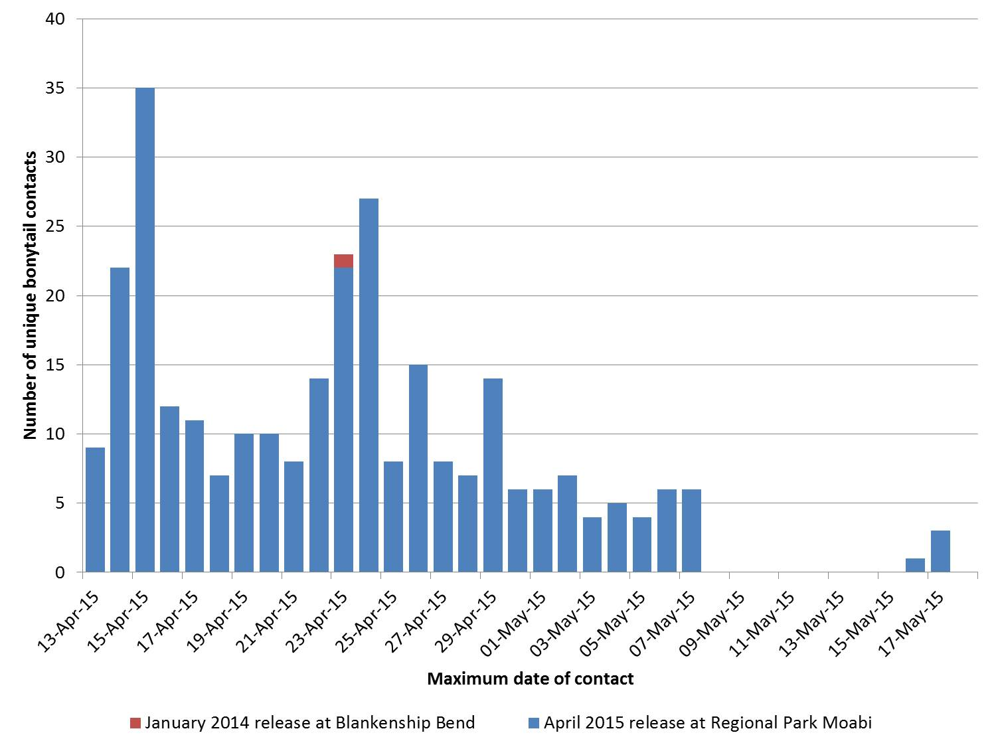

Laughlin Lagoon
Remote PIT scanning antennas deployed in Laughlin Lagoon collectively scanned for a total of 6,585 hours and contacted 484 unique fish, of which 238 were bonytail, 224 were razorback suckers, 9 were flannelmouth suckers (Catostomus latipinnis), and 13 were unknown (no record of release or capture; figure 35). Of the unique bonytail contacted, 13 fish were released September 15, 2015, at Laughlin Lagoon (mean TL = 306 mm), while all others were released December 9, 2015. Bonytail contacts from the September 2015 release group represented less than 1% of the total 1,457 bonytail released, while bonytail contacts from the more recent December 2015 release group represented 24% of the total 947 bonytail released. Most contacts (55%, only including fish stocked in December 2015) occurred the first 2 weeks (December 10, 2015 – January 8, 2016) of sampling (figure 36). No additional bonytail from the December release group were contacted during the study period through other LCR MSCP Reach 3 study efforts.

No pulse in contact rates was recorded on PIT scanners from the release site to the lagoon exit sites (i.e., locations of high relative contact rates did not shift from

Figure 34.—Mean unique bonytail contacts within three defined areas (near the release site [release], downstream from the release site at the exit point of a narrow bulrush-lined channel [middle], and where the Regional Park Moabi backwater enters the main channel [exit]) graphed over days post-release, illustrating potential egression of bonytail from the release sites to the exit of Regional Park Moabi during April – July 2015 PIT scanning, Regional Park Moabi, California; see figure 11 for site number locations.
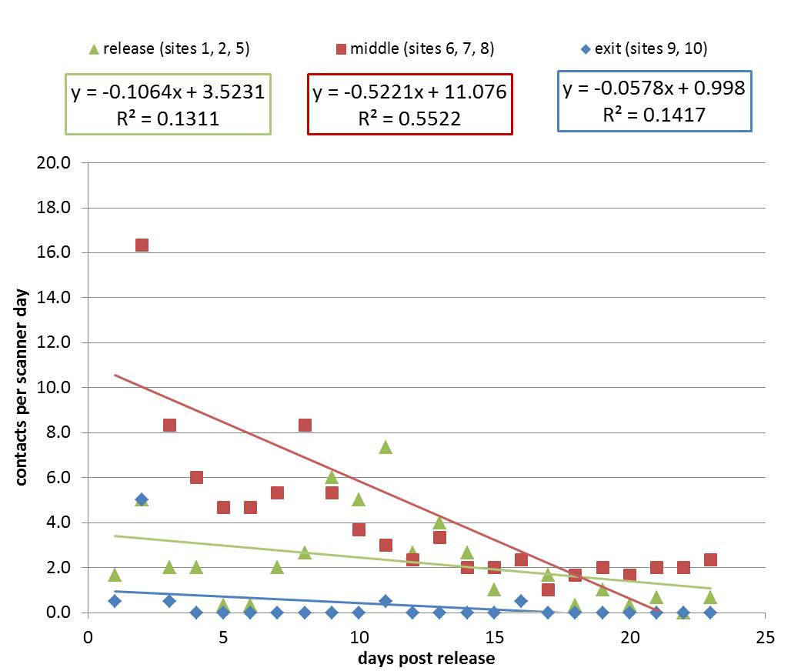

release site to lagoon exit through time; figure 37). Contact rates at all sites were variable (R = 0.28, 0.02, 0.14). A total of 62 bonytail were contacted at PIT scanners stationed either at the lagoon exit or a culvert, though most contacts occurred near a culvert. Of these 62 fish, 6 bonytail were later contacted by PIT scanners elsewhere within the lagoon, and 11 were contacted at the same scanner at a later date.

Lake Havasu Native Fish Routine Monitoring “Roundup”

Trammel netting efforts in February 2014 during the multi-agency Native Fish Routine Monitoring “Roundup” captured eight bonytail, one of which was inside
Figure 35.—Contacts of bonytail at remote PIT scanning locations from December 2015 – January 2016, Laughlin Lagoon, Nevada.
Locations with greater bonytail contacts are represented by darker colors.
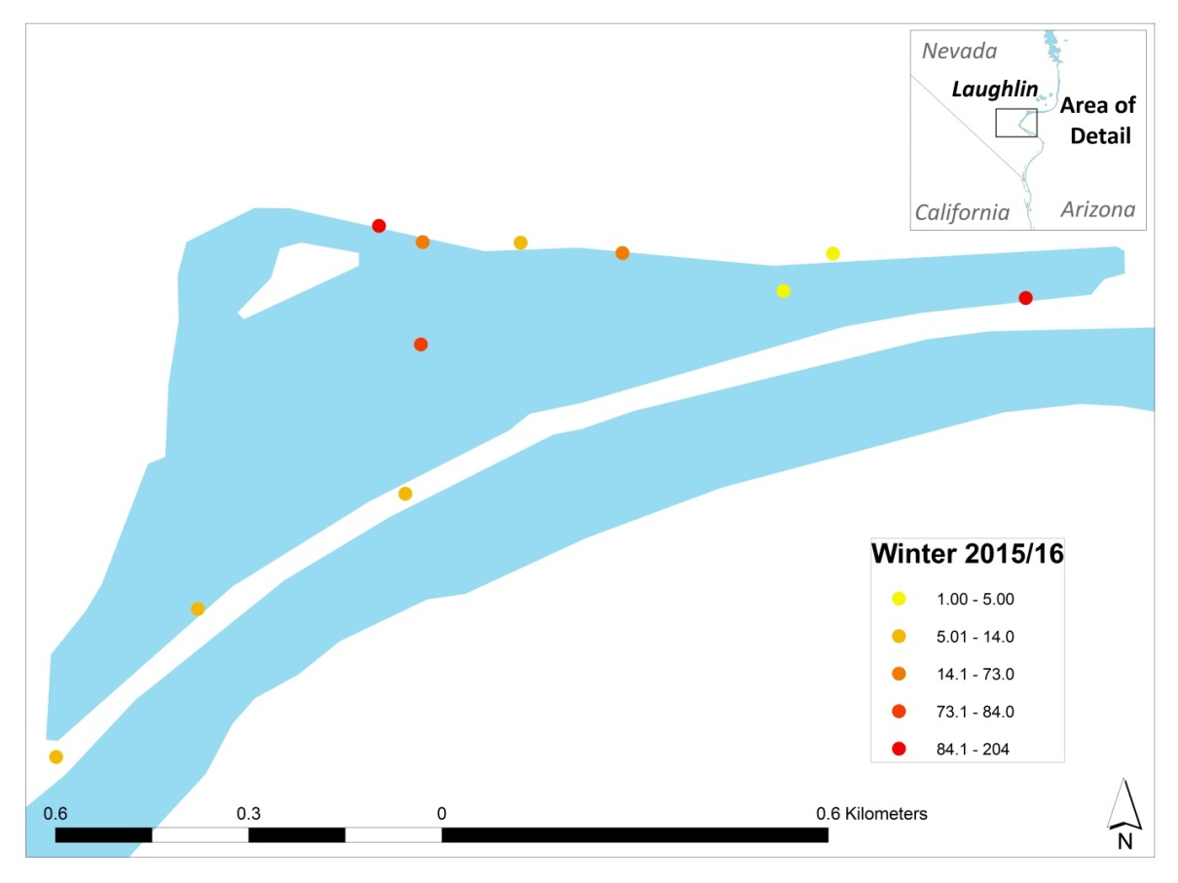

the digestive tract of a largemouth bass (Micropterus salmoides). Five of the captured bonytail had been released in October 2013, and three had been released in January 2014. One bonytail was captured in Trampas Cove, one in Blankenship Bend, and six in or near Clear Bay. Efforts during the 2015 Lake Havasu Native Fish Routine Monitoring “Roundup” resulted in 946 fishes being captured, representing 12 non-native and 2 native species (55 razorback suckers and 1 flannelmouth sucker). No bonytail were captured through trammel netting efforts. During the February 2016 Lake Havasu Native Fish Routine Monitoring “Roundup,” trammel netting efforts resulted in the capture of 595 fishes, including 11 non-native and 2 native species (66 razorback suckers and 1 flannelmouth sucker). No bonytail were captured.

Bird Observations

Potential avian predators to bonytail recorded during bird counts included great blue herons, great egrets, double-crested cormorants, gulls, and osprey in autumn 2014 at the Bill Williams River, and in winter 2015–16 at Laughlin Lagoon, and double-crested cormorants, great blue herons, and osprey in spring 2015 at

Figure 36.—Contacts of bonytail released December 9, 2015 at Laughlin Lagoon (blue), and September 15, 2015 at Laughlin Lagoon (red), over time by remote PIT scanning from December 2015 – January 2016, Laughlin Lagoon, Nevada.
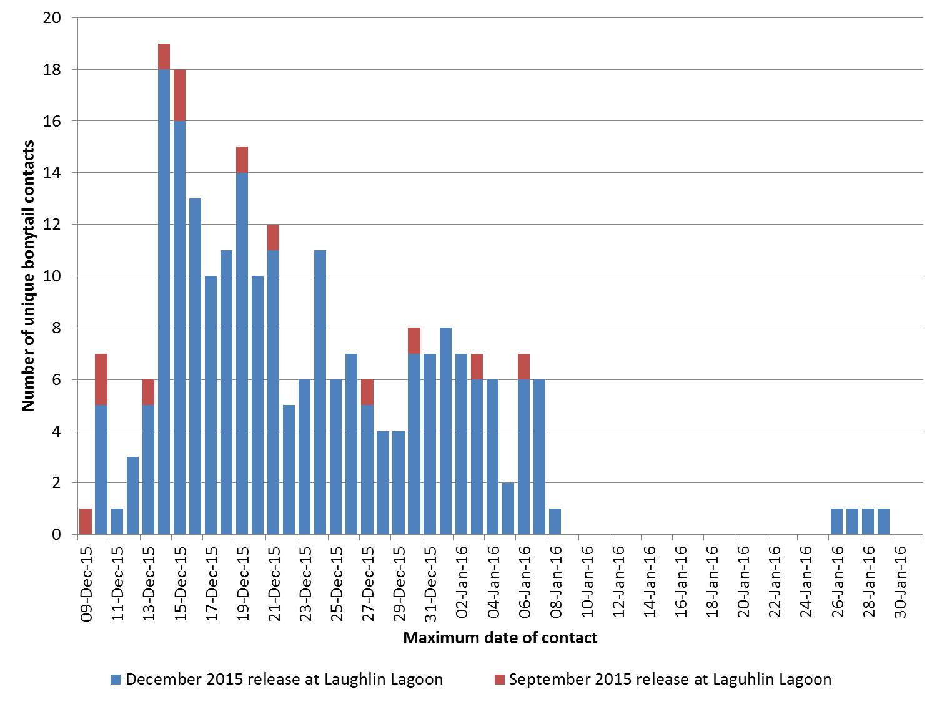

Regional Park Moabi (figure 38). double-crested cormorants were observed in greater densities than other predatory birds at the Bill Williams River. Events of avian predation observed during tracking in autumn 2014 at the Bill Williams River included an osprey in flight with an unidentified fish in its talons and a deceased bonytail with talon markings (figure 39). A great blue heron was observed striking, capturing, and consuming a bonytail during tracking at Regional Park Moabi (figure 40).

During the autumn 2014 telemetry study, trail camera footage documented the presence of double-crested cormorants, great egrets, great blue herons, gulls, and turkey vultures (Cathartes aura) at locations near the Bill Williams River NWR boat launch and cattail islands at the mouth of the Bill Williams River inlet. A fishing event conducted by a double-crested cormorant was captured on a trail camera near the boat launch in the afternoon 2 weeks after a stocking event in September. Trail camera footage suggests an increase in bird presence at the Bill Williams River after the stocking event in the morning of December 11, 2014. With the exception of 1 hour after stocking, as recorded by the programed time in the trail camera, the majority of photographs captured at this photo point contained no more than one

Figure 37.—Mean unique bonytail contacts within three defined areas (near the release site [release], at least ½ km downstream from the release site [middle], and where Laughlin Lagoon enters the main channel, including two culverts [exit]) graphed over days post-release, illustrating potential egression of bonytail from the release sites to the exits of Laughlin Lagoon during December 2015 – January 2016 PIT scanning, Laughlin Lagoon, Nevada; see figure 12 for site number locations.
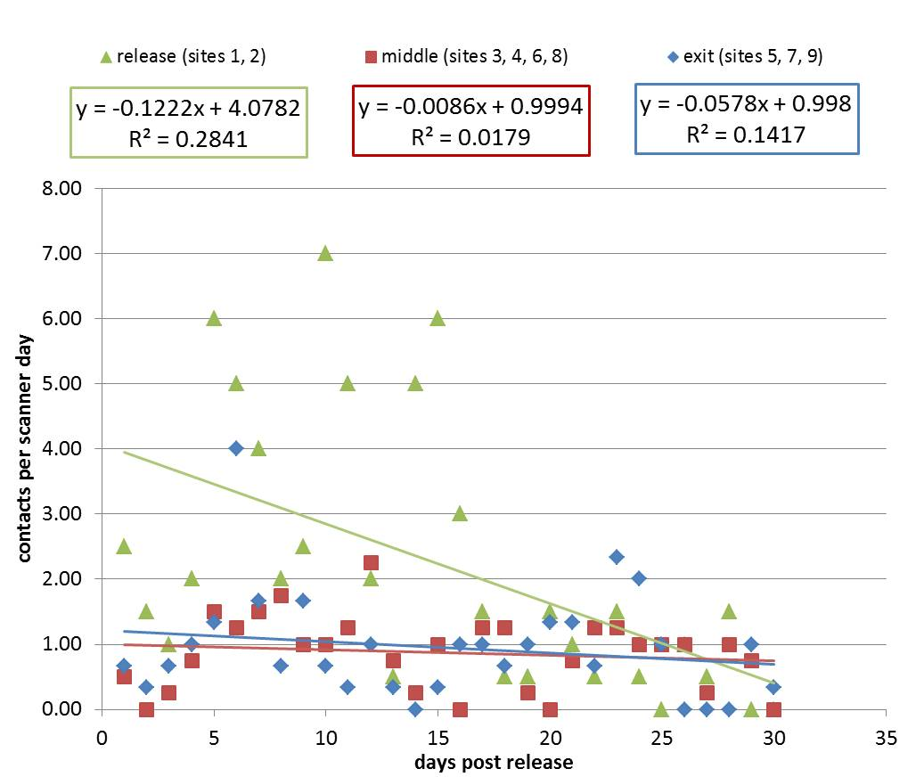

bird. Most commonly, photos were triggered by fishermen or technicians in the area. During the hour after bonytail were stocked, captured photos contained between five to seven birds (figure 41). The trail camera was not motion triggered prior to the stocking event, so no photo exists for direct comparison. During the spring 2015 telemetry study, trail camera footage at Regional Park Moabi documented the presence of great blue herons near the release site (figure 41).

Scanning for expelled PIT tags under and around known roosting sites at cattail islands in the Bill Williams River resulted in 21 unique contacts, 14 of which were bonytail and 6 of which were unknown (no record of release or capture). Of the 14 bonytail, 1 had been released in 2014, 9 in 2013, 3 in 2012, and 1 in 2011.

Figure 38.—Weekly morning bird counts conducted during the September – November 2014 telemetry study, Bill Williams River, Arizona (top), April – July 2015 telemetry study, Regional Park Moabi, California (middle), and December 2015 – February 2016 telemetry study, Laughlin Lagoon, Nevada (bottom).
Bird counts were not conducted after week 5 at Regional Park Moabi or Laughlin Lagoon.

This included three PIT tags that were not previously contacted during scanning under known roost sites in 2013 and did not include six PIT tags that were contacted in 2013.

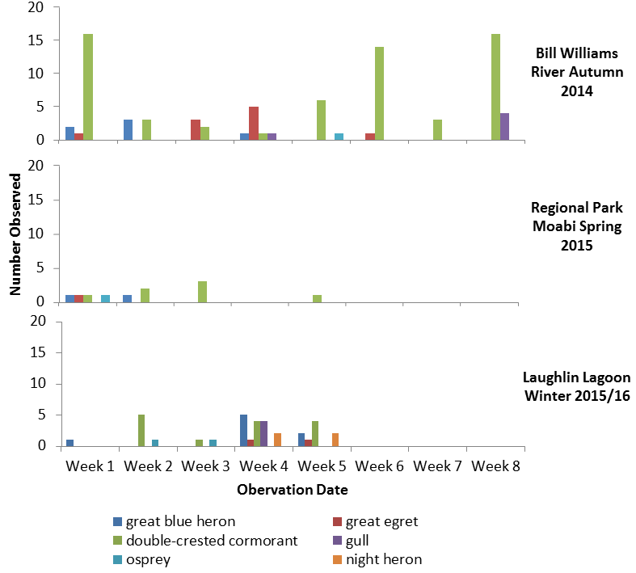

Turbidity

During the autumn 2014 telemetry study, turbidity readings were generally higher at the bottom than at the surface or mid-water column (figure 42). The mean turbidity was highest at site 3 from the bottom of the water column (7.51 NTU ± 0.33 standard error [SE]) and lowest at site 4 from the surface of the water column (0.42 NTU ± 0.04 SE). The turbidity values in autumn 2014 were lower than previously recorded in winter 2011 and spring 2012 (Karam et al. 2013).
Figure 39.—Deceased bonytail with talon markings discovered during the September – November 2014 bonytail telemetry study, Bill Williams River, Arizona.

Figure 40.—Great blue heron consuming a bonytail during the April – July 2015 bonytail telemetry study, Regional Park Moabi, California.
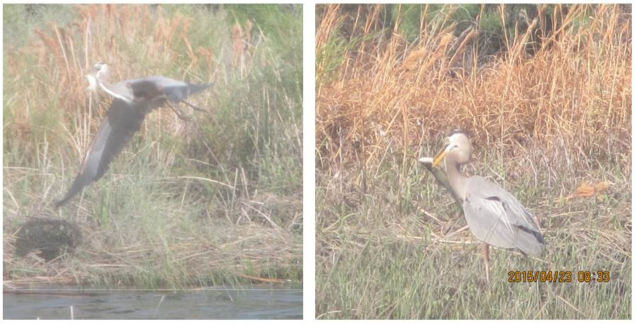
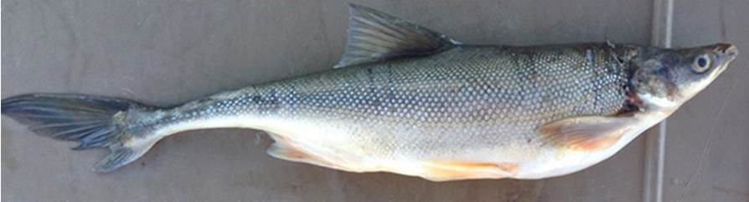

Discussion

Survival of bonytail at all study areas is low, as evidenced through acoustic telemetry, remote PIT scanning, and routine monitoring. Piscivorous birds and predatory non-native fishes both threaten stocked bonytail. Loss of contact with acoustic tags was high and may be due to tag failure or attenuated signals, but more likely is due to tag removal from the system, for instance by an avian predator, raising mortality estimates. Locations of tag recovery under roosting sites and observed capture events provide direct evidence that bird predation has an impact on post-stocking mortality of bonytail, and that impact may be significant. With the exception of study fish released at Laughlin Lagoon, most telemetry fish were lost or confirmed mortalities within a month after release.
Figure 41.—Trail camera footage of a double-crested cormorant fishing (A); birds attracted to the Bill Williams River NWR boat launch after bonytail stocking in the morning of December 11, 2014 (B); a great blue heron at the cattail islands (C) during the September – November 2014 bonytail telemetry study, Bill Williams River, Arizona; and a great blue heron standing (D) and in flight (E) near the release site during the April – July 2015 telemetry study, Regional Park Moabi, California.
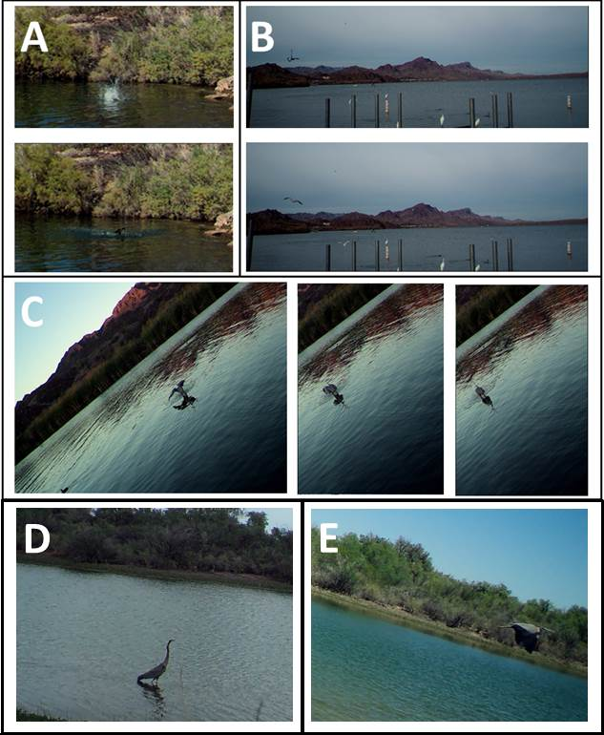

Figure 42.—Turbidity (NTU) readings taken October 2 (top), October 23 (middle), and November 19 (bottom), 2014, beginning in the upstream-most watercraft accessible portions of the Bill Williams River (water sample site 1) and ending outside of the refuge boundary for the Bill Williams River NWR, Bill Williams River, Arizona; see figure 7.
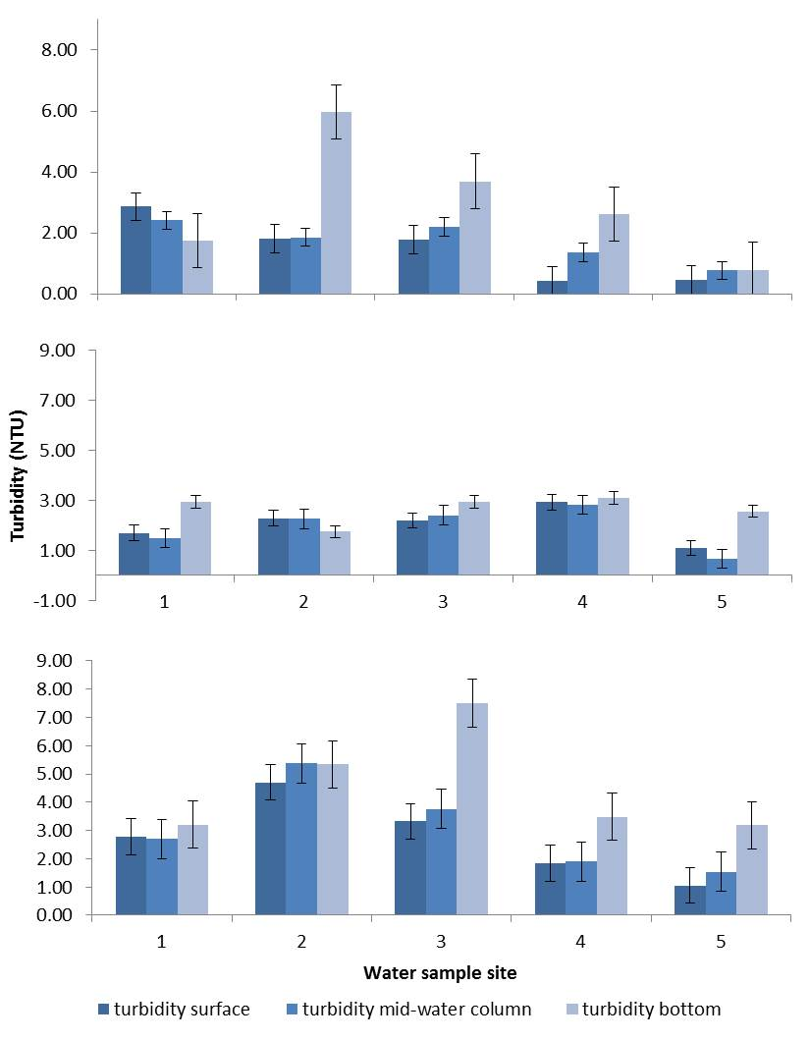
Few fish survived long enough post-release to determine habitat selectivity, although bonytail were documented to utilize bulrush. The detection and recovery of radio tags on dry land at Laughlin Lagoon support the hypothesis that acoustic tag loss is due to the removal of study fish from the water (e.g., avian predation). Data do not suggest that fish disperse far from release sites. Off-channel locations with constricted connection to the lower Colorado River, such as Regional Park Moabi and Laughlin Lagoon, are ideal sites to track survival where the potential for fish to leave the study area is minimized. This lack of dispersion from release sites also allows PIT scanning to effectively contact bonytail weeks after stocking. However, to date, it has not been possible to utilize the acquired contact data to reliably estimate post-stocking survival.

Survival

Long-term survival from the bonytail stocking program appears to be very low. Of approximately 55,000 bonytail stocked into Lake Havasu with PIT tags (1993–2014), 80 have been captured during monitoring since 1993, and only 3 were recaptured more than a year after release. Remote PIT scanning began in 2011, and since then, 1,832 bonytail have been contacted (of approximately 25,000 stocked with 134-kHz PIT tags), and of these, 6 bonytail were contacted more than a year post-stocking, and only 175 were at large for more than 30 days (unpublished data, Lower Colorado River Native Fish Database). Low survival is supported by the study results in which one-half of all telemetry study fish were determined mortalities, with most of the mortalities occurring less than a month after release. PIT scanning contacts also declined to less than half of the total contacts after 2 weeks post-release, and extensive PIT scanning conducted within the reach had contacted few bonytail while at the same time contacting thousands of razorback suckers.

While long-term survival across all study sites was low, there were minor differences in short-term survival. The decline in contacts was slower for both telemetry study fish and stocked PIT-tagged fish during tracking and scanning at Laughlin Lagoon though overall apparent survival was low. Mortality was highest at the Bill Williams River in both spring and autumn. All fish released
(N = 6) in spring 2013 were determined mortalities less than 2 weeks post-release, and 89% were determined mortalities within 8 weeks post-release during autumn 2014. Mortalities cannot be attributed to surgical techniques based on the prolonged survival of dummy-tagged fish compared to study fish at the Bill Williams River in autumn 2014, the good condition of study fish 1 week post-surgery prior to release at Laughlin Lagoon, work by Karam et al. (2011) with dummy-tagged bonytail, and work at Utah Lake with dummy-tagged June suckers [Chasmistes liorus], unpublished data).

The comparison of different release sites within a study area did not offer insight into bonytail behavior or improved survival. The mean number of weeks survived post-release was similar at the launch and inlet release sites (3.2 and 3.3, respectively) at the Bill Williams River in autumn, although the 1 active fish and 1 lost fish both originated from the inlet release. Results from backwater and main channel release sites at Blankenship Bend across seasons were inconsistent in the number of active fish by the end of the study. However, study fish from the Blankenship Bend spring 2014 telemetry study iteration were obtained from the Cibola High Levee Pond and temporarily held at a hatchery, whereas all other study fish were reared and harvested from a hatchery. Hatchery rearing may have unknown effects on bonytail behavior or survival.

Remote PIT scanning data complement telemetry data, suggesting low bonytail survival with a drop off of 60 and 30% at Regional Park Moabi and Laughlin Lagoon, respectively, within the first 2 weeks post-stocking. Declines in survival from the first to second week post-stocking are at least 90% at other release sites, which likely represents dispersal as well as mortality. Attempts to incorporate the continuous PIT scanning data collected during this project into a Barker mark-recapture model similar to the one described in Conner et al. (2014), and Barbour et al. (2013) have been unsuccessful to date. A complex and biologically realistic model with time varying survival and re-sight rates resulted in highly variable parameter estimates for survival and re-sight rates (nearly 0 to 1) among structural models with significant model likelihood values (> 10%). PIT scanning does indicate the possibility for some bonytail to survive for prolonged periods. Results at the Bill Williams River from October – December 2014 included contacts from one bonytail released in each of December 2010, November 2011, and October 2012. No identifying data regarding these contacts are known that may provide insight as to why these fish are surviving longer than the majority of bonytail.

Lack of captures by traditional sampling methods such as trammel netting and electroshocking also suggest low survival. During the February 2014, 2015, and 2016 “Roundups,” captures of bonytail (CPUE = 0.20, 0, and 0, respectively) were low compared to netting efforts of non-native predators such as largemouth bass (CPUE = 2.82, 2.35, and 3.03, respectively). The most recent bonytail stocking event was more than a year prior to the 2015 “Roundup,” when no bonytail were captured, indicating that bonytail are not surviving long term.

Actual mortality of telemetry study fish is probably higher than reported values from stationary and recovered tags because a proportion of lost fish may be composed of unobserved mortalities caused by bird predation. Thirty-six percent of the Blankenship Bend study fish, 64% of the Regional Park Moabi study fish, and 46% of the Laughlin Lagoon study fish were lost near or within the study area, with no indication of dispersal. Lost fish may be a consequence of the densely vegetated and complex habitat, wherein telemetry signals may be absorbed or scattered and thus undetectable. Blankenship Bend, for instance, offers multiple backwater systems that fish may use to seek refuge from the main channel. However, equipment and techniques ultimately proved effective in re-establishing contact with six temporarily lost fish at Blankenship Bend. Considering the success in re-establishing contact with four of six fish in less than 2 weeks, and given the broad spatial coverage of SURs and the extensive and intensive active tracking, it is less likely that most of the permanently lost fish were simply “missed.”

The maximum temporary loss of study fish at Laughlin Lagoon was as long as 3 weeks, likely a result of relatively greater vegetated complexity. SUR and hydrophone detection radii were tested through bulrush stands with a recovered tag at Regional Park Moabi and were found to be completely attenuated within only a couple of meters, confirming that study fish may be lost even in relatively smaller patches of vegetation. The use of radio tags and acoustic tags with increased range at Laughlin Lagoon allowed for greater success tracking in dense bulrush. One acoustic fish was detected by omnidirectional hydrophone and tracked with the UDR 10 m into bulrush. Tracking at Regional Park Moabi, a less vegetated system than Laughlin Lagoon, recorded study fish within bulrush after which contact was temporarily lost with some of these fish. However, contact was re-established within a week, suggesting that fish may not remain within bulrush patches for longer than several days.

Spontaneous acoustic tag failure is another possible explanation for the loss of a study fish, but in our and others’ experience, this is rare. We assert that most lost fish are a result of tag removal from the system (for example, by an avian predator). With the combination of determined mortalities and lost study fish, mortality of tagged bonytail may have been as high as 55% at Blankenship Bend, 93% at Regional Park Moabi, and 100% at Laughlin Lagoon. Lost radio tags likely represent mortalities, otherwise they would be representative of bonytail behavior that was not observed in acoustic-tagged fish – specifically, dispersal out of the study area or bonytail remaining at depths greater than 3 m (radio signal attenuated beyond detection) for extended periods (more than a few days).

Predation: Avian

Bird predation on fishes is well documented and unequivocal and may be a significant post-stocking mortality impact on bonytail. Avian predation of stocked fishes can decimate stocked rainbow trout (Oncorhynchus mykiss; Modde et al. 1996) and wild populations of cui-ui (Chasmistes cujus) (Scoppettone et al. 2014). Predatory birds such as double-crested cormorants, great egrets, great blue herons, and osprey frequent Lake Havasu, as evidenced by bird observation data. Trail cameras set to monitor the site of a bonytail stocking event at the Bill Williams River NWR documented increased bird presence and fishing in the hours directly after bonytail release (see figure 41), suggesting active predation on bonytail. Fish-eating birds are known to be attracted to places where fish are present, such as fishing boats, docks and cleaning stations, and mid-water baitfish boils. Cormorants, specifically, are attracted to areas of high fish concentration, such as stocking release sites, aquaculture ponds, and dams (Wires et al. 2001). Studies further assessing bird predation utilizing both direct observation and trail cameras are warranted. Trail cameras can be programed with motion activation to track predation success, and timed cameras can indicate bird density. Timed cameras also allow for comparison of bird density changes during stocking events. Cameras equipped with infrared capabilities could capture hunting events during dark hours.

Bonytail may be a regular diet source for great blue herons and double-crested cormorants. Evidence includes the direct observation of a great blue heron capturing and consuming a bonytail at Regional Park Moabi in spring 2015 (see figure 40), 3 radio tags recovered on land, and the location of 7 expelled acoustic and 14 PIT tags. During spring 2013 at the Bill Williams River NWR, 14 PIT tags were contacted, and 1 acoustic tag was recovered under semisubmerged woody debris, a known cormorant roost site (Mueller et al. 2014). Five acoustic tags were triangulated under power lines documented to be roost sites of double-crested cormorants (see figure 18). Two were located downstream from Parker Dam and one upstream of Parker Dam during the autumn 2014 telemetry study. Two were located downstream from Davis Dam during winter 2015–16 telemetry study. An additional tag was also triangulated downstream from Parker Dam, not associated with a roost site. Of 230,911 razorback suckers released to date into Lake Mohave, only 3 fish have been contacted by PIT scanning efforts in Reach 3, indicating, exclusive of potential data errors, that it is either rare for razorback suckers to move through a dam or survive such movement. During an entrainment radio telemetry study, Marsh and Kesner (1999) did not contact razorback suckers near Parker Dam. Assuming similar behavior and entrainment potential, tags recovered downstream from dams likely represent bonytail translocated by an avian predators.

PIT scanning at known double-crested cormorant roost sites resulted in 14 contacted PIT tags across spring 2013 (Mueller et al. 2014) and autumn 2014. Similar scanning implemented on a known seabird breeding site has successfully estimated avian predation of juvenile salmonids (Frechette et al. 2012; Sebring et al. 2013). PIT scanning at known roosting sites at Pulpit Rock has also resulted in contacts with expelled razorback sucker PIT tags (Wydoski 2014). PIT scanning beneath double-crested cormorant roosting sites may therefore provide contacts with PIT tags shed from consumed bonytail and should be incorporated routinely into future studies where detection probabilities of tags consumed by double-crested cormorants may be as high as 84% (Hostetter et al. 2015).

Based on available literature regarding daily biomass consumption of target bird predators, it is possible for bonytail stockings to be decimated in relatively short time periods. The mean weight of acoustic-tagged bonytail across all telemetry studies was 282 g, which may overestimate typical weights of stocked bonytail due to the practice of hand selecting larger study fish for telemetry surgeries. Schramm et al. (1987) report great blue herons and double-crested cormorants to consume 340 and 247 g of fish per day, respectively, translating to approximately one stocked bonytail per day. Multiplying these consumption rates with the maximum number of observed birds per observation period (see figure 38), and assuming no alternative prey, predatory birds could consume at least 570, 120, and 300 individual bonytail in 1 month at the Bill Williams River, Regional Park Moabi, and Laughlin Lagoon, respectively. These values likely represent underestimates because bird observations may only report a percentage of actual individual inhabitants and other avian predators such as great egrets and osprey and are not included. Also, the estimated mass of food consumed per day by cormorants may be closer to 890 g when food harvested for chicks is included, as calculated by Gremillet et al. (1996). Double-crested cormorants are known to nest and rear young along the LCR (Rosenberg et al. 1991). These estimates represent approximately 30% of bonytail stocked from the autumn 2014, spring 2015, and winter 2015–16 respective telemetry stocking events. Precipitous post-release declines in stocked bonytail is consistent with PIT scanning data during all scanning events in which the majority of unique bonytail (over 55%) were contacted within the first 2 weeks post-stocking. Acoustic-tagged fish from the Bill Williams River autumn study suspected to be consumed by avian predators were determined mortalities after a mean of 11 days post-release.

Any bonytail consumed by an avian predator would be lost to acoustic telemetry studies unless the tag was shed over water. This is of particular concern for double-crested cormorants, which have a nearly 50% deposition probability of expelling consumed tags on land-breeding colonies in the Columbia River basin (USA) (Hostetter et al. 2015). Loss of contact with acoustic-tagged study fish was at least 30% at all sites, excluding the Bill Williams River, where confirmed mortality was at least 89%. It is likely that contact losses are the result of tags removed from the study area by bird predation. The application of radio telemetry was useful in locating 3 of 12 (25%) radio-tagged study fish removed from the water at Laughlin Lagoon. If the percentage of study fish removed from the water is independent of tag type, it is reasonable to assume that at least 3 of 12 acoustic tags were also removed from the water (potentially 3 of the 4 lost acoustic tags). Alternatively, lost radio tags could be a result of expelled tags deposited in water deep enough to attenuate signals and decrease detection probabilities. Eight of 12 acoustic tags were confirmed mortalities in the water, suggesting that a greater proportion of radio tags, more than the 2 of 12 discovered, were evacuated in the water. Two acoustic tags were triangulated in deep water under power line roosts, and it is possible that radio tags were evacuated at this site as well but not detected.

Double-crested cormorant population numbers peak in Arizona in March – April and October – November (Wires et al. 2001) amid scheduled stocking events and associated telemetry tracking. Bonytail survival may be greater during the winter months, supported by PIT scanning data at Laughlin Lagoon in which contacts declined over time at a less accelerated rate compared to other study periods. Documentation of double-crested cormorant migration at Lake Havasu could identify ideal stocking seasons when the double-crested cormorant predation threat is lessened. Artificial structures may provide cover and reduce fish loss (Russell et al. 2008). In addition, Wires et al. (2001) suggest using exclusion nets, wires, floating ropes, flight inhibitors, and non-lethal harassment, as well as changing stocking locations to decrease bird predation and stocking at more turbid sites or artificially increasing turbidity. A telemetry study at an enclosed captive site, where non-native fish species were not present and birds could be excluded by nets or other devices, would be ideal for obtaining habitat data (e.g., the Yuma Cove backwater on Lake Mohave, Office Cove on Lake Havasu, Cibola High Levee Pond, or one of the native fish ponds at the Imperial National Wildlife Refuge).

Signal loss or recovery on land could also occur if a telemetry-tagged fish died near shore and the carcass was retrieved by an avian or terrestrial predator or scavenger. Among others, ravens (Corvus corax), coyotes (Canis latrans), or raccoons (Procyon lotor), are all common throughout the study area and which have been observed eating fish carcasses elsewhere along the LCR. The dead fish could be consumed on the shoreline and the tag left there, or the tag could be ejected and deposited far from the site. Although this possibility potentially reduces the role bird predation has on bonytail post-stocking survival, it does not impact the overall assessment of bonytail survival.

Predation: Fish

Direct observation of a bonytail in the digestive tract of a largemouth bass (Humphrey et al. 2014) illustrates the threat piscivorous fishes pose to bonytail survival. Data from February 2014, 2015, and 2016 “Roundups” suggest relatively high numbers of largemouth bass (percent of total catch = 20, 11, and 14%, respectively) in Lake Havasu (including Blankenship Bend, Topock Gorge, and Regional Park Moabi) compared to bonytail (percent of total catch = 1, 0, and 0%, respectively). Largemouth bass may take 3 days to evacuate a consumed tag (Thompson et al. 2015). One acoustic-tagged fish in the spring telemetry study at Blankenship Bend traveled a reach of 17 km in 3 days (later determined to be a mortality due to lack of movement), which could signal consumption by a piscine predator. An acoustic-tagged fish during the Laughlin Lagoon study exhibited increased displacement 5 days prior to determination of mortality, likely the result of consumption and evacuation of the study fish and tag. Tracking recorded increased displacement per day and contact at locations seldom or never visited by other tagged fish, which included the main stem river and south channel of Laughlin Lagoon (attachment 3). A higher rate of movement is consistent with that of striped bass (Morone saxatilis) (Ng et al. 2007; Wilkerson and Fisher 1997), a large pelagic piscivore that is common in Lake Havasu. Recent data suggest that striped bass can take up to 20 days to evacuate a consumed tag (Friedl et al. 2013), which adds uncertainty to mortality estimates and habitat preference assessments from a 60-day study. A tag may be tracked for up to a third of the study period before it is evacuated, during which time it is unknown if it was representative of the behavior of a bonytail or predator. If a tagged bonytail is consumed toward the end of the study, it may never be determined a mortality or casualty of predation. Telemetry tags with a dissolvable “trigger” to detect consumption by a predator are currently being tested (Hydroacoustic Technology, Inc., 2014) and could provide an important tool to further examine the impact of piscivory on bonytail survival.

Six of 17 tags were recovered in the Bill Williams River inlet under areas of heavy cover, implicating tag evacuation by fish predators. It is unknown if fish or bird predation is a greater threat to bonytail survival in the inlet compared to the arm of the Bill Williams River. The inlet is characterized by higher turbidity and greater presence of cattails and overhanging debris, and such habitat may be ideal for flathead catfish (Pylodictis olivaris). Daugherty and Sutton (2005) identified flathead catfish in the St. Joseph River, Michigan, to utilize habitat at 3 m depths consisting of large woody debris and riprap. Unlike striped bass, flathead catfish may exhibit behavior more similar to bonytail, displaying discrete area fidelity. Garrett (2010) reports that flathead catfish establish small home ranges
(< 10 km), with fidelity to several discrete areas of high use and select deep habitats associated with anthropogenic structures. There is no information on the home range of bonytail, but use of structure (riprap) has been documented (Marsh et al. 2013a), and this study indicates minimal dispersal from the release site overall. It is currently not possible to distinguish flathead catfish and bonytail behavior from telemetry data.

Bonytail may be a naïve fish toward introduced predators, causing them to be especially vulnerable to non-native species in the Colorado River (Mueller et al. 2007). O’Neill and Stewart (2015) observed bonytail using non-native predator species as cover in aquaria conditions, and Cox and Lima (2006) argue that prey naiveté is widespread in freshwater systems due to lack of historical predation compared to terrestrial and marine ecosystems. O’Neill and Stewart (2015) conditioned hatchery-raised bonytail to avoid predators, and tracking survival of these fish in situ post-release may provide insight on conditioning retention and application.

Predation: Total Length

Previous telemetry studies at the Bill Williams River NWR have reported higher survival of acoustic-tagged bonytail (Karam et al. 2013), but the mean TL of those bonytail, tagged in November 2011, was almost 100 mm longer than the mean TL of study fish used in both spring 2013 and autumn 2014 at the Bill Williams River. The mean TL of Laughlin Lagoon study fish was approximately 50 mm longer than fish from other telemetry iterations as part of this study. While the final fate of study fish from Laughlin Lagoon was grim, with 100% mortalities or lost fish, more study fish were actively tracked through week 4 post-release at Laughlin Lagoon (83% of fish released) than fish released from all other study iterations (range = 0–58% of fish released).

Great blue herons have been observed to consume trout from 300 to 390 mm TL (Hodgens et al. 2004). Brandt’s cormorants (P. penicillatus), a similar species to double-crested cormorants, were observed to consume suckers up to 400 mm TL (Derby and Lovvorn 1997), and osprey have been documented to consume fish up to 500 mm TL (Edwards 1988; Carss and Godfrey 1996). Based on mean TLs, telemetry fish (range 306–349 mm), as well as all PIT-tagged fish
(range = 260–435 mm), were at risk of bird predation. The total length at release is a known determinant of post-stocking survival in razorback suckers (Marsh et al. 2005) and other species (Jennings and Zigler 2000; Zabel and Alchord 2004; Bestgen et al.; 2006) and may be a factor in bonytail survival as well. Tagging (acoustic or radio) additional bonytail (20–30 fish) at a larger size (greater than 400 mm TL) would increase the number of available fish to assess post-stocking habitat preferences beyond 1 month post-release. Releasing larger PIT-tagged fish could also result in increased PIT scanning contacts rates and increased precision of post-stocking survival estimates.

Habitat

Close to one-half of all telemetry fish were lost or confirmed mortalities within a month after release, and few fish were available long enough post-release to determine habitat selectivity. Visual and telemetry observations did however document the use of bulrush habitat by bonytail at Laughlin Lagoon and Regional Park Moabi, where 15–20% of active tracking records reported study fish in or near the vicinity of bulrush. A total of eight bonytail, acoustic-tagged and otherwise, were visually observed in shallow waters near or in patches of bulrush. Multiple fishes were actively tracked several meters into bulrush, including fish 161 and fish 162 tracked in an open patch of water surrounded by dense bulrush (attachment 2) and fish 110 triangulated 10 m into bulrush (attachment 3).

SURs also documented study fish presence in bulrush. Thirteen of the 14 study fish released at Regional Park Moabi were contacted by SURs deployed in dense bulrush. Contact was lost with multiple fish during both the Regional Park Moabi and Laughlin Lagoon studies for several days, as well as repetitively during mid-day, the last presumed to have retreated into bulrush based on SUR coverage, before re-emerging (attachments 2 and 3). Bonytail may behave similarly at Blankenship Bend in spring as observed through the lack of detection during the day and re-emergence of study fish in the same areas at night. Fish 140 displayed this described pattern most obviously and consistently (Humphrey et al. 2014). Bulrush was not available to bonytail at the Bill Williams River, but study fish were tracked near cattails. Fish 40-2, the last active fish at the Bill Williams River in autumn 2014, was actively tracked on multiple occasions during the final week of the study, stationary near cattails (Humphrey et al. 2014).

Humpback chubs (Gila cypha), a species closely related to bonytail, have been reported to use turbidity as cover, increasing near-surface activity under conditions of high turbidity (Valdez et al. 1992) presumably to reduce predation risks (Stone 2010). Lack of evidence for egression out of the Regional Park Moabi backwater may suggest positive habitat selection for Regional Park Moabi where turbidity is relatively higher than the main channel of the Colorado River in the same area. Topock Bay is a backwater of comparable turbidity to Park Moabi and 1.5 km downstream, but no study fish were contacted within this area (nor were any fish stocked here). Based on SUR data, study fish did not permanently emigrate out of Laughlin Lagoon either, suggesting that turbidity may not be the sole factor in habitat selectivity; Laughlin Lagoon typically has relatively clear water.

Only one study fish was suspected to leave the Bill Williams River, where mean turbidities of active contact sites were slightly higher than those recorded at Blankenship Bend during the same year. Despite turbidity or the potential for an individual’s selectivity toward turbidity, survival at Blankenship Bend was greater than at the Bill Williams River. Previous telemetry studies at the Bill Williams River NWR have reported higher survival of acoustic-tagged bonytail, including studies conducted in November 2011, during which time turbidity was documented to be higher than recent sampling (Karam et al. 2013). Differences in turbidity between this and previous studies may account for the decreased survival of study fish in less turbid waters where bonytail are potentially more susceptible to predation. Regardless, differences in survival also are likely related to the smaller fish used in recent studies.

Movement and Inhabitance

Overall, bonytail monitored during this study preferred to remain where they were released or simply did not disperse from that site. PIT scanning and telemetry data did not suggest a trend toward egression out of Regional Park Moabi. PIT scanning data at Laughlin Lagoon did suggest dispersal away from the release site, but association with an exit point (culvert) may be more representative of habitat selectivity rather than egression. Telemetry fish were also recorded near or in culverts but were not recorded upstream or downstream from Laughlin Lagoon. Within the Bill Williams River, the majority of acoustic-tagged fish remained near their release site, whether the Bill Williams River arm or inlet. However, this was not the case at Blankenship Bend in spring when the mean dispersal of study fish was three times farther than fish from all other study periods. Surface water temperatures, turbidity, water velocity, and even the open design of the Blankenship Bend study site all may play a role in increased fish movement. Habitat characteristics and observed fish movement at the Bill Williams River, Regional Park Moabi, and even Blankenship Bend in autumn are not consistent with observations at Blankenship Bend in spring. Autumn turbidity and water velocity were similar to spring values at Blankenship Bend, and surface water temperatures were warmer at the Bill Williams River and Regional Park Moabi. Striped bass predation (i.e., a tracked tag was in the gut of a striped bass that had eaten a bonytail) may explain large dispersal values, but PIT scanning also documented several cases of bonytail traveling relatively far distances from release sites. For example, in spring 2015, one fish was contacted in Regional Park Moabi after being released in Blankenship Bend. In winter 2014, 11 bonytail were contacted in Trampas Cove and 1 fish in Clear Bay after being released from Blankenship Bend. Identifying the conditions that minimize egression of released bonytail should be a priority because limited egression increases the benefit of releasing bonytail at sites with high survival.

Observations regarding potential site fidelity among bonytail were recorded for fish 40-2 (attachment 1) from November 15–21, 2014, in the Bill Williams River inlet near the U.S. 95 bridge. Further investigations through active efforts established an area upstream of the U.S. 95 bridge where this fish was contacted multiple times within 130 m from November 19–21, 2014. Site fidelity was also displayed by fish 109, fish 122, and fish 127 at Laughlin Lagoon near the culvert in the east channel (attachment 3).

Displacement values from each study site likely are not directly comparable. SURs were less concentrated at Blankenship Bend than elsewhere, and therefore other sites likely detected shorter distance movements that may compound total values. Additionally, values are reported as straight line displacement that do not account for river sinuosity and consequently differences in channel morphology of chosen study areas. Displacement can be compared between seasons within the same study site, though it is difficult to compare seasonal differences at the Bill Williams River because study fish were determined mortalities so early in spring. Study fish at Blankenship Bend consistently displayed greater mean displacements in spring, similar to dispersal differences. The difference may be related to season, as mean surface water temperatures were higher in spring, and bonytail begin spawning in late spring (Wagner 1955; Minckley 1973). However, fish origin also may have played a role. Fish from the autumn 2013 study were transported directly from the hatchery, whereas spring 2014 study fish were captured from the Cibola High Levee Pond and held at the hatchery for 13 days prior to surgeries and release. The difference in rearing facility (hatchery versus a “natural” pond), method of capture prior to transport (hatchery collection versus

trammel netting), and transport time likely resulted in differing levels of stress in study fish and may account for the difference in post-stocking behavior (Portz 2009).

Tracking data support observations by others that bonytail are most active at night (Marsh and Mueller 1999; Marsh et al. 2013a) presumably to feed (Marsh et al. 2013b). Marsh et al. (2013a) observed bonytail establishing fidelity toward selective territory during the day while emerging into an isolated backwater at night. Bonytail may behave similarly at the study sites as observed by high passive contact percentages between sunset and sunrise (> 49%) during all tracking iterations where study fish survived longer than 2 weeks. Short periods of non-detection during mid-day hours were recorded for multiple fish across study sites (see figure 15). It is unclear if shorter periods of non-detection followed by a re-emergence at the same SUR occurring during the evening hours represent fish that simply swam out of detection range or fish that had moved into some type of heavy cover.

Methodologies

Regional Park Moabi and Laughlin Lagoon were chosen in part to serve as smaller, more contained study sites where study fish were less likely to be lost to tracking than in complex backwaters such as Blankenship Bend and the Bill Williams River. In such an environment, PIT scanning contacted 68% of fish released and proved to be an effective means to monitor bonytail at Regional Park Moabi but only contacted 23% of fish released at Laughlin Lagoon, perhaps due to the increased complexity of habitat within the lagoon. PIT scanning at Blankenship Bend, a larger and more open study area than Regional Park Moabi, contacted 23% of bonytail released. Efforts were less successful at the Bill Williams River where PIT scanning contacted 5% of bonytail released over two stocking events.

PIT scanning was conducted to complement telemetry data and determine if PIT scanning alone was adequate to assess post-release survival of stocked bonytail. Tag detection trends from PIT scanning and telemetry at Regional Park Moabi and Laughlin Lagoon complement each other. This indicates that PIT scanners are an effective tool to track bonytail when they are released in an environment that minimizes emigration. The complementary data also reinforce the assertion that survival of released bonytail in Lake Havasu is extremely low. It is likely that these data can be used to assess survival using a mark-recapture model, although this was not successfully completed during this study. Although the Barker model has shown promise in simulation exercises (Barbour et al. 2013; Conner et al. 2014), additional simulations will be needed to discern whether the Barker model is a tenable alternative to the Cormack-Jolly-Seber (CJS) model for realistic mark-recapture data. In the interim, structuring PIT scanning deployments to closely resemble the original sampling design the Barker model used is recommended: discrete time periods of PIT scanning within the study area and nearly continuous PIT scanning covering a larger geographic area, which includes the study area. Both PIT scanner deployment strategies should be conducted as randomly as possible within the limitations of deployment conditions. The discrete data within the study area could be used in a CJS model if the full Barker model still failed to produce satisfactory results. This is preferable to just “discretizing” continuous data because the time between sampling events would be determined a priori, and PIT scanners would be moved randomly between events, removing any re-sight probability bias due to geographic proximity.

The single and narrow exit and entrance to Regional Park Moabi created an ideal study site to investigate egression of bonytail after release. PIT scanning here did not indicate a strong tendency for fish to egress out of Regional Park Moabi, consistent with telemetry data. Based on this information, it is unlikely that loss of telemetry study fish was because of a lack of intensive tracking or equipment error in the main channel. Future studies may include similarly controlled environments with narrow choke points so as to track dispersal versus predation.

Baiting PIT scanners was not correlated with increased contact rates. In fact, at times, non-baited scanners received more contacts than baited scanners. Bait may have attracted predatory fishes as well as target species, and as a result, bonytail may have been inadvertently exposed to predation. Bait containers often had signs of attack represented by a loss of the bait container or holes in the bait container material, indicating that they were successful in attracting fish and perhaps spiny softshell turtles (Apalone spinifera), muskrat (Ondatra zibethicus), or other animals as well. Baiting was performed only on a small scale as part of supplemental PIT scanning efforts, and the loss of bait containers during PIT scanner deployments may have skewed the results. A larger effort using the improved PVC bait containers in a closed backwater environment with minimal threat of non-native predators may offer different results.

Study Sites and Seasons

The mortality of telemetry fish was 92% across both seasons at the Bill Williams River, suggesting that this location is not ideal for future stocking. While confirmed mortalities were lower at Blankenship Bend, Regional Park Moabi, and Laughlin Lagoon, percentages of lost fish after mortalities still were high (57, 100, and 100%, respectively). Assuming lost fish equates to consumption of study fish by avian predators, a larger wetted surface area and greater observed available roosting habitat over water at the Bill Williams River study site may account for greater success of expelled tag recovery compared to the other study sites. Comparing seasonal differences in study fish survival and movement at the Bill Williams River was uninformative because mortality was so high. Overall, study fish were determined mortalities sooner in spring than in autumn. Warmer spring water temperatures may have an effect of increasing fish metabolism and therefore evacuation rates of consumed tags, accounting for earlier detection.

Although Blankenship Bend had higher percentages of survival, these numbers are not directly comparable to other study iterations because the length of tracking periods differed across seasons and sites. For comparison, the number of active telemetry fish by week 6 post-release was eight of 22 (36%), including both iterations of Blankenship Bend. Despite high loss and mortality of study fish at Laughlin Lagoon by week 12, 17 of 24 (70%) study fish were active after week 6 of tracking. Overall determined mortality and loss of fish during the Laughlin Lagoon study occurred at a slower rate compared to all other study iterations. The decline in remote sensing PIT tag contacts at Laughlin Lagoon also was more gradual than recorded at other study sites. Satellite images confirm (see figure 5) Laughlin Lagoon has greater availability of dense bulrush habitat compared to other sites, and this habitat feature may offer stocked bonytail a better chance to avoid predation and thus to survive longer than at other sites. Telemetry fish at Laughlin Lagoon were also larger than fish released at Blankenship Bend, which may impart higher survival. PIT-tagged bonytail released at Laughlin Lagoon had a mean TL that was less than those released at Blankenship Bend.

The optimal location to release bonytail out of all study sites remains undetermined due to the number of confirmed mortalities and “lost” bonytail in the study. Reducing the number of “lost” bonytail by determining the actual fate of these fish in future studies to minimize uncertainty in survival estimates should therefore be a priority. This was in part accomplished at Laughlin Lagoon with radio tags, which can be tracked out of the water, and therefore be included in the analysis as fish with known fate. The use of combined radio/acoustic tags would provide the dual benefits of detectability out of water from the radio signal and long range in water imparted by the acoustic signal. However, these tags are relatively large and thus would require larger study fish. For example, Lotek (currently the only supplier of such tags) offers one combined tag, the CART 16-1 tag, which is 16 x 57 mm and weighs 23.8 gm in air. Applying the “2% rule” (Winter 1996), this tag would be suitable for a fish weighing 1,190 g or more, equating to approximately a 520–530 mm TL long bonytail. Unfortunately, bonytail of this size are rare in hatchery production stocks, backwaters, and repatriate recaptures. For example, only 1 hatchery-produced fish and 3 backwater fish were 520 mm or longer among a sample of more than 1,000 bonytail with paired length-weight data in the Lower Colorado Native Fishes Database.

While none of the sites can be recommended as an ideal stocking location that maximizes bonytail survival, this study did provide insight on characteristics that should be prioritized when evaluating future release sites. Bonytail will utilize available cover as observed by association of contacted study fish in or near bulrush and culverts during this study and riprap as observed in previous studies (Marsh et al. 2013a). Laughlin Lagoon provided such type of habitat, but bonytail may have remained vulnerable to predation here due to low turbidity. Monitoring survival, dispersal, and habitat preferences through PIT scanning efforts was most effective at sites with minimized egressions points, such as Regional Park Moabi and Laughlin Lagoon. Cover availability may increase bonytail survival, and confined sites allow for more effective monitoring. Additional potential release sites throughout the Colorado River should be evaluated for their potential to meet these criteria and further test the impact of TL at release, availability of cover, turbidity, and limited egression on survival. Studies designed to specifically address fate of lost fish and document effects of avian predation and turbidity should be performed in more controlled environments, such as disconnected ponds, where variables can be manipulated.

Recommendations

The following recommendations are suggested to improve survival of bonytail stocked into Lake Havasu and advance investigations of bonytail fate, movement, habitat preference, and environmental influence:

- Continue to PIT tag a proportion of each cohort of bonytail stocked into Lake Havasu

- Increase the size of study fish

- Stock bonytail in predator-free backwaters wherever they are available

- Coordinate hatchery operations with study designs to ensure availability of larger fish

- Continue annual trammel net monitoring of bonytail and outreach to the general public

- Use remote PIT scanning in conjunction with small-scale acoustic telemetry to evaluate the importance of size, cover, turbidity, and connectivity to the Colorado River on bonytail survival

- Implement radio telemetry on a routine basis as a supplement to acoustic telemetry

- Further investigate the role of avian predation on bonytail survival in small isolated experimental ponds

- Implement the use of predation detection tags during telemetry when they become available
- Study the use by bonytail of backwater habitats near Blankenship Bend, specifically Trampas Cove and Clear Bay

- Implement alternate stocking schedules to coincide with migratory patterns of avian predators

Literature Cited

Barbour A.B., J.M. Ponciano, and K. Lorenzen. 2013. Apparent survival estimation from continuous mark-recapture/resighting data. Methods in Ecology and Evolution 4:846–853.

Bestgen, K.R., D.W. Beyers, J.A. Rice, and G.B. Haines. 2006. Factors affecting recruitment of young Colorado pikeminnow: synthesis of predation experiments, field studies, and individual-based modeling. Transactions of the American Fisheries Society 135:1772–1742.

Bureau of Reclamation (Reclamation). 2004. Lower Colorado River Multi-Species Conservation Program, Volume II: Habitat Conservation Plan. Final. Sacramento, California.

Carss, D.N. and J.D. Godfrey. 1996. Accuracy of estimating the species and sizes of osprey prey: a test of methods. Journal of Raptor Research 30:57–67.

Conner M.M., S.N. Bennet, W.C. Saunders, and N. Bouwes. 2014. Comparison of tributary survival estimates of steelhead using Cormack-Jolly-Seber and Barker models: implications for sampling efforts and designs. Transactions of the American Fisheries Society 144:34–47.

Cox, J.G. and S.L. Lima. 2006. Naivete and an aquatic-terrestrial dichotomy in the effects of introduced predators. Trends in Ecology & Evolution 21:674–680.

Daugherty, D.J. and T.M. Sutton. 2005. Seasonal movement patterns, habitat use, and home range of flathead catfish in the lower St. Joseph River, Michigan. North American Journal of Fisheries Management 25:256–269.

Derby, C.E. and J.R. Lovvorn. 1997. Predation on fish by cormorants and pelicans in a cold-water river: a field and modeling study. Canadian Journal of Fisheries and Aquatic Sciences 54:1480–1493.

Dill, W.A. 1944. The fishery of the lower Colorado River. California Fish and Game 30:109–211.

Doelker, A. 1994. Lake Havasu Fisheries Improvement Program Native Fish Management Plan Summary of Activities, May 1993 through December 1994. Bureau of Land Management, Lake Havasu City, Arizona. 23 p.

Edwards, T.C. 1988. Temporal variation in prey preference patterns of adult ospreys. Auk 105:244–251.

Frechette D., A.K. Osterback, S.A. Hayes, M.H. Bond, J.W. Moore, S.A. Shaffer, and J.T. Harvey. 2012. Assessing avian predation on juvenile salmonids using passive integrated transponder tag recoveries and mark-recapture methods. North American Journal of Fisheries Management 32:1237–1250.

Friedl, S.E., J.E. Hightower, F.S. Scharf, and K.H. Pollock. 2013. Telemetry-based mortality estimates of juvenile spot in two North Carolina estuarine creeks. Transactions of the American Fisheries Society 142:399–415.

Garrett, D.L. 2010. Movement, habitat use, and spawning characteristics of flathead and blue catfish on the lower Missouri River and tributaries. Dissertation. University of Missouri—Columbia, 2010.

Gremillet, D., D. Rickmer, S. Wanless, M.P. Harris, and J. Regal. 1996. Determining food intake by great cormorants and European shags with electronic balances. Journal of Field Ornithology 67:637–648.

Hodgens, L.S, S.C. Blumenshine, and J.C. Bednarz. 2004. Great blue heron predation on stocked rainbow trout in an Arkansas tailwater fishery. North American Journal of Fisheries Management 24:63–75.

Hostetter, N.J., A.F. Evans, B.M. Cramer, K. Collis, D.E. Lyons, and D.D. Roby. 2015. Quantifying avian predation on fish populations: integrating predator-specific deposition probabilities in tag recovery studies. Transactions of the American Fisheries Society 144:410–422.

Humphrey, K.G., B.R. Kesner, and P.C. Marsh. 2014. Distribution and Post- Stocking Survival of Bonytail in Lake Havasu, 2014 Annual Report. Marsh & Associates, LLC. Tempe, Arizona. 98 p.

Hydroacoustic Technology, Inc. 2014. HTI’s Predation Tag.
http://www.slideshare.net/htisonar/efficacy-of-a-new-acoustic-tag-designed-to-indicate-occurrence-of-a-predation-event

Jennings, C.A. and S.J. Zigler. 2000. Ecology and biology of paddlefish in North America: historical perspectives, management approaches, and research priorities. Reviews in Fish Biology and Fisheries 10:167–181.

Karam, A.P. and P.C. Marsh. 2010. Predation of adult razorback sucker and bonytail by striped bass in Lake Mohave, Arizona-Nevada. Western North American Naturalist 70:117–120.

Karam, A.P., B.R. Kesner, and P.C. Marsh. 2008. Acoustic telemetry to assess post-stocking dispersal and mortality of razorback sucker Xyrauchen texanus. Journal of Fish Biology 73:719–727.

Karam, A.P., C.M. Adelsberger, and P.C. Marsh. 2011. Distribution and Post-Stocking Survival of Bonytail in Lake Havasu, 2010 Annual Report. Prepared for the Bureau of Reclamation, Boulder City, Nevada, under contract No. R10PC30171, by Marsh & Associates, Tempe, Arizona. 58 p.

_____. 2012. Distribution and Post-Stocking Survival of Bonytail in Lake Havasu, 2011 Annual Report. Prepared for the Bureau of Reclamation, Boulder City, Nevada, under contract No. R10PC30171, by Marsh & Associates, LLC, Tempe, Arizona. 75 p.

Karam, A.P., C.M. Adelsberger, K.A. Patterson, J.E. Warmbold, and P.C. Marsh. 2013. Distribution and Post-Stocking Survival of Bonytail in Lake Havasu, 2013 Final Report. Prepared for the Bureau of Reclamation, Boulder City, Nevada, under contract No. R10PC30171, by Marsh & Associates, Tempe, Arizona. 83 p.

Kesner, B.R., J.R. Nelson, M.K. Fell, G. Ley, and P.C. Marsh. 2010. The Development of Two Portable Remote (PIT) Scanning Systems. Colorado River Basin Science and Resource Management Symposium. U.S. Fish and Wildlife Service, Albuquerque, New Mexico.

Marsh, P.C. 1997. Sonic Telemetry of Bonytail in Lake Mohave, Arizona and Nevada, Final Report Prepared for the U.S. Geological Biological Resources Division under grant No. 1445-0009-94-1108 by Arizona State University, Tempe. 18 p.+ figures.

_____. 2004. Threatened fishes of the world: Gila elegans Baird and Girard 1853 (Cyprinidae). Environmental Biology of Fishes 70:144.

Marsh, P.C. and B.R. Kesner. 1999. Movements of Sub-Adult Razorback Sucker in a Colorado River Reservoir, Interim Progress Report prepared for the U.S. Geological Survey, Denver, Colorado under Cooperative Agreement No. 1445-009-94-1108, Subagreement 6 by Arizona State University, Tempe.

Marsh, P.C. and G. Mueller. 1999. Spring-Summer Movements of Bonytail in a Colorado River Reservoir, Lake Mohave, Arizona and Nevada. U.S. Geological Survey Open File Report 99–103. 26 p.

Marsh P.C., B.R. Kesner, and C.A. Pacey. 2005. Repatriation as a management strategy to conserve a critically imperiled fish species. North American Journal of Fisheries Management 25:547–556.

Marsh, P.C., G.A. Mueller, and M.R. Schwemm. 2013a. Diel cover use and local site fidelity of a large southwestern cyprinid, Bonytail Gila elegans in a lower Colorado River backwater. Western North American Naturalist 73:211–218.

Marsh, P.C., G.A. Mueller, and J.D. Schooley. 2013b. Springtime foods of bonytail (Cyprinidae: Gila elegans) in a lower Colorado River backwater. The Southwestern Naturalist 58:512–516.

Martin, J., V. Tolon, B.V. Moorter, M. Basille, C. Calenge. 2009. On the use of telemetry in habitat selection studies. Pages 37–55 in Telemetry: Research, Technology and Applications (D. Barculo and J. Daniels, editors). Nova Science Publishers, Inc.

Martinsen, B. and T.E. Horsberg. 1995. Comparative single-dose pharmacokinetics of four quinolones, oxolinic acid, flumequine, sarafloxacin, and enrofloxacin in Atlantic salmon (Salmo salar) held in seawater at 10 °C. Antimicrobial Agents and Chemotherapy 39(5):1059–1064.

Minckley, W.L. 1973. Fishes of Arizona. Arizona Game and Fish Department, Phoenix. 293 p.

_____. 1979. Aquatic Habitats and Fishes of the Lower Colorado River, Southwestern United States, Final Report. Prepared for the Bureau of Reclamation, Boulder City, Nevada, under contract No. 194-06-300-2529, by Arizona State University, Tempe.

Minckley, C.O. 2006. Sonic telemetry of bonytail in Lake Havasu, AZ-CA. USFWS-AZFROPA-06-011. U.S. Fish and Wildlife Service, Parker, Arizona. 18 p.

Minckley, C.O. and M.S. Thorson. 2007. A review of the distribution and management of bonytail in the Lower Colorado River Basin. American Fisheries Society Symposium 53:129–134.

Minckley, W.L. and J.E. Deacon. 1991. Battle against extinction: native fish management in the American West. University of Arizona Press, Tucson.

Modde, T., A.F. Wasowicz, and D.K. Hepworth. 1996. Cormorant and grebe predation on rainbow trout stocked in a southern Utah reservoir. North American Journal of Fisheries Management 16:388–394.

Moffett, J.W. 1942. A fishery survey of the Colorado River below Boulder Dam. California Fish and Game 28:76–86.

Mueller, G.A. 2003. The Role of Stocking in the Reestablishment and Augmentation of Native Fish in the Lower Colorado River Main Stem (1998–2002). Open-File Report 03-288. U.S. Geological Survey, Denver, Colorado. 43 p.

Mueller, G.A. and P.C. Marsh. 2002. Lost, a Desert River and its Native Fishes: A Historical Perspective of the Lower Colorado River. Information and Technology Report USGS/BRD/ITR-2002-0010. U.S. Government Printing Office, Denver, Colorado. 69 p.

Mueller, G.A., P.C. Marsh, G. Knowles, and T. Wolters. 2000. Distribution, movements, and habitat use of razorback sucker (Xyrauchen texanus) in a lower Colorado River reservoir, Arizona‐Nevada. Western North American Naturalist 60:180–187.

Mueller, G.A., J. Carpenter, R. Krapfel, and C. Figel. 2007. Preliminary Testing of the Role of Exercise and Predator Recognition for Bonytail and Razorback Sucker. U.S. Geological Survey Open File Report 2007-1423. 37 p.

Mueller, G.A., J. Carpenter, P.C. Marsh, and C.O. Minckley. 2003. Cibola High Levee Pond Annual Report, 2003. U.S. Geological Survey, Denver, Colorado. 26 p.

Mueller, J.S., B.R. Kesner, P.C. Marsh, and S.H. Gehrke. 2014. Distribution and Post-Stocking Survival of Bonytail in Lake Havasu, 2013 Annual Report. Marsh & Associates, LLC, Tempe, Arizona. 24 p.

Ng, C.L., K.W. Able, and T.M. Grothues. 2007. Habitat use, site fidelity, and movement of adult striped bass in a southern New Jersey estuary based on mobile acoustic telemetry. Transactions of the American Fisheries Society 136:1344–1355.

O’Neill M. and B. Stewart. 2015. Conditioning hatchery-raised bonytail and razorbacks to avoid predators. Presented Paper, Colorado River Aquatic Biologists Meeting, January 2015, Laughlin, Nevada. Arizona Game and Fish Department.

Pacey, C. 2015. Marsh & Associates, LLC., Tempe, Arizona, personal communication.

Portz, D.E. 2009. Stress inducing factors of bonytail hatchery and stocking practices. Bureau of Reclamation, Technical Service Center, Denver, Colorado. 50 p.

Reisner, M. 1986. Cadillac desert: The American West and its disappearing water. Penguin Books, New York. 582 p.

Rinne, J.N. and W.L. Minckley. 1991. Native fishes of arid lands: a dwindling Resource of the desert Southwest. General Technical Report RM-206. Fort Collins, Colorado. U.S. Department of Agriculture, Forest Service, Rocky Mountain Forest and Range Experiment Station, Tempe, Arizona. 45 p.

Rosenberg, K.V., R.D. Ohmart, W.C. Hunter, and B.W. Anderson. 1991. Birds of the Lower Colorado River Valley. University of Arizona Press, Tucson. 416 p.

Russell I., D. Parrott, M. Ives, D. Goldsmith, S. Fox, D. Clifton-Dey, A. Prickett, and T. Drew. 2008. Reducing fish losses to cormorants using artificial fish refuges: an experimental study. Fisheries Management and Ecology 15:189–198.

Schooley, J.D. 2010. Avian predation on Razorback Sucker Xyrauchen texanus in the Lower Colorado River. Master of Science Thesis. Arizona State University, Tempe. 153 p.

Schooley, J.D., B.R. Kesner, J.R. Campbell, J.M. Barkstedt, and P.C. Marsh. 2008. Survival of Razorback Sucker in the Lower Colorado River, Final Report. Prepared for the Bureau of Reclamation, Boulder City, NV, under Agreement No. 06-FC-30-0002, by Arizona State University, Tempe. 30 p.+ figures, tables.

Schramm, H.L., M.W. Collopy, and E.A. Okrah. 1987. Potential problems of bird predation for fish culture in Florida. Progressive Fish Culturist 49:44–49.

Scoppettone G.G., P.H. Rissler, M.C. Fabes, and D. Withers. 2014. American white pelican predation on cui-ui in Pyramid Lake, Nevada. North American Journal of Fisheries Management 34:57–67.

Sebring S.H., M.C. Carper, R.D. Ledgerwood, B.P. Sanford, G.M. Matthews, and A.F. Evans. 2013. Relative vulnerability of PIT-tagged subyearling fall Chinook salmon to predation by Caspian terns and double-crested cormorants in the Columbia River estuary. Transactions of the American Fisheries Society 142:1321–1334.

Stone, D.M. 2005. Effect of bating on hoop net catch rates of endangered humpback chub. American Journal of Fisheries Management 25:640–645.

_____. 2010. Overriding effects of species‐specific turbidity thresholds on hoopnet catch rates of native fishes in the Little Colorado River, Arizona. Transactions of the American Fisheries Society 139:1150–117.

Thompson, B.C., D.C. Gwinn, M.S. Allen. 2015. Evacuation times of radio transmitters consumed by largemouth bass. North American Journal of Fisheries Management 35:621–625.

Udall, S.L. 1964. The Lower Colorado River Land Use Plan: A Report of the Lower Colorado River Land Use Advisory Committee. U.S. Department of the Interior, Washington, D.C.

U.S. Fish and Wildlife Service (USFWS). 1980. Bonytail chub; determination as an endangered species. Federal Register 44:27710–27713.

_____. 1991. Endangered and threatened wildlife and plants; the razorback sucker (Xyrauchen texanus) determined to be an endangered species; final rule. Federal Register 56:54957–54967.

Valdez, R.A., W.J. Masslich, and W.C. Leibfried. 1992. Characterization of the Life History and Ecology of the Humpback Chub (Gila cypha) in the Grand Canyon. Annual report prepared for Bureau of Reclamation under Contract No. 0‐CS‐40‐09110 by BIO/WEST, Logan Utah. 222 p.

Wagner, R.A. 1955. Basic Survey of Lake Mohave, Completion Report.
Project F-2-R-1. Arizona Game and Fish Department, Phoenix Wildlife Restoration Division.

Wiele, S.M., R.J. Hart, H.L. Darling, and A.B. Hautzinger. 2009. Sediment Transport in the Bill Williams River and Turbidity in Lake Havasu During and Following Two High Releases from Alamo Dam, Arizona, in 2005 and 2006. U.S. Geological Survey Scientific Investigations Report 2009-5195. 22 p.
http://pubs.usgs.gov/sir/2009/5195/

Wiele, S.M., J.P. Macy, H.L. Darling, R.J. Hart, and A.B. Hautzinger. 2011. Discharge and Sediment Concentration in the Bill Williams River and Turbidity in Lake Havasu During and Following High Releases from Alamo Dam, Arizona, in March and April 2010. U.S. Geological Survey Open-File Report 2011-1129. 10 p.
http://pubs.usgs.gov/of/2011/1129/

Wilkerson M.L. and W.L. Fisher. 1997. Striped bass distribution, movements, and site fidelity in Robert S. Kerr Reservoir, Oklahoma. North American Journal of Fisheries Management 17:677–686.

Winter, J.D. 1996. Advances in underwater biotelemetry. Pages 555–590 in B.R. Murphy and D.W. Willis (editors). Fisheries Techniques, 2nd edition. American Fisheries Society, Bethesda, Maryland.

Wires, L.R., F.J. Cuthbert, D.R. Trexel, and A.R. Joshi. 2001. Status of the Double-Crested Cormorant (Phalacrocorax auritus) in North America, Final Report to U.S. Fish and Wildlife Service by the Department of Fisheries and Wildlife, University of Minnesota, St. Paul. 358 p.

Wydoski, R. 2014. Bureau of Reclamation, Denver, Colorado, personal communication.

Zabel, R.W. and S. Achord. 2004. Relating size of juveniles to survival within and among populations of Chinook salmon. Ecology 85:795–806.

Acknowledgments

Collections were permitted under the authorization of the USFWS and the States of Arizona and California. The care and use of fish used in this study were approved under Arizona State University Institutional Animal Care and Use Committee Protocol Numbers 05‐767R and 08‐959R. Work on the Bill Williams NWR was facilitated by Special Use Permit No. 15-005. This project was made possible with cooperation from M. Ulibarri, W. Knight, and other staff (SNARRC); M. Thorson and T. Knecht (USFWS Conservation Office, Parker, Arizona); L. Miller, C. Bell, and staff (Bill Williams River NWR, Parker, Arizona); J. Lantow, J. Anderson, and A. Finnegan (LCR MSCP Office – Boulder City, Nevada); D. Gray (CAP, Phoenix, Arizona); K. Koch (Bureau of Land Management, Lake Havasu, Arizona); J. Guthrie (Arizona State Parks, Lake Havasu, Arizona); A. Burgad, C. Ehlo, S. Gehrke, W. Massure, J. Mueller, J. Wisenall, and B. Woodward (M&A); and T. Dowling and M. Saltzgiver (Wayne State University, Detroit, Michigan). This work was supported under Reclamation Agreement Number R13PD30019.

Attachment 1

Individual Fish Narratives for the September – November 2014 Bonytail Telemetry Study

The following provides a detailed narrative of post-stocking tracking efforts for all telemetered fish during the September – November 2014 bonytail study.

1 Release Group

Fish 2-1

Fish 2 (total length [TL] = 305 millimeters [mm] and mass [M] = 232 grams [g]) was released into the Bill Williams River National Wildlife Refuge (Bill Williams River NWR) near the U.S. Fish and Wildlife Service (USFWS) boat launch on September 30, 2014. This fish was continuously contacted passively by submersible ultrasonic receivers (SURs) stationed across from Bird Island and along the refuge’s boundary buoy line through the evening of September 30, through October 1, and into the morning of October 3. During this time period, active efforts confirmed the fish’s location in this area. Fish 2 was actively contacted in lacustrine open water and near the entrance to the cove formed by the Central Arizona Project (CAP) water intake in the evening of September 30. Fish 2 was not contacted for several hours mid-day on both October 1 and 2 as well as through the very early morning of October 2 before it was actively contacted in the northern portion of the lake west of the Bill Williams River mouth. The fish was also out of SUR detection range for a couple of hours in the afternoon of October 2 and several hours in the late evening of October 2. After the morning of October 3, fish 2 was not contacted again until October 7 by active efforts 300 meters north of the fishing pier on the CAP intake peninsula. Initially, the fish appeared to be active but was determined stationary and recorded as a mortality on October 9. This tag was recovered by scuba divers on October 15, 2014.

Fish 4-1

Fish 4 (TL = 320 mm and M = 290 g) was released into the Bill Williams River NWR near the USFWS boat launch on September 30, 2014. In the evening of September 30, this fish was actively contacted several times near the boat launch and visually observed swimming in poor condition near the water’s surface through submerged vegetation. Through the late morning of October 1, fish 4 was passively contacted by SURs both across from Bird Island and at the
8th buoy along the refuge’s boundary buoy line. This fish was not contacted again until October 20 when it was briefly recorded by SUR in the peripheral channel of the Bill Williams River. Contacts here also occurred in the late evening of October 31 and early morning of November 1. Later in the morning of November 1, this fish was passively contacted by SURs stationed across from Bird Island and near the fishing pier where it was continuously contacted into the evening of November 1 and the morning of November 2, though it was not

detected for several hours in the late evening of November 1 and early morning of November 2 as well as for a couple of hours in the later morning of November 2. By the afternoon of November 2, in addition to continuously being contacted by SURs across from Bird Island and the fishing pier, fish 4 was also contacted by a SUR at the 8th buoy along the refuge’s boundary. This pattern continued into the evening of November 2, though the fish was also briefly contacted by a SUR stationed at the 4th buoy, and through the entirety of November 3 with a couple hours of non-detection in the afternoon of November 3. Through most of the mid-day and afternoon of November 3, fish 4 remained solely near the SUR across from Bird Island. That evening, the fish was most consistently near the fishing pier. Fish 4 was not contacted for several hours in the early morning of November 4 before active tracking triangulated the fish near the Bill Williams River mouth. Within 2 hours, fish 4 was contacted multiple times by SURs across from Bird Island, the fishing pier, and the 8th buoy. Active tracking contacted the fish near the tip of the CAP intake peninsula and recorded the fish as actively moving. Fish 4 was not contacted through the morning of November 4 but was recorded near the fishing pier into the late evening of November 4 to the evening of November 5 after several hours of non-detection during the late afternoon of November 4 and 5. Active tracking confirmed the fish’s location northwest of the fishing pier in the early morning and evening of November 5. Later in the evening of November 5, fish 4 became more active, as evidenced by contacts on SURs across from Bird Island, the fishing pier, and the 8th and 12th buoys within the range of a couple hours. On the 22:00 hour of November 5, fish 4 was passively contacted downstream near the Takeoff Point boat launch but appeared to have returned to its usual area near the 8th and 12th buoys and across from Bird Island in the morning of November 6. In the later morning and through the afternoon, fish 4 remained solely within detection range of the SUR across from Bird Island. Through the late evening of November 6 and early morning of November 7, this fish appeared active, being contacted by SURs across from Bird Island, the fishing pier, and the 8th buoy. Through the remainder of the morning and into the afternoon of November 7, fish 4 remained most consistently near the SUR across from Bird Island, only being contact briefly at the 8th buoy in the afternoon. Fish 4 was then passively tracked across from Bird Island, near the fishing pier, near the 8th buoy, near the 12th buoy, and even near the 16th buoy into the evening of November 7. During the 23:00 hour of November 7, this fish again was passively tracked near the Takeoff Point boat launch but returned to SURs across from Bird Island, the fishing pier, and the 8th buoy in the early morning of November 8. Contact was lost with fish 4 until the evening of November 10 when it was actively triangulated east of the 4th buoy and appeared active. Fish 4 was determined a mortality in this area on November 11, 2014. This tag was retrieved by scuba divers on November 13.

Fish 32-1

Fish 32 (TL = 310 mm and M = 206 g) was released into the Bill Williams River inlet on September 30, 2014. A SUR stationed upstream of the release site contacted fish 32 periodically in the evening of September 30. Fish 32 was briefly contacted by the SUR downstream from the release site in the morning of October 1 before the fish traveled upstream to the SUR upstream of the release site. This fish was only contacted actively during most of the day of October 1 in the middle of the river channel but was passively tracked near the SUR upstream of the release site in the late evening of October 1 and into the morning of October 2. Fish 32 was not contacted on October 3. In the evening of October 4, the fish was passively tracked near the most upstream SUR. Active tracking recorded fish 32 inactive and upstream in the Bill Williams River on October 9 when it was also determined a mortality. This tag was recovered by scuba divers on October 15, 2014.

Fish 34-1

Fish 34 (TL = 335 mm and M = 277 g) was released into the Bill Williams River inlet on September 30, 2014. The afternoon of September 30, fish 34 was contacted actively near the release site and passively through the evening by a SUR placed downstream from the release site. In the late evening of September 30 and very early morning of October 1, this fish moved within detection range of the SUR placed at the U.S. 95 bridge in the right channel. In the late afternoon, fish 34 had traveled out of the river inlet to near the SUR deployed at the 8th buoy at the refuge’s boundary and the SUR deployed across from Bird Island. This fish was mostly tracked at the 8th buoy into the afternoon before it moved out of detection range through most of the remaining daylight hours. Fish 34
re-emerged between the same SURs in the evening of October 1. Active tracking efforts next triangulated fish 34 west of the boat launch and north of the fishing pier in the morning of October 2. The fish was next contacted actively in the morning of October 7 west of the inlet’s mouth and then again in the early morning of October 8 southwest of the inlet’s mouth near disconnected cattail (Typha sp.). Fish 34 continued to be actively contacted in this area, south of the inlet’s mouth, in the morning and late evening of October 9, the evening of October 14, the afternoon of October 28, and the morning and evening of November 4. Fish 34 was determined a mortality on November 4, 2014, and tag 34 was retrieved by scuba divers on November 13.

Fish 36-1

Fish 36 (TL = 335 mm and M = 250 g) was released into the Bill Williams River inlet on September 30, 2014, and was actively contacted that afternoon near the release site. A SUR downstream from the release site recorded this fish into the evening of September 30 and into the morning of October 1. Active efforts confirmed the fish’s location in the area, near submerged vegetation. Later in the morning of October 1, fish 36 was passively contacted near the U.S. 95 bridge, in both the right and left channel, by SURs. Fish 36 then turned upstream, passing the SUR downstream from the release site, and moving to the SUR upstream of the release site in the late morning and early afternoon of October 1. Active tracking that afternoon also recorded fish 36. Through the afternoon, this fish was again passively contacted at the U.S. 95 bridge in the right channel and at the SUR downstream from the release site. In the evening of October 1, fish 36 moved within detection range of a SUR deployed in the peripheral channel of the river’s inlet, as well as at both channels under the U.S. 95 bridge where the fish appeared to be active. In the morning of October 2, the fish was mostly tracked passively in the right channel under the U.S. 95 bridge. Active efforts that morning contacted the fish downstream from the bridge in the inlet’s main channel and noted the fish as moving downstream and mid-channel. Later active efforts that morning triangulated the fish tucked back into cattails where it was not disturbed. Through the later morning of October 2, fish 36 was contacted near a SUR placed at a roost site at the mouth of the inlet. The fish was out of detection range through most of the mid-day until it was contacted passively in the right channel at the U.S. 95 bridge and by the SUR downstream from the release site. That evening, the fish moved back downstream to the SUR at the inlet’s mouth, where active tracking also triangulated the fish, and it remained until the morning of October 3 when it traveled back to the U.S. 95 bridge where it was contacted in both the left and right channel and at the SUR downstream from the release site. Fish 36 remained near the SUR placed at the inlet’s mouth, as evidenced by contacts occurring in the morning and evening of October 3, briefly for a couple of hours in the morning of October 4, through the morning and then only a few hours in the evening of October 5, for a brief period of time in the morning and evening of October 6, through the morning and into the evening of October 7, and through most of October 8. Passive and active contacts in the evening of October 7 and active contacts in the early morning of October 8 recorded the fish downstream from the U.S. 95 bridge in the main channel upstream of cattails, river left, and mid-channel. Through the morning of October 9, fish 36 was contacted passively in the left and right channel near the U.S. 95 bridge, downstream from the release site, and in the peripheral channel. Active efforts triangulated the fish mid-channel in the left channel. In the later morning and afternoon of October 9, fish 36 was passively tracked in the peripheral channel, and in the evening of October 9, fish 36 was actively tracked near the mouth of the peripheral channel. Beginning in the morning and through most of the day of both October 10 and 11, this fish remained in the peripheral channel, as evidenced by passive contacts, occasionally being contacted at the bridge. Fish 36 was not contacted through the evening of October 11 but did re-emerge briefly in the morning of October 12 at the same location. Fish 36 was not contacted again until October 29, passively, at the cove near the north shore near the refuge’s boundary. Fish 36 was determined a mortality on October 30 when tag 36 was discovered actively downstream from Parker Dam below power lines known to be double-crested cormorant roosting sites (see figure 18).

Fish 38-1

Fish 38 (TL = 335 mm and M = 254 g) was released into the Bill Williams River inlet on September 30, 2014. Fish 38 was immediately contacted actively near the release site. The SUR downstream from the release site tracked the fish through the late afternoon before the fish traveled downstream to the U.S. 95 bridge where it was contacted by SURs on both the right and left channel. Active tracking in the late evening of September 30 triangulated the fish 0.8 kilometer upstream of the U.S. 95 bridge. Fish 38 appeared to remain in this area through the evening and into the morning of October 1. In the later morning, the fish moved within detection range of the SUR placed at the roost site in the inlet’s mouth but then moved back upstream toward the bridge and remained in range of the SUR deployed downstream from the release site through the afternoon. Fish 38 was also contacted here in the morning of October 2, was not contacted during much of the day, but did re-emerge here in the evening, where it was actively triangulated moving near the shore, and into the early morning of October 3. Fish 38 then swam upstream past the SUR deployed upstream of the release site and to the most upstream SUR before quickly returning downstream. In the evening of October 3 and into the morning of October 4, the fish was back within range of the SUR downstream from the release site. In the evening of October 4, fish 38 was contacted both at the SUR downstream from and upstream of the release site. The fish was out of detection range for several hours but was passively contacted throughout the morning and then again briefly in the evening of October 6 downstream from the release site. The fish also remained at this location through October 7. Fish 38 was determined a mortality on October 7, 2014, but tag 38 was not successfully recovered by scuba divers due to difficult diving conditions.

Fish 40-1

Fish 40 (TL = 305 mm and M = 262 g) was released into the Bill Williams River inlet on September 30, 2014, and immediately contacted actively near the release site. The SUR deployed downstream from the release site recorded fish 40 through the afternoon of September 30, through all of October 1, through the morning of October 2, and for a couple of hours in the evening of October 2 when it was also actively triangulated near the release site. Fish 40 was also detected here passively, sporadically through the morning of October 3. This fish was not contacted again until October 7 by active efforts downstream from the release site in cattails on river left. Fish 40 was determined a mortality on October 7, 2014, and tag 40 was retrieved by scuba divers on October 15.

Fish 68-1

Fish 68 (TL = 340 mm and M = 306 g) was released into the Bill Williams River NWR near the USFWS boat launch on September 30, 2014. After release, fish 68 was recorded by a SUR deployed across from Bird Island and by a SUR deployed at the 8th and 12th buoys along the refuge’s boundary. Active efforts that evening triangulated the fish between the fishing pier and boat launch and later in the evening near Havasu Springs at a rock outcropping. Fish 68 remained within detection of SURs at the 8th and 12th buoys along the refuge’s boundary and occasionally across from Bird Island through the evening of September 30 throughout the morning, afternoon, and early evening of October 1, throughout October 2, and the early morning of October 3. Active tracking on October 1 triangulated this fish moving downstream from a cattail clump through bushy pondweed where the fish was also visually observed swimming. In the afternoon of October 3, SURs at the 16th buoy, as well as the 8th and 12th buoys along the refuge’s boundary, recorded fish 68. Briefly in the early evening, fish 68 was recorded by a SUR at the cove on the north shore near the refuge’s boundary. Into the late evening of October 3 and into the morning of October 4, passive contacts continued to record this fish in this area. Fish 68 was not detected for several hours in the morning of October 4 but was passively tracked across from Bird Island and at the 8th buoy of the refuge’s boundary in the later morning. Again, the fish was not detected through mid-day of October 4. In the early evening of October 4, fish 68 was contacted at the 8th and 12th buoys along the refuge’s boundary. Though not completely continuous, most passive contacts then occurred at the 8th buoy along the refuge’s boundary through the evening of October 4, the morning of October 5, the evening of October 5, the morning of October 6, and the afternoon of October 6. Brief passive contacts occurred in the afternoon of October 5 across from Bird Island. Contacts then shifted to the 12th buoy along the refuge’s boundary through the evening of October 6. Active tracking on October 6 triangulated fish 68 on the north side of the basin and recorded the fish as active. Passive contacts then returned back to the 8th buoy through the morning of October 7. Active tracking in the morning of October 7 recorded the fish to be actively moving east of the 8th buoy, but evening active efforts triangulated the fish in the same location east of the 8th buoy. Fish 68 was determined a mortality on October 7, 2014, and tag 68 was retrieved by scuba divers on October 15, 2015.

Fish 70-1

Fish 70 (TL = 320 mm and M = 231 g) was released into the Bill Williams River NWR near the USFWS boat launch on September 30, 2014. This fish was first contacted actively near the release location in the afternoon of September 30 and then near the fishing pier in the evening of September 30. Beginning in the early morning of October 1, fish 70 was contacted passively at the 8th buoy along the refuge’s boundary. Fish 70 was out of detection range in the later morning of October 1 and most of the evening of October 1. In the early morning of October 2, active tracking triangulated fish 70 near the refuge’s boundary line. The SUR at the 8th buoy along the refuge’s boundary continued to contact fish 70 briefly in the morning and through the evening of October 2 as well as briefly in the morning of October 3. Fish 68 was next contacted actively on October 7 near the cattail islands at the mouth of the Bill Williams River inlet and in the evening of October 10 west of the inlet’s mouth. Fish 70 was determined a mortality on October 10, 2014, and tag 70 was retrieved by scuba divers on October 15.

Fish 72-1

Fish 72 (TL = 355 mm and M = 338 g) was released into the Bill Williams River NWR near the USFWS boat launch on September 30, 2014. Active tracking contacted the fish on September 30 in the mid-evening between the launch site and fishing pier and in the late evening between the launch site and north shore. Passive efforts detected fish 72 near the roost site in the cattail islands in the late evening of October 1. Through the morning of October 2, fish 72 was contacted by SURs at the right and left channel under the U.S. 95 bridge and downstream from the release site. This fish was not detected through much of the daylight hours of October 2 but was contacted by active efforts in the evening of October 2 upstream of the U.S. 95 bridge near cattails and was observed to move mid-channel. For most of the remainder of the evening of October 2, fish 70 was passively contacted in the left channel under the U.S. 95 bridge and was actively triangulated during this time at the bridge in the left channel possibly behind cattails. Fish 70 remained in this area into the morning of October 3, as evidenced by SUR data. Later in the morning of October 3, fish 70 moved downstream to be contacted by the SUR in the peripheral channel of the Bill Williams River inlet for a couple of hours in the mid-morning, periodically in the late morning and afternoon, and into the early evening. After several hours of non-detection in the late evening of October 3, fish 70 re-emerged at the same SUR in the early morning of October 4. Fish 70 was not detected through most of the daylight hours of October 4 but was passively contacted through the evening of October 4 and periodically in the morning of October 5 at SURs across from Bird Island and then at the 8th and 12th buoys along the refuge’s boundary. In the early morning of October 6, fish 70 was contacted by SUR at the roost site at the cattail islands and then by the SUR in the peripheral channel of the Bill Williams River inlet where it was continuously contacted through the morning. Fish 70 was not contacted for a couple of hours during the mid-day of October 6 but did re-emerge at the same SUR in the afternoon, where it remained through the evening. Fish 70 was not detected for several hours in the late evening of October 6 but again re-emerged at the same SUR in the morning of October 7, where it remained through the morning. Later that morning, fish 70 was contacted by the SUR in the right channel under the U.S. 95 bridge but was again contacted in the peripheral channel in the afternoon of October 7. In the evening of October 7, fish 70 was actively triangulated downstream from the bridge in the left channel in cattails. Fish 70 was determined a mortality on October 7, 2014, and tag 70 was retrieved by scuba divers on October 15.

Fish 141-1

Fish 141 (TL = 315 mm and M = 244 g) was released into the Bill Williams River NWR near the USFWS boat launch on September 30, 2014. Active tracking in the evening of September 30 contacted fish 141 near the boat launch and later north of the fishing pier. Passive tracking that evening contacted fish 141 at SURs placed across from Bird Island and at the 8th, 12th, and 16th buoys along the refuge’s boundary. On both October 1 and October 2, fish 141 was continuously contacted at these locations through the morning, was not detected through the afternoon, re-emerged within the same area, and was continuously contacted through the evening. Fish 141 was also continuously contacted through the morning of October 3 at these same SURs in addition to the SUR at the cove on the north shore near the refuge’s boundary. This fish was not detected through the late morning of October 3 and only periodically in the afternoon by the SUR deployed across from Bird Island. Fish 141 was not contacted again until active efforts on the morning of October 7, north of the fishing pier. In the late morning of October 9, fish 141 was actively triangulated south of the Bill Williams River inlet’s mouth near the cattail islands. Active efforts also detected the fish in the evening of October 13 north of the fishing pier and west of the boat launch. Fish 141 was determined a mortality on October 13, 2014, and tag 141 was retrieved by scuba divers on October 15.

Fish 177-1

Fish 177 (TL = 320 mm and M = 225 g) was released into the Bill Williams River inlet on September 30, 2014. This fish was first passively contacted downstream from the release site and then upstream of the release site into the evening of September 30. Active tracking contacted the fish in vegetation upstream of the release site and in the same area a couple of hours later that evening. On October 1, fish 177 was only contacted passively at the SUR upstream of the release site but only in the early morning and then periodically in the evening. However, fish 177 remained within detection radius of this SUR through the morning of October 2 before moving downstream to be contacted by the SUR downstream from the release site. Fish 177 was not contacted through much of the day of October 2 but did re-emerge at the same SUR in the evening. Through much of the remainder of the evening of October 2, this fish was contacted by SURs in the right channel under the U.S. 95 bridge and in the peripheral channel of the Bill Williams River inlet. Fish 177 was only contacted briefly by passive efforts in the peripheral channel of the inlet in the evening of October 6 and the morning of October 12. In the morning of October 14, fish 177 was first contacted by the SUR across from Bird Island and then at the 8th buoy along the refuge’s boundary. In the late morning of October 28, fish 177 was passively tracked at the 16th buoy along the refuge’s boundary. Fish 177 was determined a mortality when it was actively triangulated below power lines, known to be double-crested cormorant roosting sites, downstream from Parker Dam on October 30, 2014. This tag was not recovered.

2 Release Group

Fish 2-2

Fish 2 (TL = 330 mm and M = 310 g) was released into the Bill Williams River inlet on October 21, 2014, and immediately contacted by a SUR stationed downstream from the release site. SURs indicate that several hours after release, this fish moved upstream, passing a SUR placed upstream of the release site, to the most upstream SUR. The few contacts made with fish 2 on October 22 and 23 were all at the most upstream SUR. The few contacts on October 24 and 25 were at the SUR upstream of the release site. By the early morning of October 27, fish 2 was consistently and only contacted at the most upstream SUR. Active efforts confirmed the fish’s location near this SUR several meters from the shore under overhanging vegetation and a large amount of woody debris. Fish 2 was determined a mortality on October 28, 2014. This tag was not retrieved due to unsafe diving conditions, but it did remain at this location throughout the study period.

Fish 32-2

Fish 32 (TL = 325 mm and M = 313 g) was released into the Bill Williams River inlet on October 21, 2014. The fish was initially contacted at the SUR downstream from the release site, but moved upstream toward the SUR upstream of the release site in the evening of October 21 and arrived at the most upstream SUR in the early morning of October 22, though it returned downstream to the SUR upstream of the release site in the evening of October 22. In the late evening of October 22 and early morning of October 23, fish 32 traveled back within range of the most upstream SUR. Fish 32 was next passively contacted in the evening of October 23 upstream of the release site. Active triangulation later that evening found the fish to appear inactive in this area. In the morning of October 24, fish 32 was initially passively contacted downstream from the release site but then moved closer to the SUR upstream of the release site. Fish 32 was out of detection range through most of the day of October 24 but did re-emerge near the SUR upstream of the release site where it was passively contacted periodically through the evening. This fish was contacted passively on the 6:00 hour of October 25 upstream of the release site and then at the same SUR through the later morning, afternoon, and early evening of October 25. Later in the evening of October 26, fish 32 was passively contacted downstream from the release site. While it was not detected for several hours in the late evening, it did re-emerge near the same SUR in the early morning of October 26, where it remained through the morning. Fish 32 was recorded by the SUR upstream of the release site through the later morning and into the afternoon of October 26. Fish 32 was next within range of the SUR downstream from the release site through most of the late evening of October 26 and morning of October 27 and then several times briefly upstream of the release site in the evening of October 27. Beginning downstream from the release site and moving upstream, fish 32 was passively tracked through the morning of October 28, with a gap in detection of a few hours. Active tracking in the later morning of October 28 also contacted the fish upstream of the release site. However, the fish was not contacted again until later that evening in the same area. Fish 32 moved back downstream early in the morning of October 29, and then back upstream where it was detected through the morning. During this time, active efforts triangulated the fish upstream of the bridge, downstream from the mentioned SURs. Fish 32 was not tracked during most of the day but was again contacted passively upstream of the release site through much of the evening of October 29. Through the morning of October 30, fish 32 was contacted both at SURs upstream of and downstream from the release site before moving out of detection range. Active tracking in the evening of October 30 detected the fish in the river between the bridge and release site. Later passive tracking recorded the fish upstream of the release site through the late evening of October 30 and into the morning and early afternoon of October 31. With the exception of periods of non-detection lasting several hours mid-day on October 31, November 1, and November 5, and most of the day on November 2 and November 6, fish 32 remained within detection of the SUR stationed upstream of the release site from October 31 to November 5 and through the morning of November 6. Active tracking on November 4 triangulated the fish upstream of the release site near cattails and was not disturbed by the boat. Fish 32 was determined a mortality on November 4, 2014, and the tag was recovered by scuba divers on November 13.

Fish 40-2

Fish 40 (TL = 315 mm and M = 312 g) was released into the Bill Williams River inlet on October 21, 2014. Passive and active tracking recorded this fish upstream of the release site through the evening of October 21. Later that evening, passive tracking recorded the fish downstream from the release site where it remained into the morning of October 22. Later that morning, fish 40 moved downstream to where it was contacted passively in both the left and right channel near the U.S. 95 bridge and at the SUR deployed at a roost site in the inlet’s mouth. In the afternoon of October 22, fish 40 was near the bridge according to passive tracking, and into the evening, the fish moved downstream within range of the SUR at the inlet’s mouth where it remained into the morning of October 23. Later that morning, fish 40 was contacted passively by SURs placed south of the inlet’s mouth and at the fishing pier before moving closer to the SUR deployed across from Bird Island. In the evening of October 23, active tracking triangulated the fish near the inlet’s mouth, but fish 40 did not remain at this location when revisited 30 minutes later. Through the morning and into the afternoon of October 25, fish 40 was contacted passively in Boot Cove. Later in the afternoon, fish 40 was passively tracked near the SUR placed across from Bird Island, the 8th buoy at the refuge’s boundary, and the fishing pier. That evening, the fish then moved closer to the inlet’s mouth, being contacted passively by SURs at the most downstream cattail island, the roost site in the mouth, and on the east side of the middle cattail island. Fish 40 also appeared at this site in the morning of October 26. Through the evening of October 26 and the morning of October 27, fish 40 was passively tracked in Boot Cove. Fish 40 was actively triangulated outside of Boot Cove in the afternoon of October 27. The fish remained within detection range of the SUR at the fishing pier through the evening of October 27, the morning of October 28, briefly in the early evening of October 30, briefly in the morning of October 31, and in the afternoon of November 1. Between passive contacts, fish 40 was actively tracked in the morning of October 29 and recorded as active. Fish 40 was next contacted briefly in the morning of November 3 at the most downstream SUR deployed across from Takeoff Point but returned to near the fishing pier for a brief amount of time in the evening of November 4 and for several hours in the morning of November 5. Again, fish 40 moved within detection range of the SUR across from Takeoff Point but then quickly returned to near the fishing pier. Active tracking recorded the fish northwest of the boat launch in the evening of November 5. Later that evening, this fish was recorded by passive efforts at the fishing pier, downstream in the inlet’s mouth, across from Bird Island, and at the 8th buoy in the refuge’s boundary. Early in the morning of November 6, fish 40 was passively tracked across from Takeoff Point, across form Bird Island, along the refuge’s boundary, and at the fishing pier. Later in the morning, as well as through part of the morning on November 7, the fish appeared to remain near the fishing pier, as evidenced by SUR contacts. In the late afternoon of November 6, fish 40 was actively triangulated south of the inlet’s mouth and northwest of the boat launch. In the evening of November 7, this fish was passively tracked near the fishing pier, the 8th buoy of the refuge’s boundary, the downstream island in the inlet’s mouth, and across from Bird Island. Fish 40 continued to be tracked by these SURs through the morning of November 8, the evening of November 8 and into the morning of November 9, the evening of November 9 and into the morning of November 10, the evening of November 10 and earlier morning of November 11, and the afternoon of November 11. During this time, fish 40 was most commonly passively contacted near the fishing pier. This fish was also actively triangulated north of the fishing pier in the evening of November 10. Fish 40 was also actively triangulated north to northeast of the fishing pier in the evening of November 11 and mid- and early morning of November 12. Fish 40 was sporadically contacted on November 12 and 13 at the most downstream island of the inlet’s mouth by passive efforts. Also in the morning of November 13, fish 40 was passively contacted at the inlet’s mouth, the 8th buoy of the refuge’s boundary, and the fishing pier. With a brief exception in the late evening, through most of the evening of November 13 and into the morning of November 14, fish 40 was passively tracked in Boot Cove. Later that morning, the fish moved within detection range of the 8th buoy at the refuge’s boundary, the fishing pier, and the most downstream island of the inlet’s mouth. The fish was not contacted through most of the afternoon but re-emerged at the same SUR in the inlet’s mouth in the evening of November 14 and was then contacted again by SURs at the inlet’s mouth, the 8th buoy of the refuge’s boundary, and the fishing pier. After only several hours of non-detection, this pattern continued through the morning of November 15. At this time, fish 40 was suspected to be a mortality; however, upon investigation by scuba divers, the fish was determined to still remain active. Fish 40 then moved upstream into the inlet on November 15, being contacted passively at the roost site in the inlet’s mouth and the U.S. 95 bridge. Fish 40 then remained in the inlet, being contacted passively upstream of the release site in the evening of November 15 and the morning of November 16. Later in the morning of November 16, fish 40 was detected by SURs downstream from the release site and in the left and right channel at the U.S. 95 bridge. Through mid-day, fish 40 remained within range of the SUR downstream from the release site. Fish 40 was briefly contacted passively at the U.S. 95 bridge in the evening of November 16 but then continuously contacted at this location in the right channel through the morning of November 17, the afternoon of November 17, briefly in the morning of November 18, briefly in the late evening of November 18, and through the morning of November 19. During this time, fish 40 was occasionally contacted in the left channel at the U.S. 95 bridge. After all SURs were retrieved, fish 40 continued to be actively tracked. In the morning of November 19, fish 40 was actively tracked upstream of the U.S. 95 bridge and recorded as moving, but contact was lost after 10 minutes. Later in the morning of November 19, fish 40 was contacted in the same area. In the evening of November 19, fish 40 was actively triangulated downstream from the U.S. 95 bridge. Here, the use of a dredge revealed that submerged aquatic vegetation was absent. Later in the evening of November 19, fish 40 was actively triangulated near a clump of cattail in the river inlet. This fish did not move from this location for up to 3 hours that evening. In the morning of November 20, fish 40 was actively triangulated upstream of the bridge at the same location as the previous morning. The fish was not disturbed by the boat. In the evening of November 20, fish 40 was again upstream of the U.S. 95 bridge but 100 m downstream from the previously triangulated location. Later tracking that evening did appear to disturb the fish, and it moved downstream. Upon motoring the boat away from the area, fish 40 returned to its disturbed location. In the morning of November 21, fish 40 was upstream of the U.S. 95 bridge in a similar location. Fish 40 was still active by the end of the autumn telemetry study.

Fish 68-2

Fish 68 (TL = 315 mm and M = 271 g) was released into the Bill Williams River inlet on October 21, 2014. SURs immediately contacted this fish downstream from the release site and later that evening upstream of the release site. Active tracking triangulated the fish upstream of the SUR placed upstream of the release site on river left. The fish was not disturbed by boat at this time. The fish was not contacted again until the evening of October 22 at the most upstream SUR in the Bill Williams River where it remained into the morning of October 23. In the evening of October 23, active efforts contacted fish 68 downstream from the release site and upstream of the U.S. 95 bridge where the fish was recorded as moving upstream. Through the late evening of October 23, fish 68 was passively tracked near the SUR deployed upstream of the release site. The fish was not contacted on October 24 but was passively detected periodically through October 25 at the most upstream SUR site and briefly at the SUR upstream of the release site. On October 26 and 28, fish 68 was only passively recorded at the most upstream SUR site for short periods of time in the mornings. In the late morning of October 28 and early morning of October 29, fish 68 was also actively triangulated upstream of the most upstream SUR site in the mid-channel near woody debris. In the morning of October 29, this fish continued to be passively tracked at the most upstream SUR site. Fish 68 then moved downstream through the afternoon of October 29, as evidenced by passive contacts on SURs deployed upstream of the release site, downstream from the release site, at the roost site among the cattail islands, and the U.S. 95 bridge in the left and right channels. Next, the fish was passively contacted at the fishing pier, across from Takeoff Point, the cove on the north shore near the refuge’s boundary, and the 8th, 12th, and 16th buoys along the refuge’s boundary. Fish 68 continued to be contacted at these locations through the evening of October 29. This pattern continued into the morning of October 30 along with additional passive contacts across from Bird Island in the early morning. Later in the morning, passive contact at the 4th buoy along the refuge’s boundary was added to the contact locations. By the afternoon and into the evening of October 30 and morning of October 31, passive tracking was dominated by contacts of SURs located at buoys along the refuge’s boundary. Active tracking confirmed the fish’s location in the evening of October 30 between the 8th and 12th buoys. Later in the morning of October 31, SURs at the cove on the north shore near the refuge’s boundary, at Takeoff Point, and across from Takeoff Point recorded contacts of fish 68. Through most of the afternoon and into the evening of October 31, fish 68 remained within range of the SUR across from Takeoff Point. Into the later evening of October 31 and early morning of November 1, fish 68 began to be contacted at the buoys along the refuge’s boundary, the cove on the north shore near the refuge’s boundary, and this fishing pier, in addition to Takeoff Point. Through the later morning, afternoon, and evening, fish 68 was only contacted by the SUR across from Takeoff Point. The fish was last contacted at this time before being actively detected under power lines upstream of Parker Dam. Fish 68 was determined a mortality November 12, 2014, and tag 68 was recovered by scuba divers on November 13.

Fish 70-2

Fish 70 (TL = 340 mm and M = 340 g) was released into the Bill Williams River inlet on October 21, 2014, and was immediately passively contacted by a SUR deployed downstream from the release site. Through the evening of October 21, SURs in the right and left channel at the U.S. 95 bridge contacted fish 70. Active tracking confirmed the fish’s location during this time near the bridge and described the fish to be active. Fish 70 remained near this location through the morning of October 22 before moving out of detection range. In the late evening of October 22 and early morning of October 23, the fish was passively contacted downstream from the release site. In the later morning of October 23, fish 70 was also contacted by SURs at the U.S. 95 bridge. Active tracking during this time again confirmed the fish’s location twice upstream of the bridge. Fish 70 was not contacted during most of the mid-day but was passively tracked by SURs at the U.S. 95 bridge and in the peripheral channel of the Bill Williams River inlet in the evening of October 23. Fish 70 was next contacted by SURs across from Bird Island, the 8th and 12th buoys along the refuge’s boundary, and at the most downstream cattail island where it was continuously contacted into the morning of October 24. During the morning of October 24, fish 70 was also passively contacted at the fishing pier and across from Bird Island. Fish 70 was only briefly contacted in the evening of October 24 at the 8th buoy along the refuge’s boundary. Beginning in the morning and through the evening of October 25, fish 70 was continuously contacted at the 8th and 12th buoys along the refuge’s boundary. Fish 70 moved out of detection range in the late evening of October 25 and emerged near the SUR deployed across from Bird Island in the early morning of October 26 when it was also within detection range of SURs at the 8th, 12th, and occasionally 4th buoy along the refuge’s boundary. With the exception of moving out of detection range for a couple of hours in the mid-day, fish 70 remained in this area through the afternoon and early evening of October 26. Fish 70 was next passively contacted near the fishing pier, the most downstream cattail island, and downstream from the release site in the evening of October 26 as it traveled upstream the Bill Williams River inlet before moving out of SUR detection radii for several hours. Through October 27, 28, and 29, fish 70 exhibited the same pattern of behavior. During this time, fish 70 was passively contacted in both the right and left channels under the U.S. 95 bridge and downstream from the release site through the morning hours, not contacted through most of the daylight hours, and then emerged in the same area where it was continuously contacted through the evening. In the late morning on October 28 and early morning on October 29, during times of non-detection on SURs, fish 70 was actively tracked upstream of the U.S. 95 bridge and was observed moving downstream on October 29. Fish 70 continued to be contacted by these same SURs as well as the SUR upstream of the release site through the morning of October 30. Fish 70 was not contacted again until active efforts on November 4 upstream of the U.S. 95 bridge where it was determined a mortality. Tag 70 was recovered by scuba divers on November 13, 2014.

Fish 72-2

Fish 72 (TL = 325 mm and M = 3316 g) was released into the Bill Williams River inlet on October 21, 2014. Passive tracking briefly contacted fish 72 in the afternoon of October 21 downstream from the release site. Fish 72 was next contacted for a couple of hours on October 29 in the afternoon by the SUR at the cove on the north shore near the refuge’s boundary. On October 30, fish 72 was contacted downstream from Parker Dam upstream of the boom barrier. Fish 72 was determined a mortality on October 30, 2014, and tag 72 was not retrieved.

Fish 141-2

Fish 141 (TL = 320 mm and M = 248 g) was released into the Bill Williams River inlet on October 21, 2014. After release, this fish was immediately contacted passively downstream from the release site and from the left and right channel of the U.S. 95 bridge where it continued to be contacted through the evening. Also during the evening, active efforts observed the fish to be active downstream from the SUR downstream from the release site. Later that evening, active tracking detected the fish downstream from the bridge, where it remained for at least 30 minutes. Through the morning of October 22, fish 141 was contacted continuously by the SURs deployed in the peripheral channel of the Bill Williams River inlet and in the right channel under the U.S. 95 bridge. Fish 141 was next passively contacted through the evening of October 24 at the 8th, 12th, and 16th buoys along the refuge’s boundary. Later in the evening of October 24 and briefly in the early morning of October 25, the fish was contacted by the SUR deployed across from Takeoff Point. Fish 141 was not contacted again until the evening of October 27 and into the morning of October 28, again across from Takeoff Point. Later that morning, the fish was contacted by SURs deployed across from Takeoff Point, and at Takeoff Point, as well as at buoys along the refuge’s boundary and briefly at the cove on the north shore near the refuge’s boundary. Fish 141 was not contacted through most of the daylight hours of October 28 but did re-emerge near the SUR across from Takeoff Point in the evening of October 28, where it continued to be contacted into the morning of October 29. Similar to the previous day, this fish was not contacted through most of the daylight hours of October 29 but did re-emerge at the same SUR across from Takeoff Point in the evening of October 29. Fish 141 was last contacted by SUR at this location on October 29, 2014.

Attachment 2

Individual Fish Narratives for the April – May 2015 Bonytail Telemetry Study

The following provides a detailed narrative of post-stocking tracking efforts for all telemetered fish during the April – May 2015 bonytail study.

Fish 152

Fish 152 (total length [TL] = 360 millimeters [mm] and mass [M] = 361 grams [g]) was released into Regional Park Moabi on April 13, 2015. This fish was immediately contacted upstream of the upper inlet’s bend (see figure 4) in the evening of April 13. Submersible ultrasonic receivers (SURs) indicated that fish 152 remained upstream of the upper inlet’s bend through the morning of April 14 and within the upper inlet through the remainder of the day until the late evening when the fish moved out of contact range. The fish was contacted by SURs in the upper inlet for a couple hours in the early morning and evening of April 15. Fish 152 was last contacted by the SUR deployed at the most downstream site of the upper inlet on April 15.

Fish 153

Fish 153 (TL = 350 mm and M = 335 g) was released into Regional Park Moabi on April 13, 2015. This fish remained in the upper inlet into the evening and moved out through Regional Park Moabi in the late evening of April 13 to be later contacted by SUR downstream from Regional Park Moabi at the U.S. Geological Survey gaging station on April 16, 17, 18, 22, and 23. Fish 153 traveled down to Pulpit Rock to be contacted by SUR on April 25, returned upstream past the gaging station on April 27, and to the entrance of Regional Park Moabi on May 3. In the early morning of May 4, this fish moved among SURs that included sites in the bulrush (Scirpus sp.) channel, Plane Cove, the water taxi channel, the upper inlet, and the boat slips. Fish 153 was not contacted again until the evening of May 4 when it moved from the boat slips to the upper inlet, occasionally being contacted by SURs placed in bulrush where it remained until the evening of May 5, before traveling around the lower inlet near SURs at the entrance to Regional Park Moabi, the water taxi channel, the boat slips, and Plane Cove. Fish 153 was contacted by these same SURs in the early morning of May 6. Passive and active efforts in the evening of May 6 tracked the fish at the boat slips near the hazard buoy, downstream in the water taxi channel, back upstream to the hazard buoy, and then downstream close to shore. Active tracking in the afternoon of May 7 triangulated fish 153 close to the plane in Plane Cove, and passive tracking indicated that the fish later left the area and traveled downstream toward the boat slips and then the water taxi channel. In the very early morning of May 8, the fish was triangulated in bulrush in the water taxi channel and was inactive here for at least an hour. For the entirety of May 8, fish 153 remained within contact of SURs at the Regional Park Moabi entrance and in the water taxi channel. This fish was contacted by SURs throughout the lower inlet, most consistently in the water taxi channel, through May 9 and 10. Beginning on May 11, fish 153 was consistently reported by the SUR in the water taxi channel, with occasional gaps in contacts in the afternoon and early evenings. On May 27, fish 153 actively triangulated and was determined a mortality in the water taxi channel several meters from the sandy shore. The tag was recovered on June 9, 2015.

Fish 154

Fish 154 (TL = 361 mm and M = 420 g) was released into Regional Park Moabi on April 13, 2015. Through April 13, this fish was contacted throughout the upper inlet before moving downstream into the lower inlet in the late evening of April 13. On April 14, fish 154 was passively contacted in Plane Cove, at the boat slips, and in the water taxi channel and actively contacted in the water taxi channel in the late morning, near the boat launch in the early afternoon, and at the boat slips in the evening. Fish 154 was most consistently contacted by SURs in the water taxi channel and at the backwater entrance throughout April 15. Additionally, on April 15, fish 154 was actively triangulated in the downstream portion of the water taxi channel in the morning, heard moving upstream of that location in the afternoon, and triangulated again in the downstream portion of the water taxi channel in the mid- and late evening. On April 16, fish 154 spent the early morning near the backwater entrance and in the water taxi channel but then moved up past the boat slips to Plane Cove where it was actively triangulated and recorded as inactive through the morning. Fish 154 was actively contacted again in the same area in the evening of April 16 before SURs tracked the fish moving into the upper inlet where it remained through April 17, 18, and the very early morning hours of April 19. This fish was not contacted again until April 29 by active efforts that reported the fish to be traveling upstream from the water taxi channel and then downstream before contact was completely lost. Fish 154 was last contacted here on April 29.

Fish 155

Fish 155 (TL = 336 mm and M = 292 g) was released into Regional Park Moabi on April 13, 2015. This fish remained in the upper inlet, mostly upstream of the bend, through April 13. In the morning of April 14, fish 155 was contacted by SURs further downstream that included the bulrush channel and Plane Cove, though the fish was out of contact for a couple of hours in the later morning. In the afternoon of April 14, active efforts triangulated fish 155 downstream from the bulrush channel entrance, while SURs stationed in Plane Cove and at the boat slips continued to contact the fish through the afternoon. Fish 155 swam into range of the SUR in the water taxi channel in the late afternoon before returning to the upper inlet and bulrush channel and then back out to the boat slips. SURs continued to contact the fish at the boat slips and in Plane Cove through most of April 15. Active efforts tracked the fish through the afternoon in the upper portion of the boat slips through the afternoon and then in vegetation in the bulrush channel in the evening. Fish 155 was not contacted again until the evening of April 18 and morning of April 19 by a SUR in bulrush. The fish was next contacted briefly in the evening of April 22 and then again in morning of April 23 by passive efforts in the bulrush channel. Through the late morning to the evening of April 23, fish 155 remained in the upper inlet, as evidenced by SURs and active efforts. Through the daylight hours of April 24, fish 155 was only contacted by SUR in Plane Cove. The fish was briefly contacted passively in the upper inlet and bulrush channel in the early morning of April 25 but then spent most of the day back in Plane Cove, moving within range of the SUR at the boat slips before moving out of contact through the evening. Again, during the daylight hours of April 26, fish 155 was contacted passively in Plane Cove and occasionally at the boat slips. Similar behavior occurred as fish 155 traveled into the upper inlet and through the bulrush channel in the morning of April 27 and then spent the remainder of the day between Plane Cove and the boat slips. In the evening of April 27, the fish was actively triangulated near the pirate ship at the boat slips and later upstream in Plane Cove. Throughout April 28, fish 155 was still contacted in Plane Cove and at the boat slips by passive efforts, while active tracking recorded fish 155 as actively moving upstream from Plane Cove in the morning, active moving downstream to the water taxi channel in the evening, and actively moving upstream near the hazard buoy. Similar behavior was observed on April 29, as evidenced by SUR data recording the fish again in Plane Cove and at the boat slips through most of the day, though the fish was out of contact range in the late evening of April 29 and early morning of April 30. Active tracking through the morning of April 29 contacted fish 155 moving near the boat launch, and active efforts followed the fish upstream into an area of bulrush before it changed course downstream to another patch of bulrush and then further downstream through the boat slips. Through most of April 30, SURs contacted fish 155 again in Plane Cove and at the boat slips, and active tracking recorded the fish as very active in the morning near the plane in Plane Cove, perhaps avoiding the boat. On May 1, active efforts triangulated fish 155 near shore downstream from the plane in Plane Cove. Fish 155 was determined a mortality on May 1, 2015, and the tag was recovered on May 5.

Fish 156

Fish 156 (TL = 354 mm and M = 320 g) was released into Regional Park Moabi on April 13, 2015. Throughout April 13 and into the early morning of April 14, fish 156 remained within the upper inlet. SURs contacted the fish within bulrush early on April 14 as well as within the upper inlet, before the fish moved downstream to be contacted passively at Plane Cove and the boat slips and very briefly in the water taxi channel. By the evening of April 14, fish 156 returned back upstream to be contacted briefly by SURs in the upper inlet, bulrush channel, and in bulrush, before the fish returned back downstream past Plane Cove to the boat slips. Beginning in the early morning of April 15, fish 156 traveled past Plane Cove, the boat slips, and the water taxi channel to be contacted by SUR at the backwater entrance. Fish 156 was not contacted by any SUR outside of Regional Park Moabi but was last contacted here on April 15.

Fish 157

Fish 157 (TL = 344 mm and M = 297 g) was released into Regional Park Moabi on April 13, 2015. Throughout April 13, 14, and 15, fish 157 remained in the upper inlet, likely near the release site and occasionally near the bulrush channel, based on SUR contacts and active tracking data. In the morning of April 16, fish 157 moved downstream through the bulrush channel to be contacted passively and actively in Plane Cove and at the boat slips. In addition to these locations, fish 157 was also contacted by SUR in the water taxi channel and was actively contacted near the docks, at a buoy near the docks, and near a sandy shore throughout the evening of April 16. On April 17, fish 157 was passively contacted in Plane Cove in the early morning, at the boat slips through much of the day, and in the water taxi channel in the evening. On April 18, fish 157 was initially contacted in Plane Cove but then remained near the boat slips throughout the entirety of the day. This fish was contacted by SURs mostly at the boat slips on April 19 as well, though it was contacted for a couple of hours at Plane Cove in the evening. From April 20 to May 1, fish 157 mostly remained within range of the SUR deployed at the boat slips, occasionally being contacted by SURs positioned in the water taxi channel and Plane Cove, and periodically moving out of detection range of any SUR for several hours, with no apparent pattern. Active efforts during this time period confirmed fish 157’s location. In the evening of April 20, fish 157 was also contacted among the boat slips, recorded as moving close to shore on one active triangulation occasion. In the morning of April 21, this fish was swimming between bulrush and Dock D and moved closer to Dock E where it then remained for a couple of hours. In the evening of April 21 and morning of April 22, the fish was near the pirate ship, and it appeared to remain in the afternoon before moving to near the fuel dock in the evening of April 22 and morning of April 23. In the evening of April 23, fish 157 was actively contacted near the buoy next to the pirate ship. In the evening of April 27, this fish was near the pirate ship and actively moving around Dock F. Fish 157 was near Dock C in the main channel in the morning of April 28, under the pirate ship in the evening of April 28, and was tracked moving out from under the pirate ship in the morning of April 29. This fish began moving upstream, swimming under the docks through the morning of April 30. In the early morning of May 1, the fish swam upstream from the fuel dock to under Dock A. On May 2, the behavior of fish 157 began to change, as it was only passively tracked briefly in the morning of May 2 at the boat slips and Plane Cove. On May 3, passive tracking contacted the fish in the bulrush channel and the upper inlet throughout morning and evening. Fish 157 remained in this area on May 4, though it moved out of contact detection in the late afternoon and through the evening. In the morning of May 5, fish 157 was passively contacted in the bulrush before being contacted in the bulrush channel. In the morning of May 6, the fish was passively tracked in the upper inlet. During this time, it was also actively tracked several meters from bulrush and later tucked into bulrush a couple of meters deep, where it remained for over an hour before contact was lost. Fish 157 was last contacted on May 6.

Fish 158

Fish 158 (TL = 342 mm and M = 284 g) was released into Regional Park Moabi on April 13, 2015. This fish remained in the upper inlet through April 13, 14, 15, and 16 and was recorded as active near the buoy in the evening of April 14 and near the release site in the morning and evening of April 15 by active tracking efforts. Fish 158 was passively contacted several times during this period by SUR placed in bulrush. In the evening of April 15, the fish was out of detection for several hours after being contacted by SUR in bulrush. In the evening of April 16, the fish was more consistently contacted in the bulrush channel where it appeared to remain through the morning and afternoon of April 17 according to passive records. Fish 158 was passively contacted in Plane Cove in the late afternoon and then at the boat slips in the evening of April 18. The fish was not contacted on April 19 but was contacted briefly in the morning of April 20 and briefly in the morning of April 21, in the water taxi channel. There were more brief contacts recorded passively in Plane Cove in the afternoon of April 21, and then not again until the evening of April 24, where the fish was also contacted by the SUR at the boat slips. Fish 158 was again contacted briefly at the boat slips in the afternoon of April 25 and morning of April 26. The last contact of fish 158 was by passive efforts in Plane Cove in the evening of April 26.

Fish 159

Fish 159 (TL = 354 mm and M = 361 g) was released into Regional Park Moabi on April 13, 2015. This fish remained in the upper inlet after release from April 13 to April 23. Contacts were predominately at the SUR deployed upstream of the bend and otherwise usually at the SUR stationed near the shore protection sign and occasionally at the SUR deployed in the upstream portion of the bulrush channel. Often, fish 159 predominated at the SUR upstream of the bend during the daylight hours but was also found to predominate here between sunset and sunrise. Active tracking during this time found the fish consistently in the same area near the bend, often stationary and not active until April 21 when active efforts recorded the fish as moving upstream along the shore on river left and April 22 when efforts triangulated the fish near the buoy. On April 24, fish 159 traveled from upstream of the bend, past the shore protection sign, through the bulrush channel, and out to Plane Cove with brief contacts at the boat slips, where it remained through most of April 25. On April 26, this fish was contacted at the boat slips and in the water taxi channel in the morning, Plane Cove in the afternoon, and back in the upper inlet in the late evening. Fish 159 was upstream of the bend in the early morning of April 27 moved toward the bulrush channel in the late morning, and was not contacted for the remainder of the day. On April 28, this fish emerged at an SUR placed in the bulrush in the morning and continued to be passively contacted in the bulrush channel in the evening. Active tracking in the late evening of April 28 confirmed the fish’s location in bulrush in the bulrush channel. The fish remained at this location through April 29, as evidenced by passive and active efforts. On April 30, the fish was not contacted actively but was recorded on SURs briefly in the bulrush channel in the morning, and then in the bulrush channel, near the shore protection sign, and upstream of the bend through the evening of April 30. Fish 159 was not contacted at all on May 1. The fish was passively contacted in the morning of May 2, again in the bulrush channel. That afternoon, the fish was recorded near the shore protection sign and upstream of the bend before moving back into the bulrush in the evening. Fish 159 remained in the upper inlet on May 3; however, it was predominately contacted upstream of the bend through much of the day before moving out to Plane Cove in the late evening. On May 4, fish 159 was initially in Plane Cove and then near the boat slips in the morning, back in Plane Cove through the afternoon, and then returned to the boat slips for the evening. On May 5, fish 159 was passively contacted in Plane Cove in the morning before it traveled back upstream into the upper inlet where it was active tracked near the buoy and passively tracked upstream of the bend through the mid-afternoon. However, this fish was passively recorded to travel from the upper inlet, past Plane Cove, the boat slips, and the water taxi channel, and out to the entrance to Regional Park Moabi in the late afternoon. Fish 159 was last contacted by this SUR on May 5.

Fish 160

Fish 160 (TL = 333 mm and M = 286 g) was released into Regional Park Moabi on April 13, 2015. This fish remained in the upper inlet through April 13. In the morning of April 14, the fish moved from upstream of the bend to the bulrush channel and out to the Plane Cove, boat slips, and then the water taxi channel. Through the afternoon and evening of April 14, fish 160 remained within range of SURs deployed at the boat slips and in the water taxi channel and was actively contacted in the water taxi channel and river left and recorded as inactive. Through the morning of April 15, this fish was passively recorded in the water taxi channel and occasionally near the backwater entrance and was actively recorded in the same area as the previous evening in the downstream portion of the water taxi channel. Fish 160 was not contacted during the day but was contacted in the evening by a SUR deployed outside of Regional Park Moabi across the main channel from beach peninsula camping. The fish was also contacted actively at the exit of the backwater before the signal was lost. Later on April 15,

the fish was passively contacted briefly at Pulpit Rock and then again at Pulpit Rock a week later in the afternoon of April 22. Fish 160 was last contacted at Pulpit Rock on April 22.

Fish 161

Fish 161 (TL = 343 mm and M = 297 g) was released into Regional Park Moabi on April 13, 2015. This fish remained in the upper inlet through April 13 and was predominately upstream of the bend in the evening of April 13. In the morning of April 14, this fish traveled from upstream of the bend in the upper inlet to the bulrush channel out to Plane Cove. After an absence of contacts through the afternoon, the fish traveled from Plane Cove past the boat slips to the water taxi channel in the late afternoon of April 14 and then returned back upstream near Plane Cove and the boat slips, as evidenced by passive and active efforts. In the morning of April 15, fish 161 began in Plane Cove where it was passively contacted and actively contacted near a buoy, and then moved out of detection until the evening when it was contacted passively in Plane Cove and in the water taxi channel and then the bulrush channel and the upper inlet. In the morning of April 16, the fish began in the upper inlet and was then contacted by SURs in the bulrush before moving out of contact for the remainder of the day. Fish 161 emerged at the SUR in the bulrush in the early morning of April 17 and then traveled into the upper inlet and then downstream to Plane Cove where it remained through the afternoon before returning to the bulrush channel in the evening. Through the morning of April 18, fish 161 was continuously contacted passively by SURs in the bulrush and bulrush channel. The fish was not contacted through most of the afternoon but emerged in the bulrush channel where it remained through the evening of April 18. Throughout April 19, this fish was recorded by SURs in the bulrush, bulrush channel, and upper inlet, including upstream of the bend. Fish 161 was only contacted passively in bulrush through the morning of April 20, and briefly in the evening of April 20, as well as for several hours in the morning of April 21. The fish was contacted passively and actively upstream of the bend in the upper inlet through the afternoon of April 21 and then further downstream in the upper inlet through the evening before retreating back into the bulrush in the late evening of April 21. In the morning of April 22, fish 161 was likely near bulrush in the downstream portion of the upper inlet before retreating into the bulrush when contact was lost. In the evening of April 22, the fish was contacted passively at multiple locations in the upper inlet. In the morning of April 23, fish 161 began in the upper inlet and moved into the bulrush, as evidenced by passive efforts. During this time, active tracking contacted the fish in the bulrush where it appeared to remain throughout the remainder of the day on April 23 and through the morning of April 24. The fish was passively contacted out of the bulrush in the afternoon of April 24 but returned to the bulrush and then the bulrush channel by the late afternoon. The fish was not contacted on April 26 but was contacted briefly by SUR in Plane Cove on April 27. Fish 161 was last contacted on April 27.

Fish 162

Fish 162 (TL = 340 mm and M = 299 g) was released into Regional Park Moabi on April 13, 2015. This fish remained in the upper inlet through April 13 and was contacted by a SUR deployed in the bulrush in the late evening. Fish 162 spent the early morning of April 14 in the upper inlet before moving downstream to be contacted passively in Plane Cove, near the boat slips, and in the water taxi channel through the late morning and afternoon. This fish then moved back upstream into the upper inlet where contacts included those in the bulrush. In the early morning of April 15, fish 162 emerged likely from the bulrush in Plane Cove before being passively contacted by SURs deployed at the boat slips and in the water taxi channel. Later in the morning, this fish moved back into the upper inlet, bulrush channel, and then bulrush but re-emerged in Plane Cove, as confirmed by active efforts. In the afternoon, fish 162 moved downstream to the water taxi channel and then returned through the bulrush and bulrush channel to upstream of the bend in the upper inlet in the evening hours of April 15. On April 16, fish 162 began in the upper inlet in the morning, moved out to the water taxi channel in the mid-morning, and then spent most of the afternoon and evening in Plane Cove where active tracking found the fish to have traveled upstream. Fish 162 was only contacted in the upper inlet on April 17 and was only contacted in the bulrush channel in the evening. Contacts on April 18 and 19 were only in the morning and included SURs in the bulrush channel and at both SURs deployed in the bulrush. Contacts on April 20 and 21 were only in the evening and included SURs deployed at the shore protection sign, bulrush channel, and bulrush, as well as active contact in the bulrush. On April 22, fish 162 was passively recorded for a couple of hours in Plane Cove in the morning and evening and then back in the bulrush later that evening. This fish was contacted both passively and actively in the bulrush through the morning of April 23 before moving out of contact range. Fish162 was contacted very briefly in Plane Cove and in the water taxi channel in the evening and April 24 and for several hours in Plane Cove in the morning of April 25 and evening of April 27, where it was also recorded swimming downstream by active tracking. On April 28, fish 162 was passively contacted at the boat slips through the morning and briefly in the afternoon, in Plane Cove and at the boat slips in the evening, the water taxi channel and entrance to Regional Park Moabi later in the evening, and then back in Plane Cove. Active tracking during the evening triangulated the fish in the water taxi channel and later farther upstream in bulrush. Fish 162 was last contacted on April 28.

Fish 163

Fish 163 (TL = 363 mm and M = 280 g) was released into Regional Park Moabi on April 13, 2015. This fish remained in the upper inlet through April 13 but traveled downstream where it was passively tracked in Plane Cove and the boat slips through the morning of April 14 before being passively contacted at the boat slips and the water taxi channel through the afternoon and early evening. On April 15, this fish was inconsistently contacted in Plane Cove by passive and active efforts in the morning, passively contacted in the bulrush channel in the early evening, and briefly passively tracked in Plane Cove later in the evening. In the early morning of April 16, fish 163 remained in Plane Cove but moved back into the upper inlet through much of the remainder of the day, with occasional contacts back in Plane Cove and a final contact before moving out of detection range in the bulrush channel. Passive contacts on April 17 included the upper inlet, bulrush channel, and Plane Cove in the morning and the boat slips sporadically in the evening. Brief contacts on April 18 included Plane Cove in the morning and the bulrush channel in the evening. Contacts were restricted to the upper inlet on April 19, though several hours of non-detection existed in the late morning and late evening. Most contacts on April 20 were also in the upper inlet, though brief contacts existed in the bulrush and Plane Cove. Very few passive contacts were recorded on April 21, all in the evening in Plane Cove. On April 22, fish 163 was passively contacted in Plane Cove and the boat slips in the morning and in the upper inlet, bulrush channel, and bulrush in evening. This fish was also triangulated very close to the bulrush during this time. Fish 163 remained in the upper inlet and near the bulrush channel through April 23, with several periods of non-detection in the morning. In the morning of April 24, this fish was recorded by SURs upstream of the bend, in the wash, at the shore protection sign, and in the bulrush channel. This fish was not contacted again until April 27 by SUR in the wash in the early morning, afternoon, and then evening. Fish 163 was also triangulated in the evening of April 27 tucked back in bulrush near the wash but swam away possibly due to disturbance by the boat. In the early morning of April 29, passive efforts again contacted the fish in the wash, and in the evening of April 29, the fish was passively tracked upstream of the bend, in the bulrush channel, and in the bulrush. On April 30 through the morning, fish 163 was passively tracked near Plane Cove, the water taxi channel, and the boat slips. Active tracking during this time initially found the fish to be moving quickly toward the shore river left and later found the fish tucked back in bulrush where it was visually observed (see figure 25). That evening, the fish was found again in the bulrush in a similar location but had moved several hours later. Fish 163 was not contacted again until the evening of May 3 by passive efforts in the upper inlet that included the wash. Fish 163 was contacted briefly in the evening of May 6, the morning of May 8, the evening of May 8, and the morning of May 9, all in the wash. A brief passive contact also occurred upstream of the bend in the morning of May 9. Passive contacts in the wash were also recorded in the evening of May 10, the morning of May 11, the morning of May 12, the afternoon of May 12, and throughout the morning of May 14. In the early evening of May 14, this fish was passively contacted in the upper inlet, bulrush, Plane Cove, at the boat slips, and bulrush channel, all before returning back to the wash. On May 15, fish 163 was passively contacted in the upper inlet through the morning and in the bulrush channel in the late evening. On May 16, this fish was in the upper inlet and moved out to Plane Cove in the late evening. On May 17, this fish was inconsistently contacted in Plane Cove throughout the day and then returned to the upper inlet in the evening. The opposite occurred on May 18 when the fish remained in the upper inlet through the morning but was contacted passively back in Plane Cove briefly in the morning and through much of the evening. Fish 163 was predominately in the upper inlet through May 19 but was contacted briefly in the early and late morning and evening in Plane Cove. On May 20, this fish was again in the upper inlet through the early morning and evening but back in Plane Cove, with occasional contacts near the boat slips later through the morning and in the early evening and late evening. On May 21, fish 163 began in the upper inlet in the early morning, moved to Plane Cove, the boat slips, and the water taxi channel, and then it became stationary in Plane Cove. The SUR in Plane Cove continued to record fish 163 until the tag was recovered. Active tracking triangulated the tag across from the boat launch near bulrush and determined the fish a mortality on May 26. Tag 163 was recovered on June 10.

Fish 164

Fish 164 (TL = 335 mm and M = 295 g) was released into Regional Park Moabi on April 13, 2015. This fish remained in the upper inlet through April 13. On April 14, fish 164 was contacted in the upper inlet through the early morning, Plane Cove in the late morning and early afternoon, the boat slips and water taxi channel in the afternoon, back in the upper inlet in the evening, and then back past Plane Cove, the boat slips, and the water taxi channel into the late evening. On April 15, fish 164 was passively tracked in the water taxi channel and near the entrance to Regional Park Moabi through the morning and actively tracked in the area river left. This fish was at the boat slips in the late morning and afternoon, confirmed by passive and active tracking. Through the evening, fish 164 was tracked at Plane Cove, the boat slips, and water taxi channel passively and was found to be swimming throughout the lower inlet through active tracking efforts. In the early morning of April 16, the fish was passively tracked at the boat slips and was passively and actively tracked in Plane Cove in the mid-morning and found to be traveling downstream. After an afternoon in Plane Cove, the fish moved to the boat slips by the evening. In the very early morning of April 17, fish 164 was still at the boat slips and was actively triangulated near Dock D, though it had moved from the area within an hour. Through the remainder of the day, this fish was in Plane Cove and then in the water taxi channel in the late evening. By the mid-morning of April 18, fish 164 emerged in Plane Cove where it remained through much of the day before moving to the boat slips and water taxi channel in the late evening. On April 19, this fish was passively contacted in Plane Cove beginning in the mid-morning through most of the day, with brief contact at the boat slips, and it was passively contacted in the upper inlet, Plane Cove, and the boat slips throughout the evening. Through the morning of April 20, fish 164 was passively contacted at the boat slips, the water taxi channel, and the bulrush channel. Through much of the day, the fish remained in Plane Cove before moving down to the boat slips and then upstream to the bulrush channel where it was also actively triangulated near a bulrush patch swimming downstream before returning to the boat slips. Fish 164 was at the boat slips and Plane Cove in the early morning, the upper inlet and bulrush channel in the mid-morning, and then remained in Plane Cove through the remainder of April 21. Fish 164 was most consistently in Plane Cove on April 22 and 23, as evidenced by passive and active tracking, though the fish was also contacted in the upper inlet and bulrush channel in the mid-morning of April 22 and 23. Beginning April 24, the fish was only contacted in Plane Cove, and active tracking during this time triangulated the fish near the plane. Fish 164 was determined a mortality on April 28, and the tag was recovered on May 5.

Fish 165

Fish 165 (TL = 367 mm and M = 399 g) was released into Regional Park Moabi on April 13, 2015. This fish remained in the upper inlet through April 13. Fish 165 remained predominately in the upper inlet through April 14, as evidenced by passive and active efforts, but did move out to Plane Cove and the boat slips in the evening. On April 15, this fish was contacted passively in Plane Cove in the early morning, the boat slips in the mid-morning, passively and actively in the water taxi channel later in the morning, passively in the water taxi channel and near Regional Park Moabi entrance in the late morning and afternoon, passively in the water taxi channel, at the boat slips, and in Plane Cove into the late evening, and it was actively followed during the evening from the backwater entrance to the boat slips and later triangulated in the water taxi channel. During most of April 16, fish 165 was predominately in Plane Cove, occasionally being passively contacted at the boat slips or in the water taxi channel, and not detected at all for several hours in the late morning. In the early morning of April 17, the fish was actively triangulated in open water in Plane Cove and remained in the area for several hours according to SUR data. This fish was not detected through the mid-morning but did re-emerge in Plane Cove in the late morning, where it remained through the afternoon before moving within range of the SUR deployed at the boat slips in the evening. Initially in Plane Cove in the early morning on April 18, fish 165 moved to the boat slips, and then back upstream to the upper inlet where it remained through much of the afternoon. Beginning in the late evening of April 18 and early morning of April 19, fish 165 was contacted by the SUR deployed in the bulrush. Fish 165 was consistently contacted in the upper inlet and bulrush channel through April 19(where it was also briefly contacted by passive efforts in the bulrush in the afternoon and evening), 20, 21, 22, 23, and 24. This fish was briefly contacted passively from the SUR deployed in the wash in the morning and evening of April 22, the morning of April 23, and the morning of April 24. Several periods of non-detection occurred in the evening of April 19, afternoon of April 20, 21, 22, and evening of April 24. Active efforts during this time confirmed the fish’s location and found the fish to be active in the evening of April 20 and the morning and evening of April 22. On April 25, fish 165 deviated from its most recent pattern of behavior when it was passively tracked predominately in Plane Cove and occasionally at the boat slips in the morning and evening but not contacted through much of the daylight hours. Also, in the late morning, this fish was briefly passively recorded by a SUR deployed outside of Regional Park Moabi across from peninsula camping. Fish 165 was only contacted passively in Plane Cove on April 26, with a period of non-detection in the morning. On April 27, this fish was contacted passively in Plane Cove through most of the morning and much of the afternoon and then contacted in the water taxi channel and near the Regional Park Moabi entrance in the evening, as confirmed by active tracking. On April 28, fish 165 returned to the upper inlet and bulrush channel where it was contacted by passive and active efforts through the morning. Fish 165 was last contacted in the bulrush channel by SUR on April 28.

Attachment 3

Individual Fish Narratives for the December 2015 – March 2016 Bonytail Telemetry Study

The following provides a detailed narrative of post-stocking tracking efforts for all telemetered fish during the December 2015 – March 2016 bonytail study.

Acoustic-Tagged Group

Fish 107

Fish 107 (total length [TL] = 393 millimeters [mm] and mass [M] = 492 grams [g]) was released into Laughlin Lagoon on December 9, 2015. This fish remained near the marina where it was contacted by submersible ultrasonic receivers (SURs) almost every hour until December 14, except through the mid-day hours of December 12. Beginning in the afternoon on December 15, fish 107 was passively tracked in the upper “T”, near the exit of the lagoon and briefly in the east channel during the later hours of the evening. By the early morning of December 15, this fish returned to the marina, where it was continuously contacted passively and actively until December 20, with the exception of the late morning of December 18 and the late evening of December 18, in which the fish was also contacted in the upper “T”. Throughout the mid-morning of December 20, fish 107 was passively tracked at the exit to the lagoon, the upper “T”, and the east channel. Beginning in the afternoon and into the late evening of December 21, this fish was passively contacted at the marina, the upper “T”, the east channel, the exit to the lagoon, and actively contacted in the little “T” swimming near bulrush. Fish 107 was not contacted in the early morning hours of December 22 but was tracked by SURs in the upper “T”, the exit to the lagoon, the east channel, and the marina through the mid-morning. This fish was not contacted again until December 27 when SURs recorded the fish continuously throughout the day at the exit to the lagoon, the upper “T”, the east channel, the lagoon culvert, the Laguna Villas dock, and the marina. The fish was contacted in the afternoon of December 27 in the river downstream from the lagoon entrance. This pattern continued into the early morning of December 28 as fish 107 continued to be contacted throughout the lagoon. Beginning in the late morning of December 28, fish 107 became stationary and was only contacted by SUR on the west side of the east channel. Active contacts beginning in the evening of December 29 continuously contacted this fish in the east channel just east of the upper “T” mid-channel, and this fish was determined a mortality at this time. This tag was recovered mid-channel on February 17, 2016 (see figure 28).

Fish 108

Fish 108 (TL = 401 mm and M = 487 g) was released into Laughlin Lagoon on December 9, 2015. This fish was only contacted in the marina until December 23. After release, SURs continuously recorded the fish, with the exception of the afternoons of December 10, 18, 19, and 22. During this time, active tracking triangulated the fish near boat slip B8 in the mid-morning of December 8, moving near slip L30 in the early evening of December 10, moving downstream from boat slip L31 in the late evening of December 15, and in the swim area in the evening of December 21. Fish 108 was briefly contacted by SURs in the upper “T” in the mid-morning of December 23 after which longer periods of no contact occurred. The fish was next contacted the morning of December 28 in the marina and then contacted briefly in the upper “T” on January 1, 2016. No contact occurred for multiple weeks before SURs recorded fish 108 in the upper “T” through the late morning and afternoon and through the evening of January 26 as well as the late mornings and evenings of January 27, 28, 29, 30, 31, February 1, and February 2; the early afternoon and evening of February 3; the early afternoon and late evening of February 4; the early morning, early afternoon, and late evening of February 5; the late morning and afternoon of February 6; and the evening of February 7. Fish 108 was last contacted on February 7 in the upper “T”.

Fish 109

Fish 109 (TL = 392 mm and M = 503 g) was released into Laughlin Lagoon on December 9, 2015. This fish remained in or near the marina for a week post-release. SURs recorded the fish continuously, with the exception of periods of non-detection, including the afternoon of December 10 and the late morning of December 13. Active efforts during this time triangulated the fish under boat slip L5 in the morning of December 10, near the south shore of the marina later in the morning of December 10, and on multiple occasions in the evening of December 10. During the evening of December 14, the fish was triangulated close to the corner of the docks at boat slip M21, where SURs in the upper “T” also contacted the fish, and in the late evening of December 15, fish 109 was several meters out from boat slips L13 and L12. In the evening of December 16, active efforts tracked the fish past the little “t” toward the exit to the lagoon, confirmed by SUR records. By the early morning of December 17, the fish had returned north and was continuously contacted until December 26 in the east channel, either on the west end or in the middle, occasionally being briefly contacted in the upper “T” and marina. Periods of non-detection during this time included most of the daylight hours of December 17; the afternoons of December 21, 23, and 24; the late morning and afternoon of December 25; and the early morning of December 26. Brief contacts in the upper “T” and marina were during the mornings of December 17, 19, 21, 23, and 25 and the afternoon and evening of December 26. Active efforts during this time contacted the fish in the middle of the east channel in the evening of December 22. Beginning in the evening of December 26 and through most of December 27, fish 109 was continuously contacted at the lagoon culvert in the east end of the east channel. This fish was not contacted on December 28 but was recorded by SURs in the evening of December 29 at the Laguna Villas dock before the fish moved past the lagoon culvert and further west in the east channel and finally returned to the lagoon culvert by the early morning of December 30. Active tracking during this time triangulated the fish near the culvert in the mid-channel. Fish 109 was contacted at the Laguna Villas dock in the afternoon and evening of January 3 and the early morning of January 4. By late morning of January 4, the fish moved west through the east channel and was contacted by SURs in the east channel and in the upper “T” in the evening of January 4 and the early morning of January 5. In the afternoon of January 5, the fish returned to the lagoon culvert, and active efforts triangulated the fish under a private dock surrounded by bulrush near the lagoon culvert in the morning of January 5 and under tumble weed blown into bulrush in the early evening of January 5. During the later evening of January 5, the fish remained near the Laguna Villas dock. This fish moved west through the east channel in the early morning of January 6 before returning east, where active efforts in the late morning triangulated the fish in bulrush in the same area as previously recorded. This fish was not detected through most of the daylight hours of January 6 but was tracked from the east end to the west end of the east channel through the late evening of January 6. In the evening of January 7, fish 109 was active tracked to be moving near shore in the east channel, confirmed by SUR records. The fish was only recorded in the east channel in the evenings of January 8 and 9 (briefly being contacted in the upper “T”) and then was continuously recorded in the east channel through all of January 10, briefly being contacted in the upper “T” in the evening hours. Through the morning of January 11, this fish was predominately contacted on the western end of the east channel near the upper “T”, and through the evening, the fish was predominately contacted in the middle of the east channel occasionally near the lagoon culvert. During the morning of January 12, the fish was only contacted in the middle of the east channel, and during the evening, this fish moved from the middle of the east channel toward the east end, including the Laguna Villas dock before moving back toward the west in the late evening. This fish was determined a mortality on February 19 after its tag was triangulated directly under power lines known to be roost sites of double-crested cormorants just downstream from Davis Dam (see figure 28).

Fish 110

Fish 110 (TL = 387 mm and M = 469 g) was released into Laughlin Lagoon on December 9, 2015. This fish remained in or near the marina throughout most of the study. SURs continuously recorded this fish in the marina, except for periods of non-detection that included the late evening of December 9; the mid-morning on the December 15; the late morning and afternoon of December 16; mid-day on December 17; the afternoon on December 18; the afternoon and evening of December 19; the mid-morning, afternoon, and evening of December 20; and the late afternoon of December 24. During this time, active efforts also contacted fish 110 in the marina and triangulated the fish close to shore at the point in the morning of December 10 near the east end of the marina, in the evening of December 10 (confirmed by SURs records recording the fish near the upper “T” and marina at this time), near shore at the point in the evening of December 20, near shore close to bulrush at the west end of the marina near the swim area in the morning of December 15, and under boat slip M18 in the very early morning of December 16 (prior to which time this fish was also contacted by an SUR in the upper “T”). A visual observation occurred in bulrush near the swim area at the west end of the marina in the late evening of December 21. Fish 110 was not contacted for several days after December 26. This fish was briefly contacted in the marina in the late evening of December 30 and early morning of December 31 as well as briefly in the afternoon and briefly again in the evening of December 31. Fish 110 was not contacted on January 1, 2016, but was contacted briefly in the marina in the late evening on January 2, the late morning of January 3, the early morning of the 4, and the afternoon of January 4. Also in the afternoon of January 4, fish 110 was actively triangulated 10 meters deep into bulrush at the east end of the marina. This fish was not contacted on January 5 but was triangulated in the morning of January 6 near shore at the point. SURs in the marina also recorded fish 110 at this time and continuously contacted the fish in the marina, with periods of non-detection in the late afternoon of January 7; the mid-morning and evening of January 8; most of the day on January 9; the early and late morning and the afternoon and late evening of January 10; the early and late morning of January 11; the mid-morning of January 12; most of the day on January 13; the morning, afternoon, and late evening of January 14; the mid-morning, afternoon, and the early evening of January 15; the mid-morning and afternoon of January 16; the mid-morning and afternoon of January 17; the late morning and early evening of January 18; the mid-morning late evening of January 19; the early morning and late afternoon of January 20; the early morning and late afternoon of January 21; and most of the morning of January 22. Active efforts triangulated the fish between boat slips B20 and M1 in the evening of January 25, where this fish was determined a mortality. This tag was recovered by scuba divers on February 17, 2016 (see figure 28).

Fish 111

Fish 111 (TL = 391 mm and M = 575 g) was released into Laughlin Lagoon on December 9, 2015, and initially remained in or near the marina. SURs continuously contacted the fish in the marina, with periods of non-detection occurring in the afternoon of December 10; the late morning of December 12; the afternoon of December 13; the late morning of December 17; the late morning, late afternoon, and early evening of December 21; most of the daylight hours of December 22 (though active efforts contacted this fish at this time); the late afternoon of December 23; the afternoon of December 24; most of the daylight hours and the late evening of December 26; the daylight hours of December 27; the mid-morning and afternoon of December 28; the late morning and afternoon of December 29; most of the daylight hours and the late afternoon of December 30; the daylight hours of December 31; the late morning and afternoon of January 1, 2016; the late morning and afternoon of January 2; most of January 3, except the morning; all of January 4 and 5; most of the daylight hours of January 6; most of the daylight hours of January 8; most of January 9, except the morning; the early morning and most of the daylight hours of January 10; the early morning and most of the daylight hours of January 11; the daylight hours of January 12; the mid-morning of January 14; most of January 15, 16, 17, and 18, except the early mornings of each; and most of January 19 and 20, except several hours in the morning. Fish 111 was likely toward the east end of the marina in the afternoon of December 14 and late evening of January 7 because SURs deployed in the upper “T” also recorded the fish at this time. Active efforts recorded the fish near the south shore of the marina in the morning of December 10 and on the east end of the marina in the evening of December 10. The fish was actively tracked again near the south shore of the marina in the evening of December 14, the morning and evening of December 15, the morning and afternoon of December 16, and the early morning of December 17. In the evening of December 21, the fish was triangulated near boat slip B9, and in the morning of January 6, the fish was triangulated in bulrush near boat slip M18. In the late afternoon on January 7, the fish was triangulated in a culvert in the marina, but several hours later the fish was back near shore close to the point in the marina. Fish 111 was only contacted passively in the marina during the morning and evening of January 8; the morning of January 9; the mornings and evenings of January 10, 11, and 12; the morning of January 13; the mid-morning, afternoon, and the evening of January 14; and the mornings of January 15, 17, 18, 19, and 20. This fish was not contacted again until the late evening of February 3 and the morning of February 4 by passive efforts in the upper “T”. Fish 111 was passively contacted throughout the east channel through the late evening of February 4 and the morning and evening of February 5. During the evening of February 5 and the early morning of February 6, the fish was also contacted at the lagoon culvert, and later during the morning of February 6, the fish was also contacted in the lower “T” where it remained through the early evening of February 6. On February 7 during the early morning, this fish was briefly contacted at the exit to the lagoon and continuously contacted in the lower “T”. Contact was lost with fish 111 on February 7. This fish was determined a mortality on February 19, 2016, when its tag was triangulated under power lines just downstream from Davis Dam, known double-crested cormorant roost sites (see figure 28).

Fish 112

Fish 112 (TL = 419 mm and M = 579 g) was released into Laughlin Lagoon on December 9, 2015. This fish was first actively triangulated in the marina in the morning of December 10 and toward the eastern end of the marina in the evening of December 10. SURs confirmed these locations, continuously contacting this fish in the marina through December 9, 10, 11, 12, 13, and through the early afternoon of December 14, with the exception of a period of non-detection during the afternoon of December 10 and brief passive records in the upper “T” during the early morning of December 13 and the afternoon of December 14. In the late afternoon of December 14, fish 112 was passively contacted near the exit to the lagoon and then continued to be passively contacted in the upper “T” through the evening of December 14; all of December 15, 16, and 17; and the mid-morning through late evening of December 18; all of December 19 through the morning and early afternoon of December 20; and the late morning and early afternoon of December 21, with brief contacts in the western end of the east channel in the afternoon of December 16, the morning of December 17, and the afternoon of December 18. Also, active efforts triangulated the fish in the upper “T” in bulrush during the late evening of December 16. During the late evening of December 21, fish 112 was triangulated in the lower “T” 2 meters into bulrush. The fish was not contacted on December 23 but was passively recorded in the marina in the early morning and near the upper “T” in the late morning of December 24 as well as in the marina and near the exit to the lagoon in the evening of December 24. Fish 112 was only briefly contacted in the upper “T” passively in the morning of December 25 and then continued to be contacted near this SUR from the mid-morning through the afternoon of December 27. The fish was next contacted at the same location through the morning and into the evening of December 30. Triangulation confirmed the fish’s location in the upper “T” in bulrush during the morning hours. During the late evening of December 30, this fish returned to the marina and was only briefly contacted here in the early morning of December 31 and the evening of January 1, 2016. Fish 112 was initially recorded in the upper “T” but moved into the western end of the eastern channel through the evening of January 2. The fish was then continuously contacted by SURs deployed in the western end of the eastern channel, the upper “T”, and the marina through the early morning of January 3 and only contacted in the upper “T” through the later morning and early afternoon of January 3. Active tracking the morning of January 5 contacted the fish in the upper “T”. SURs also recorded this fish in the area in the mid-morning of January 5 as well as briefly in the early evening of January 5 and through the afternoon of January 7. During the evening of January 7; most of January 8, except for the afternoon; early morning, briefly in the afternoon, and the evening of January 9; and most of the morning of January 10, fish 112 was passively contacted between the western end of the eastern channel and upper “T”, with the exception of brief contact in the early morning of January 9 in the middle of the east channel. This fish was not contacted on January 11, 12, or 13 and was only briefly contacted in the marina during the late evening of January 14 and the early morning of January 15 before contact was lost.

Fish 122

Fish 122 (TL = 405 mm and M = 617 g) was released into Laughlin Lagoon on December 9, 2015. This fish was passively tracked in the marina and the upper “T” through the evening of December 9. Through all of December 10, the fish was passively tracked in the east channel and upper “T” and actively tracked in the marina in the morning. In the evening, the fish was triangulated near salt cedar (Tamarix sp.) in the east channel and recorded to be moving toward the main channel. The fish was in the same location 30 minutes later. The fish remained close to the upper “T” and on the west side of the east channel through the morning and evening of December 11 before moving east in the east channel to the lagoon culvert in the later evening of December 11. This fish then moved west through the east channel in the morning of December 12 and was continuously contacted by SURs on the west side of the east channel through December 12 and early morning of December 13. A period of non-detection occurred through the late morning and afternoon of December 13. Fish 122 moved through the east channel, continuing to be contacted by SURs in the upper “T” and the west end and middle of the east channel, with periods of non-detection through the afternoon of December 14 and the late morning and early afternoon of December 15. During the early evening of December 14, fish 122 was triangulated near bulrush in the east channel. In the late evening of December 15, this fish was passively tracked at the lagoon culvert and at the far east end of the east channel at the Laguna Villas dock. The fish remained in this area in the early morning of December 16 and then returned west through the east channel, with periods of non-detection in the mid-morning and through the afternoon and early evening of December 16. Fish 122 remained in the western portion of the east channel through December 17, 18, 19, 20, and 21, with brief contact in the upper “T”; in the evening of December 17 and periods of non-detection in the late morning and late afternoon of December 17; the afternoon of December 18; the late morning through the evening of December 20; and the afternoon of December 21. By the evening, the fish had moved east to the lagoon culvert and was passively contacted at the Laguna Villas dock in the morning of December 22. Through the morning and evening of December 23, this fish was recorded by passive efforts throughout the east channel, including at the lagoon culvert, west and middle of the east channel, and upper “T”. Fish 122 was mostly contacted on the west end of the east channel through the mornings and evenings of December 24 and 25 and the morning of December 26. In the evening of December 26, the fish was passively contacted in the middle of the east channel but returned to the west end by the morning of December 27, where it was also contacted in the evening of December 27, the morning and the evening of December 28, and the morning of December 29. During this time, the fish was not contacted through the afternoons. In the evening of December 29, fish 122 returned to the east end of the east channel where it was contacted at the lagoon culvert and Laguna Villas dock passively and by active efforts east of the culvert near bulrush. The fish was briefly contacted by SURs at the lagoon culvert in the evening of December 30 and at the Laguna Villas dock in the early morning of December 31. In the late morning of December 31, fish 122 was contacted by the SUR deployed on the main stem river side of the culvert. Fish 122 was not contacted again until the evening of January 6 at the lagoon culvert. A period of non-detection occurred in the late evening of January 6 and early morning of January 7. Passive contacts at the lagoon culvert continued through the early morning and briefly in the evening of January 7. During the evening, active efforts confirmed the location of the fish in the area near the lagoon culvert. Fish 122 was not contacted on January 8 and was only contacted passively at the lagoon culvert briefly in the morning of January 9; the morning and briefly in the evening of January 10; the evening of January 11; the early morning and evening of January 12; the mid-morning and evening of January 15; the early morning, briefly in the mid-morning, and early evening of January 16; the mid-mornings of January 18, 20, and 21, through the entirety of January 23 and 24; and in the morning of January 25. During the late morning of January 22, this fish was passively contacted at the main stem river side of the culvert. In the morning of January 28, this fish was actively triangulated and visually observed at the edge of bulrush where the fish was feeding, disturbed the sediment, and swam out to the mid-channel (see figure 25). Fish 122 was briefly contacted at the main stem river side of the culvert in the afternoon of January 28 but remained on the lagoon side through the evening of January 28, the morning and evening of January 29, the morning of January 30, and was not contacted on January 31. The fish remained near the lagoon culvert, as evidenced by passive contacts in the morning and late afternoon and evening of February 2 and the early mornings of February 3, 5, 6, and 7. During the afternoon of February 7, fish 122 was passively contacted on the main stem river side of the culvert. On February 8, this fish was at the lagoon culvert in the morning and was briefly contacted farther west in the east channel, and on February 9, this fish was only briefly contacted at the main stem river side of the culvert in the morning. Throughout the morning and evening of February 10, this fish was only passively contacted at the lagoon culvert before contact was lost in this area in the early morning of February 11. This fish was determined a mortality, and the tag was recovered on February 29, 1 meter from shore approximately 25 meters east of the lagoon culvert along the levee road in a gap between bulrush and shore over an area that is usually exposed at low water levels (see figure 28).

Fish 123

Fish 123 (TL = 416 mm and M = 636 g) was released into Laughlin Lagoon on December 9, 2015. For the first 10 days post-release, this fish remained in or near the marina. Passive efforts recorded the fish continuously, with periods of non-detection in the afternoon and briefly in the evening of December 10, the late morning of December 12, the late morning and afternoon of December 15, the mid-morning and afternoon of December 17, and the early evening of December 18. Active efforts confirmed the fish in the marina. Among other records, efforts triangulated the fish under the dock at boat slip L1in the marina in the morning of December 10 before the fish moved west 30 minutes later. Later that morning, the fish was also contacted near the shore at the point in the marina. In the morning of December 15, the fish was triangulated under the dock at boat slip L19. The fish was likely toward the east end of the marina in the evening of December 14 and the evening of December 18, as evidenced by SUR records from the upper “T”. This fish was not contacted for approximately a month through the end of December and beginning of January. In the evening of January 17, fish 123 was passively tracked first in the upper “T”, then on the west side of the east channel, and finally briefly in the middle of the east channel. By the morning of January 18, the fish returned west in the east channel toward the upper “T” where it continued to be contacted through January 27, with brief occasional contacts by the SUR deployed in the middle of the east channel. Periods of non-detection occurred in the late morning and early afternoon of January 18; most of the daylight hours and early evenings of January 19, 22, and 23; most of the daylight hours of January 20 and 21; and all of January 25, 26, and 27, with the exception of the early morning hours. Fish 123 was passively tracked in the east channel and near the upper “T” in the morning and evening of January 28. In the evening of January 28, fish 123 was actively contacted in the east channel moving westward from one side of the channel to the other. From January 29 to February 3, this fish was passively recorded in the east channel, with occasional contacts in the upper “T” and periods of non-detection each day during most of the daylight hours. On February 4 and 6, the fish was contacted in the same area in the morning hours before contact was completely lost. Fish 123 was last contacted in the upper “T” in the early afternoon of February 6.

Fish 124

Fish 124 (TL = 419 mm and M = 701 g) was released into Laughlin Lagoon on December 9, 2015. This fish remained in or near the marina initially after release, where it was continuously recorded by SURs with periods of non-detection in the late evening of December 9, the early afternoon of December 10, the late evening of December 12, the early morning of December 14, and the evening of December 18. During this time, SURs also contacted the fish in or near the upper “T” in the early morning of December 10, late afternoon of December 14, the early evening of December 17, and the late afternoon of December 18. Active efforts continued to contact this fish in the marina and included triangulations near boat slip B8 in the morning of December 10, near the south shore of the marina in the evening of December 10, east of the point in the morning of December 15, under the dock at boat slip C3 in the evening of December 15, and under the dock at boat slips B4 and B3 in the late morning of December 16. After December 18, this fish was not contacted again until the late evening of January 6, 2016, and the morning of January 8 still in the marina. Fish 124 then remained in the marina, but longer periods of non-detection were recorded. The fish was only contacted by SUR in the marina in the evening of January 13, the early morning of January 14, the early morning of January15, the early morning and late evening of January 17, the early morning of January 18, and through most of January 19, with the exception of the early morning. Through the morning of January 20, fish 124 was passively contacted in the upper “T”, the west end of the east channel, and briefly in the middle of the east channel. With the exception of the early morning of January 21, the late morning of January 22, and the mid-morning of January 23, fish 124 was exclusively tracked in the upper “T” into the afternoon of January 23. Fish 124 was then contacted both by SURs deployed in the west end of the east channel and in the upper “T” through the evening of January 23, the early morning of January 24, the early and late morning (excluding mid-morning) of January 25, and the mid-morning of January 26. In the early morning of January 26, the fish had been actively tracked in the east channel, initially the mid-channel, before retreating to bulrush. This fish then was only contacted at the west end of the east channel in the late evening of January 26 and the early morning of January 27. Active efforts confirmed the fish to be in the area in the evening of January 26 when the fish was triangulated several meters into bulrush in very shallow water. Fish 124 was actively contacted in the same area moving along the bulrush line in the morning of January 28. SURs recorded the fish in the east channel in the morning of January 29. Beginning on January 30 through February 3, this tag became very active and was continuously contacted throughout the lagoon, including at SURs deployed in the east channel, in the upper and lower “t”, outside of the lagoon at the upstream and downstream exit, and throughout the south channel (no other study fish was contacted in the south channel). On February 16, this tag was contacted near the exit, and on February 17, this tag was recovered by scuba divers and the fish determined a mortality suspected to be due to striped bass predation based on behavioral changes in contacts (see figure 28).

Fish 125

Fish 125 (TL = 385 mm and M = 494 g) was released into Laughlin Lagoon on December 9, 2015. Initially, this fish remained in or near the marina, as evidenced by SUR records continuously recording the fish in the marina with brief contacts in the upper “T” in the evening of December 9; the late evening of December 10; the early evenings of December 14 and 15, the late mornings of December 19 and 20; and periods of non-detection during the late evening of December 9; the late morning and mid-evening of December 12; the afternoons of December 13, 14, and 15; the late morning of December 17; the afternoon of December 20; and late afternoon of December 21. Active tracking during this time triangulated fish 125 in the marina under a dock at boat slip L5 on multiple occasions in the morning of December 10 and near the upper “T” in the late evening of December 10. The fish was also actively contacted near the south shore of the marina in the evening of December 14 and observed moving through the marina in the morning of December 15. The fish was triangulated near the docks of boat slips L30 and L31 in the late evening of December 15, under the dock of boat slip L35 in the late morning of December 16, and was potentially chased under the dock of boat slip M22 in the evening of December 21. Fish 125 moved out of the marina in the morning of December 22 through the east channel. During the evening of December 22, the fish was triangulated in bulrush near the lagoon culvert where SURs also contacted the fish. The fish remained in the area through the early morning of December 23 but moved west into the later morning. The fish was passively contacted in the east channel in the early mornings and evenings of December 24, 25, and 26; only through the morning of December 17; and the morning and afternoon of December 28. The fish moved further west in the late evening of December 28 into detection range of the SUR deployed in the upper “T”. The fish was actively triangulated in the east channel, mid-channel, in the early morning of December 29, and the fish remained in this area through all of December 29 and the early morning of December 30. The fish was only briefly contacted in the east channel in the afternoon of December 30. Fish 125 was not contacted again until the morning of January 7 at the river culvert and then the evening of January 8 and late afternoon of January 16 in the western end of the east channel. In the late evening of January 26, this fish was triangulated in the east channel a couple of meters back into bulrush. The fish remained stationary at this spot when investigated on January 27 and 28. The tag was recovered by scuba divers on February 17, resting on bulrush above the substrate, suggesting deposit by a bird or predator near the water’s surface (see figure 28). The fish was therefore determined to be a mortality on January 26.

Fish 126

Fish 126 (TL = 380 mm and M = 566 g) was released into Laughlin Lagoon on December 9, 2015. This fish was continuously tracked in the marina through December 28, with periods of non-detection in the late evening of December 9, the afternoon of December 10, the late morning and mid-evening of December 12, the afternoon and early evening of December 13, the afternoon of December 14, the late morning of December 15, the late morning and early evening of December 17, most of the daylight hours and the early evening of December 19, the mid-morning of December 20, and the afternoon and early evening of December 20. During this time, active tracking efforts contacted the fish east of the point in the marina in the morning of December 10, on the east side of the marina in the evening of December 10, close to shore across from boat slip M12 in the evening of December 14, near the south shore of the marina in the morning of December 15, under the dock at boat slip B15 in the late morning of December 16, near the south shore of the marina close to bulrush actively moving in the afternoon of December 21 (confirmed by snorkel), and near the swim area in the evening of December 21. In the evening of December 28, fish 126 was passively contacted near the upper “T”. Through most of December 29 and the morning and afternoon of December 30, this fish was contacted by SURs deployed either in the marina or in the upper “T”. In the evening of December 29, this fish was actively tracked near the docks at boat slip M19 and near boat slip M18 in the morning of December 30. Through the afternoon and evening of December 30, fish 126 moved east, as evidenced by SUR contacts in the upper “T” and east channel. Fish 126 was only contacted in the east channel through most of December 31 before returning closer to the upper “T” in the late evening of December 31 and early morning of January 1, 2016. This fish was continuously contacted by SUR either in the west end of the east channel or the upper “T” through the morning of January 15, with a brief period of passive contact in the middle of the east channel in the late evening of January 8, and periods of non-detection in the evening of January 5, most of the daylight hours of January 6, the early morning of January 9, and the evening of January 14. This fish was exclusively contacted in the west end of the east channel continuously through the morning of January 17. During this time, active efforts contacted the fish near shore in bulrush in the morning of January 5 before moving away upon approach of the boat and in the same area in the afternoon of January 5. Fish 126 was also actively contacted in the evening of January 5, 1 meter into bulrush, but it moved again to the south side of the channel upon approach of the boat. In the evening of January 7 and morning of January 8, the fish was actively contacted in bulrush in the east channel. After January 17, fish 126 was not contacted again until the evening of January 25 by active efforts in the mudflat. The tag remained at this location and upon investigation on January 28 by snorkeling effort, the fish was determined a mortality based on high visibility and a lack of visual observation of the fish. The tag was recovered by scuba divers on February 17 on the mudflat north of a bulrush patch (see figure 28).

Fish 127

Fish 127 (TL = 430 mm and M = 634 g) was released into Laughlin Lagoon on December 9, 2015. This fish left the marina immediately and was passively contacted in the upper “T” and the west end of the east channel through December 10. Active tracking on December 10 triangulated this fish mid-channel in the east channel in the morning and on the edge of bulrush in the east channel in the evening where it remained for at least 20 minutes. Fish 127 remained in this area in the morning of December 11 but moved east through the east channel to the Laguna Villas dock where it was passively contacted in the evening of December 11, the morning of December 12, and evening of December 12. In the late evenings and early mornings of December 12 and 13, the fish moved east to the lagoon culvert and then further east in the evening of December 13 near the upper “T”. During most of December 14, this fish was at the west end of the east channel but moved past the lagoon culvert to the Laguna Villas dock in the late evening. The fish was also contacted in this area in the evening of December 15 and the early morning of December 16. Also in the morning of December 16, fish 127 was triangulated in bulrush across from private property near the lagoon culvert. This fish was visually observed in the afternoon of December 16 near a private dock surrounded by bulrush (see figure 25). Fish 127 remained in this area, as evidenced by SUR contacts in the evening of December 16, the evening of December 17, and the evening of December 19. During the morning and evening of December 20 and the morning of December 21, the fish was exclusively contacted at the lagoon culvert. SURs suggest that the fish moved west through the east channel in the evening of December 21. In the early morning of December 22, the fish was actively tracked in bulrush in the east channel. The fish returned to near the lagoon culvert in the evening of December 22, where it was actively tracked near the culvert moving potentially in the flow of the culvert. This fish was passively recorded near the culvert in the evenings of December 23 and 24; the early mornings and evenings of December 25, 26, and 27; and the evenings of December 28 and 29. In the morning of December 28, the early mornings of December 30 and 31, and the early morning of January 1, fish 127 was contacted by the SUR deployed in the main stem river at the culvert. This fish continued to be associated with the culvert on the lagoon side in the mornings and evenings of the December 30, 31, and January 1; the morning of January 2; the evening of January 3; the mornings and evenings of January 4 and 5; and the evening of January 6 throughout most of January 7 and 8 (except the mid-morning of each); all of January 9; most of January 10, 11, and 12 (except the late morning and afternoon of each); the morning and briefly in the afternoon of January 13; briefly in the morning and through the mid-evening of January 14; and the mornings and late evenings of January 15 and 16. Meanwhile, this fish was passively contacted at the opposite end of the culvert in the main stem river briefly in the late morning of January 4, the morning of January 5, briefly in the early morning of January 8, and the morning of January 11. During this time, the fish was actively tracked and recorded near bulrush at the lagoon culvert but moved out into the open in the morning of January 5. This fish was also contacted at the edge of bulrush in the early evening of January 5 but moved toward the culvert upon approach of the boat. During the morning of January 8, fish 127 was again actively contacted near the culvert and was recorded as active. In the morning of January 17, fish 127 moved near the Laguna Villas dock where it was contacted passively through the morning of January 18 and again in the evening of January 21. The fish was near SURs deployed at the lagoon and main stem river culvert in the late morning of January 22 and at the lagoon side of the culvert in the early evening of January 22 before moving west through the east channel in the evening of January 22. Through the morning and into the afternoon of January 23, fish 127 was passively tracked in the west end of the east channel and in the upper “T”. Through the evening of January 23, the early morning of January 24, and periodically through the evening of January 24, this fish was exclusively contacted at the west end of the east channel. By the early morning of January 25, fish 127 returned to near the lagoon culvert. Active efforts in the evening of January 25 contacted the fish in bulrush near the culvert where the fish remained for at least 30 minutes. After 2 hours, the fish was triangulated again in bulrush east from the period triangulation. In the early morning of January 26, this fish was located under a private dock surrounded by bulrush where this fish was also triangulated in the late morning and late evening of January 26, the morning and evening of January 28, and the morning of January 29. In the evening of January 28, the fish had moved out from near the dock and was triangulated in the same area to the west 5 meters into thin bulrush. This fish was last contacted by SUR in the late morning of January 29 near the lagoon culvert.

Radio-Tagged Group

Fish 011

Fish 011 (TL = 395 mm and M = 521 g) was released into Laughlin Lagoon on December 9, 2015. This fish was triangulated under the docks in the marina at boat slip C1 near the ramp in the afternoon of December 9 after release. The fish was then triangulated near the south shore of the marina in the morning of December 10. In the evening of December 10, fish 011 was heard near the docks at boat slips C4 and L30. This fish could be detected in the east channel from the lagoon culvert in the evening of December 22. It was heard coming from the southwest or northeast of the upper “T” in the afternoon of December 29 and was faintly detected in the early evening of December 29 from the little “t” and weakly detected from the marina’s launch site later in the evening of December 29. In the morning of December 30, this fish was detected with a weak signal from the upper “T” and a stronger signal at the little “t”. Fish 011 was detected from the bulrush at the east end of the marina, the little “t”, and near the exit to the lagoon all throughout the evening of January 4, 2016. A strong signal was detected near the exit to the lagoon in the morning of January 6 when only a weak signal could be heard from the marina. During the evening of January 7, this fish could be detected away from the bulrush of the marina and from the little “t”. In the late morning of January 26, the fish was heard at the little “t” and was determined to be located toward the mudflat. Upon listening from the east side of the mudflat, the tag’s location in the mudflat was confirmed. The fish could also be heard from the marina at this time. Throughout the late morning and afternoon of January 27, this fish was detected from the marina, the up and downstream levee road, near the exit to the lagoon, and the little “t”. It was determined that the tag was near the mudflat and a mortality on January 27. This tag was recovered February 17 on a large nest in thick bulrush, likely deposited by a large nesting bird or mammal such as a great blue heron (see figure 28).

Fish 021

Fish 021 (TL = 424 mm and M = 608 g) was released into Laughlin Lagoon on December 9, 2015. This fish was detected in the marina on December 10 from boat slips C4 and L30 and toward the east end through the evening. In the evening of December 14, the fish was still detected from in the marina near boat slip M21, as well as in the morning of December 16 from near the C boat slips, and the afternoon of December 16 from the east side of the east channel. In the late morning of December 22, this fish was determined to be in bulrush at the east end of the marina. Through the evening of December 29, fish 021 was heard from the upper “T”, the little “t”, and at the launch of the marina. In the morning of December 30, the fish was detected from the east end of the marina and the little “t.” Through the afternoon of January 4, this fish was detected again from the east end of the marina and the little “t” as well as the marina’s launch. The signal from this fish was strong in the marina near boat slip M17 in the late morning of January 6 and could be heard from the east end of the marina in the early evening of January 7. In the late morning of January 26, the fish was detected from multiple sides of the mudflat and was determined to be on or near the mudflat. On January 27, the fish was detected from the mudflat, the marina, the up- and downstream levee road, the exit to the lagoon, and the little “t”, and it was again determined to be located on the mudflat prior to contact loss.

Fish 041

Fish 041 (TL = 383 mm and M = 526 g) was released into Laughlin Lagoon on December 9, 2015. This fish was detected in the marina near the east end and boat slip C4 on December 10. In the evening of December 14, the fish was heard from within the marina at boat slip M21 and from the east side of the marina across from boat slip M17 in the morning of December 15. In the morning of December 16, fish 041 was still detected in the marina from boat slip M16 as well as the C boat slips and the little “t.” By the afternoon of December 16, this fish was triangulated to be in the bulrush at the east end of the marina where the fish was also detected in this area in the late morning of December 22, the afternoon of December 29, the morning of December 30, and the afternoon of January 4. In the evenings of January 4 and 5, this fish was detected from the exit to the lagoon, was heard from the marina’s launch earlier in the evening of January 5, and was detected again from the culvert in the east channel in the morning of January 7. This fish was then detected in the east channel and in the mornings of January 26 and 27 and was triangulated to be in bulrush near the lagoon culvert across from private property prior to loss of contact.

Fish 061

Fish 061 (TL = 382 mm and M = 524 g) was released into Laughlin Lagoon on December 9, 2015. This fish was detected in the marina from boat slips C4 and L30 in the evening of December 10, boat slip M21 in the evening of December 14, boat slip M16 in the early morning of December 16, the C boat slips in the late morning of December 16, and boat slip B4 in the early afternoon of December 16. Later in the afternoon of December 16, fish 061 could be detected from the west side of the east channel. In the late morning of December 22 this fish was heard from the east end of the marina and was triangulated behind boat slips M17 and M18 near the shoreline. The fish was then detected east or west of the little “t” in the afternoon of December 29 and was heard from the marina’s launch in the evening of December 29 and the morning of December 30. Fish 061 was also detected from the little “t” in the late morning of December 30, the marina’s launch, the east end of the marina, and the little “t” in the late afternoon of January 4. The signal was strong in the morning of

January 6 from the east end of the marina, and the fish was triangulated in the bulrush at the east end of the marina in the early evening of January 7 prior to contact loss.

Fish 671

Fish 671 (TL = 405 mm and M = 575 g) was released into Laughlin Lagoon on December 9, 2015. This fish was detected from in the marina near boat slip B10 in the morning of December 10 and near boat slips L30 and C4 in the evening of December 10. In the later evening of December 10, this fish could also be detected from near the exit to the marina. In the evening of December 14, fish 671 was detected from boat slip M21; in the early morning of December 16, this fish was detected from boat slip M16; and in the late morning of December 16, the fish was detected from the C boat slips prior to contact loss.

Fish 681

Fish 681 (TL = 383 mm and M = 502 g) was released into Laughlin Lagoon on December 9, 2015. This fish was detected from inside the marina near the east end and from boat slip B10 in the morning of December 10, boat slips C4 and L30 and near the exit in the evening of December 10, boat slips M21
and C5 in the evening of December 14, boat slip M16 in the early morning of December 16, and the C boat slips in the late morning of December 16. Fish 681 was triangulated in the bulrush at the east end of the marina in the late morning of December 22. In the afternoon of December 29, this fish was heard north or south from the upper “T” and east or west from the little “t”. On December 30 in the morning, the fish could be faintly heard from the east side of the marina. Through the afternoon of January 4, fish 681was heard from the marina’s launch, the east end of the marina, and the little “t”. This fish was also heard from boat slip M17 in the marina in the morning of January 6 and was triangulated in the bulrush on the east side of the marina in the early evening of January 7. On January 27, fish 681 was detected from the marina, the up- and downstream levee road, near the exit to the lagoon, the little “t”, and it was determined to be located on the mudflat prior to contact loss.

Fish 691

Fish 691 (TL = 385 mm and M = 502 g) was released into Laughlin Lagoon on December 9, 2015. This fish was detected from boat slip L30 and the east side of the marina on December 10. In the morning of December 15, this tag was recovered just south of the little “t” along the shoreline under an exposed pipe.

Because this area of shoreline is intermittently submerged at higher water levels, the shallow depth suggests that the tag may have evacuated by an avian or mammalian predator (see figure 28).

Fish 761

Fish 761 (TL = 440 mm and M = 796 g) was released into Laughlin Lagoon on December 9, 2015. This fish was detected in the marina from the east end in the morning of December 10, boat slips L30 and C4 and the east end of the marina in the evening of December 10, and at boat slip M21 in the evening of December 14. In the evening of December 15, this fish was detected from near the exit to the lagoon and was observed to be moving upstream and was later triangulated near the little “t” between bulrush and the mudflat mid-channel in the evening of December 22. In the afternoon of December 29, fish 761 was detected to the north or south of the little “t”, and in the morning of December 30, the fish was faintly detected at the little “t”. In the evening of January 4, this fish was heard again from the little “t” but not in the marina. This fish was determined a mortality on February 18, and the tag was recovered by scuba divers in water 2.8 meters deep at the little “t” (see figure 28).

Fish 771

Fish 771 (TL = 444 mm and M = 835 g) was released into Laughlin Lagoon on December 9, 2015. This fish was detected from within the marina at boat slip M21 in the evening of December 14, boat slip M16 in the early morning of December 16, the C boat slips in the late morning of December 16, and on the west side of the east channel in the afternoon of December 16. This fish was detected in late morning of December 22 near the east end of the marina and was triangulated near shore and the point close to bulrush and reported to have moved away upon approach of the boat. The fish was later detected faintly from the little “t” in the afternoon of December 29 from the marina’s launch, in the evening of December 29 faintly from the upper “T”, and strongly from within the bulrush at the east end of the marina across from boat slips M18 and M19 in the morning of December 30. In the afternoon of January 4, the fish was triangulated in the bulrush toward the shore at the east end of the marina and could be heard from the little “t”. The fish could also be detected from the exit to the lagoon and within the marina at boat slip M17 in the morning of January 6. In the afternoon of January 7, the fish was detected from the bulrush at the east end of the marina. Fish 771 was later detected west of the little “t” in the late morning of January 26, west of the bulrush at the east end of the marina in the afternoon of January 26, west of the mudflat in the morning of January 27, from the marina in the late morning of January 27, and it was determined to be located near the mudflat near the little “t” in the afternoon of January 27. This fish was determined a mortality January 27, and the tag was recovered February 17 on land in thick brush just south of the marina exit. Based on the density of the brush and availability of perch locations above where the tag was found, it is possible the tag was deposited by an avian predator (see figure 28).

Fish 781

Fish 781 (TL = 405 mm and M = 564 g) was released into Laughlin Lagoon on December 9, 2015. This fish was detected near the south shore of the marina in the morning of December 10, boat slip M21 in the evening of December 14, boat slip M16 in the early morning of December 16, and the C boat slips in the late morning of December 16. The fish was triangulated under the dock at boat slips C4 and C5 in the late morning of December 22, where it could also be heard from the east end of the marina. In the morning of December 30, this fish was faintly detected at the east end of the marina across from boat slips M18 and M19. Prior to loss of contact, on January 4, fish 781 was detected from the marina’s launch in the afternoon and faintly from near the exit to the lagoon in the evening.

Fish 792

Fish 792 (TL = 409 mm and M = 573 g) was released into Laughlin Lagoon on December 9, 2015. PIT scanners interfered with this tag frequency and may attribute to inaccuracy of detections. This fish was detected from within the marina on December 10, 14, 16, 22, 29, and 30. The fish was also heard from the little and upper “T” in the morning of December 30. In the afternoon of January 4, this fish was detected from the marina’s launch and suspected to be in the bulrush at the east end of the marina close to shore. The fish was also detected with a strong signal in this area in the morning of January 6 and the evening of January 7 but was not successfully triangulated due to PIT scanner interference. In the late morning of January 26, fish 792 was determined to be between the two “Ts” and the east end of the marina. Through the late morning and early afternoon of January 27, the fish was detected from the marina, the upstream levee road, near the exit to the lagoon, the little “t”, and it was determined to be located on or near the mudflat before contact was lost.

Fish 801

Fish 801 (TL = 391 mm and M = 549 g) was released into Laughlin Lagoon on December 9, 2015. This fish was detected in the marina from boat slip B10 in the morning of December 10, boat slip C4 and the east end of the marina in the evening of December 10, boat slip C5 in the evening of December 14, and boat slip M16 in the early morning of December 16. In the late morning of December 22, fish 801 was triangulated under the docks in the marina. The fish was later detected from the marina’s launch in the evening of December 29, close to the bulrush at the east end of the marina in the morning of December 30, from the exit to the lagoon in the evening of January 4, from the marina’s launch in the afternoon of January 5, and from the exit to the lagoon in the afternoon of January 27. This fish was determined a mortality on February 18, and while the tag was not recovered, the tag was triangulated in the water by scuba divers to be on a shelf west of the exit to the lagoon near a submerged metal pipe (see figure 28).

